NORTHERN TERRITORY OF AUSTRALIA
WOrk health and safety (national uniform legislation) AMENDMENT (Engineered Stone) REGULATIONS 2023
_____________________________
Subordinate Legislation No. 25 of 2023
_____________________________

Table of provisions

1 Title 2
2 Commencement 2
3 Regulations amended 2
4 Regulation 5 amended (Definitions) 2
5 Regulation 144 amended (Meaning of electrical equipment) 2
6 Regulation 163 amended (Duty of person conducting business or undertaking) 3
7 Part 4.9 inserted 3
Part 4.9 Processing engineered stone containing crystalline silica
184A Duty to prevent uncontrolled processing of engineered stone
8 Regulation 221 amended (Plant used in connection with tree lopping) 5
9 Schedule 13 amended (Placard requirements) 5
10 Repeal of Regulations 6

NORTHERN TERRITORY OF AUSTRALIA
_____________________________
Subordinate Legislation No. 25 of 2023
_____________________________
Work Health and Safety (National Uniform Legislation) Amendment (Engineered Stone) Regulations 2023
I, Hugh Crosby Heggie, Administrator of the Northern Territory of Australia, acting with the advice of the Executive Council, make the following regulations under the Work Health and Safety (National Uniform Legislation) Act 2011.

Responsible Minister:

C. J. PAECH
Attorney-General and Minister for Justice

H. C. HEGGIE
Administrator
Date of making: 21 December 2023

- Title
These Regulations may be cited as the Work Health and Safety (National Uniform Legislation) Amendment (Engineered Stone) Regulations 2023.
- Commencement
These Regulations commence on the day after the day on which they are made.
- Regulations amended
These Regulations amend the Work Health and Safety (National Uniform Legislation) Regulations 2011.
- Regulation 5 amended (Definitions)
Regulation 5(1), definition boiler, paragraph (e)(iii)
omit
AS 2593:2004
insert
AS 2593:2021
- Regulation 144 amended (Meaning of electrical equipment)
Regulation 144(1), definition electrical equipment, paragraph (d)
omit
AS 2832.1:2004
insert
AS 2832.1:2015
- Regulation 163 amended (Duty of person conducting business or undertaking)
Regulation 163(1), (2) and (3)
omit (all references)
AS/NZS 3012:2010
insert
AS/NZS 3012:2019
- Part 4.9 inserted
After regulation 184
insert

Part 4.9 Processing engineered stone containing crystalline silica

184A Duty to prevent uncontrolled processing of engineered stone
(1) A person conducting a business or undertaking must not process, or direct or allow a worker to process, engineered stone unless the processing of the stone is controlled.
Maximum penalty:
(a) in the case of an individual – $6 000.
(b) in the case of a body corporate – $30 000.
Note for subregulation (1)
Strict liability applies to each physical element of this offence. See section 12B of the Act.
(2) In subregulation (1), processing of engineered stone is controlled if:
(a) at least one of the following systems is used while the engineered stone is processed:
(i) a water delivery system that supplies a continuous feed of water over the stone being processed to supress the generation of dust;
(ii) an on-tool extraction system;
(iii) a local exhaust ventilation system; and
(b) each worker who is processing engineered stone is provided with respiratory protective equipment.
(3) In this regulation:
engineered stone means an artificial product that:
(a) contains crystalline silica; and
(b) is created by combining natural stone materials with other chemical constituents such as water, resins or pigments; and
(c) undergoes a process to become hardened;
but does not include the following:
(d) concrete and cement products;
(e) bricks, pavers and other similar blocks;
(f) ceramic and porcelain wall and floor tiles;
(g) roof tiles;
(h) grout, mortar and render;
(i) plasterboard.
processing, in relation to engineered stone, means using power tools or other mechanical plant to cut, grind, trim, sand, abrasive polish or drill the engineered stone.
respiratory protective equipment means personal protective equipment that:
(a) is designed to prevent a person wearing the equipment from inhaling airborne contaminants; and
(b) complies with AS/NZS 1716:2012 (Respiratory protective devices).
Note for regulation 184A
Regulations 44 and 46 apply to the use of personal protective equipment, including the respiratory protective equipment provided under subregulation (2)(b).
- Regulation 221 amended (Plant used in connection with tree lopping)
Regulation 221(2), definition harness
omit
AS/NZS 1891.1:2007 (Industrial fall-arrest systems – Harnesses and ancillary equipment)
insert
AS/NZS 1891.1:2020 (Personal equipment for work at height – Manufacturing requirements for full body combination and lower body harnesses)
- Schedule 13 amended (Placard requirements)
(1) Schedule 13, clause 3(3), definition red
omit
AS 2700S-1996
insert
AS 2700S-2011
(2) Schedule 13, clause 5(3), Figure 13.3
omit, insert
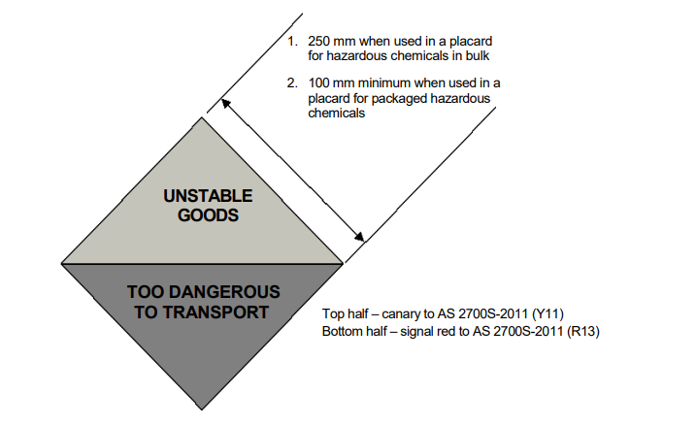

Figure 13.3 Label for unstable explosive, organic peroxide type A or self reactive substance type A
- Repeal of Regulations
These Regulations are repealed on the day after they commence.

