NORTHERN TERRITORY OF AUSTRALIA
Northern territory Rates amendment REGULATIONS 2022
_____________________________
Subordinate Legislation No. 3 of 2022
_____________________________

Table of provisions

1 Title 2
2 Commencement 2
3 Regulations amended 2
4 Schedule replaced 2
Schedule Prescribed areas
5 Repeal of Regulations 2

NORTHERN TERRITORY OF AUSTRALIA
_____________________________
Subordinate Legislation No. 3 of 2022*
_____________________________
Northern Territory Rates Amendment Regulations 2022
I, Vicki Susan O'Halloran, Administrator of the Northern Territory of Australia, acting with the advice of the Executive Council, make the following regulations under the Northern Territory Rates Act 1971.

Responsible Minister:

C. J. PAECH
Minister for Local Government

V. S. O'HALLORAN
Administrator
Date of making: 17 February 2022

- Title
These Regulations may be cited as the Northern Territory Rates Amendment Regulations 2022.
- Commencement
These Regulations commence on 1 July 2022.
- Regulations amended
These Regulations amend the Northern Territory Rates Regulations 1971.
- Schedule replaced
Schedule
repeal, insert

Schedule Prescribed areas
regulation 2
Part A
All that area of land shown bounded by thick black lines on the map in Part B.
Part B
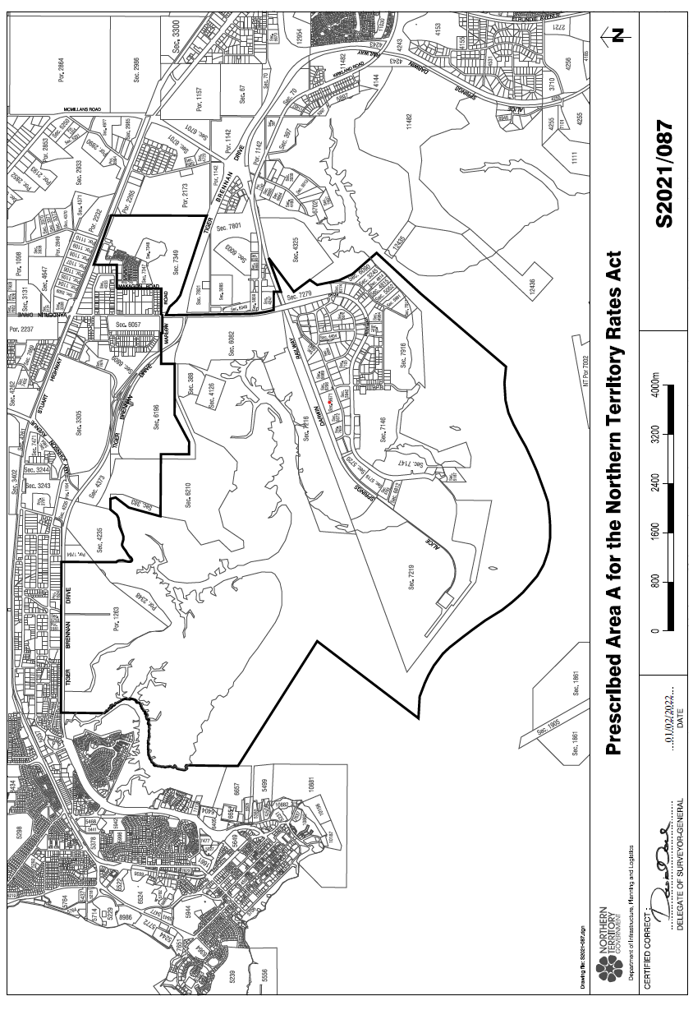

- Repeal of Regulations
These Regulations are repealed on the day after they commence.

