NORTHERN TERRITORY OF AUSTRALIA
LEGISLATIVE ASSEMBLY (POWERS AND PRIVILEGES) REGULATIONS
_____________________________
Subordinate Legislation No. 12 of 2007
_____________________________

TABLE OF PROVISIONS
Regulation

1. Citation
2. Act amended
3. Amendment of Schedule 2
4. Expiry

NORTHERN TERRITORY OF AUSTRALIA
_____________________________
Subordinate Legislation No. 12 of 2007*
_____________________________
Legislative Assembly (Powers and Privileges) Regulations
I, EDWARD JOSEPH EGAN, the Administrator of the Northern Territory of Australia, acting with the advice of the Executive Council, make the following regulations under the Legislative Assembly (Powers and Privileges) Act.

Dated 16 May 2007.

E. J. EGAN
Administrator

By His Honour's Command

P. R. HENDERSON
Minister for Employment, Education and Training
acting for the
Chief Minister

1. Citation
These Regulations may be cited as the Legislative Assembly (Powers and Privileges) Regulations.
2. Act amended
These Regulations amend the Legislative Assembly (Powers and Privileges) Act.
3. Amendment of Schedule 2
(1) Schedule 2, paragraph (a), before "the"
insert
except for the period specified in paragraph (ab) –
(2) Schedule 2, after paragraph (a)
insert
(ab) for the period commencing on 26 May 2007 and ending on 30 May 2007 – the area of land described in Part AB and shown bounded by thick black lines on the map in that Part; and
(3) Schedule 2, after Part A
insert
Part AB
All that parcel of land in the Town of Darwin in the Northern Territory of Australia containing an area of 3.87 hectares more or less and bounded by lines described as follows:
Commencing at the western corner of lot 5949; thence south-easterly by the south-western boundary of the said lot and its prolongation south-easterly to the south-eastern boundary of the Esplanade; thence generally south-westerly, westerly and north-westerly by south-eastern, southern and south-western boundaries of the Esplanade to the south-westerly prolongation of the most southern south-eastern boundary of lot 5796; thence north-easterly by the said prolongation to the south-western boundary of the Legislative Assembly Precinct as defined on survey plan S90/319 lodged with the Surveyor General, Darwin; thence generally north-westerly, north-easterly and south-easterly by south-western, north-western and north-eastern boundaries of the said Precinct to the south-westerly prolongation of a line 16.3 metres north-westerly of and parallel to the south-eastern boundary of lot 3940; thence north-easterly by the said prolongation and line to the north-eastern boundary of lot 3940; thence north-westerly by part of the said boundary to the south-westerly prolongation of the south-eastern boundary of Bennett Street; thence north-easterly by the said prolongation and boundary to a point 61 metres north-easterly of the most northern western corner of lot 4820; thence south-easterly by a line bearing 134 degrees 38 minutes for 104 metres; thence south-westerly by a line bearing 224 degrees 38 minutes for 3 metres; thence south-easterly by a line bearing 224 degrees 38 minutes to a south-eastern boundary of lot 7270(A) as defined on survey plan S2000/182 lodged with the Surveyor General, Darwin; thence south-westerly, south-easterly and again south-westerly by part of a south-eastern, a north-eastern and a south-eastern boundary of the said lot to the point of commencement.
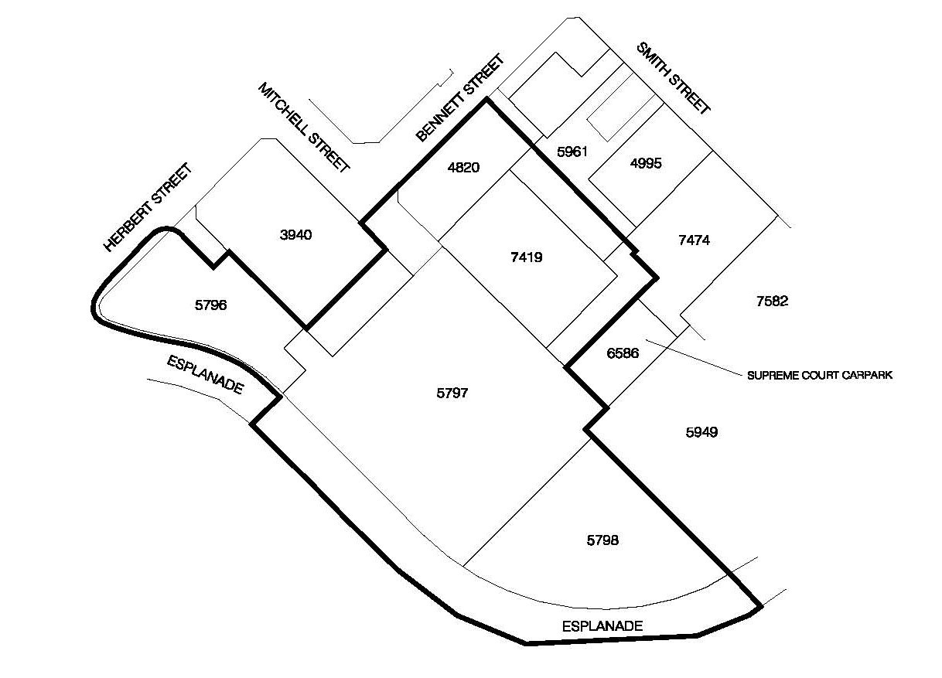
4. Expiry
These Regulations expire on the day after they commence.

