NORTHERN TERRITORY OF AUSTRALIA
PROPERTY ACTIVATION REGULATIONS 2019
As in force at 1 July 2019
Table of provisions

1 Citation 1
2 Commencement 1
3 Darwin CBD levy area 1
Schedule Darwin Central Business District levy area
ENDNOTES

NORTHERN TERRITORY OF AUSTRALIA
____________________
As in force at 1 July 2019
____________________
PROPERTY ACTIVATION REGULATIONS 2019
Regulations under the Property Activation Act 2019

1 Citation
These Regulations may be cited as the Property Activation Regulations 2019.

2 Commencement
These Regulations commence on the commencement of the Property Activation Act 2019.

3 Darwin CBD levy area
For section 8(1) of the Act, the area described in the Schedule, Part A and shown bordered by a thick black line in the diagram in the Schedule, Part B is prescribed as the Darwin Central Business District levy area.

Schedule Darwin Central Business District levy area
regulation 3
Part A
All that area of land within the Town of Darwin containing an area of 108 hectares more or less and bounded by the lines described as follows:
commencing at the southernmost corner of Lot 5633 Town of Darwin; then generally north-westerly by the south-western boundary of Lot 5633 and its prolongation to the centreline of Doctors Gully Road; then generally north-easterly by that centreline to the prolongation of the north-eastern boundary of Lot 5633; then generally north-easterly across Doctors Gully Road to the westernmost corner of Lot 8073 Town of Darwin; then generally north-easterly by the north-western boundary of Lot 8073 to the northernmost corner of that lot; then generally easterly across Mitchell Street to the westernmost corner of Unit 8985 Town of Darwin; then generally north-easterly by the north-western boundaries of Unit 8985 and Lot 2445 Town of Darwin to the northernmost corner of Lot 2445; then generally south-easterly by part of the north-eastern boundary of Lot 2445 to the westernmost corner of Lot 2446 Town of Darwin; then north-easterly by the north-western boundary of Lot 2446 and its prolongation to the centreline of Smith Street; then generally north-westerly, north-easterly and south-easterly by the centrelines of Smith Street and Harriet Place to the prolongation of the north-western boundary of Lot 1757 Town of Darwin; then generally north-easterly by that prolongation and the north-western boundary of Lot 1757 to the northernmost corner of that lot; then generally north-easterly across Gardens Road to the westernmost corner of Lot 1756 Town of Darwin; then generally north-easterly by the north-western boundary of Lot 1756 to the northernmost corner of that lot; then generally north-easterly across Dashwood Place to the westernmost corner of Lot 7845 Town of Darwin; then generally north-easterly by the north-western boundary of Lot 7845 to the northernmost corner of that lot; then generally north-easterly across Dashwood Place to the westernmost corner of Unit 10832 Town of Darwin; then generally north-easterly by the north-western boundary of Unit 10832 and its prolongation to the centreline of Woods Street; then generally north-westerly and north-easterly by the centrelines of Woods Street and Cashman Street to the intersection with a line perpendicular to the north-western boundary of Lot 1666 Town of Darwin commencing at the northernmost corner of that lot; then generally east by that perpendicular line to the northernmost corner of Lot 1666; then generally south-easterly by part of the north-eastern boundary of Lot 1666 to the westernmost corner of Lot 157 Town of Darwin; then generally north-easterly by the north-western boundary of that lot and its prolongation to the centreline of McMinn Street; then generally south-easterly and southerly by that centreline to the prolongation of the south-eastern boundary of Lot 6597 Town of Darwin; then generally south-westerly by that prolongation and the south-eastern boundaries of Lots 6597, 7790, 7827, 7602 and 7601 Town of Darwin to the southernmost corner of Lot 7601; then generally north-westerly by part of the south-western boundary of Lot 7601 to the easternmost corner of Lot 7262 Town of Darwin; then generally westerly along the southern boundaries of Lots 7262 and 7794 Town of Darwin to the southernmost corner of Lot 7794; then generally north-westerly by the south-western boundary of Lot 7794 and its prolongation to the intersection with the centreline of the Esplanade; then generally south-westerly, westerly and north-westerly by that centreline to the intersection with the centreline of Daly Street; then generally westerly to the point of commencement.
Part B
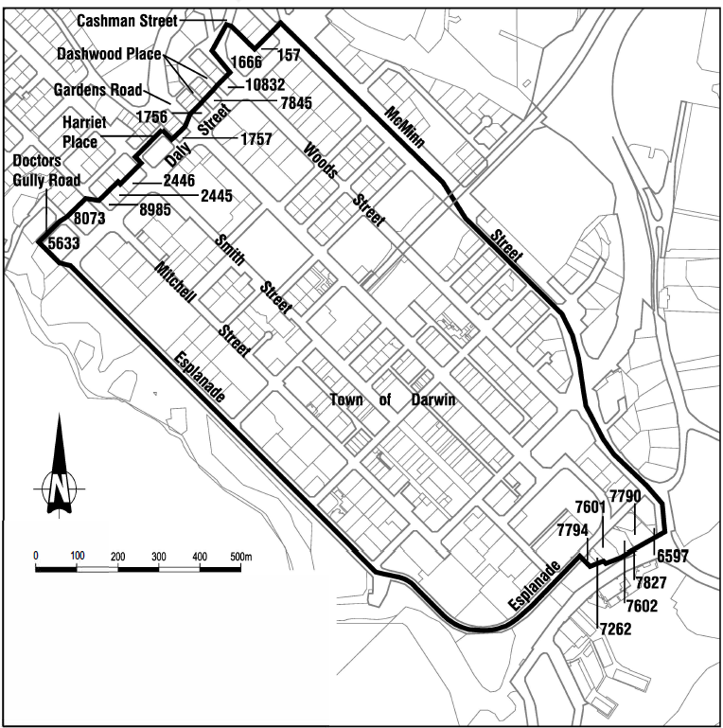

ENDNOTES

1 KEY
Key to abbreviations

amd = amended od = order
app = appendix om = omitted
bl = by-law pt = Part
ch = Chapter r = regulation/rule
cl = clause rem = remainder
div = Division renum = renumbered
exp = expires/expired rep = repealed
f = forms s = section
Gaz = Gazette sch = Schedule
hdg = heading sdiv = Subdivision
ins = inserted SL = Subordinate Legislation
lt = long title sub = substituted
nc = not commenced
2 LIST OF LEGISLATION
Property Activation Regulations 2019 (SL No. 14, 2019)
Notified | 1 July 2019
Commenced | 1 July 2019 (r 2 and s 2 Property Activation Act 2019 (Act No. 21, 2019))

