NORTHERN TERRITORY OF AUSTRALIA
MOTOR VEHICLES (STANDARDS) regulations 2003
As in force at 1 July 2021
Table of provisions

Part 1 Preliminary
1 Citation 1
2 Commencement 1
3 Application 1
4 Interpretation 1
4A Excluded provisions 5
Part 2 Motor vehicles standards
Division 1 Mass limits of vehicles
5 Mass limit for wheel 5
6 Mass limit for tyre 5
7 Mass limit for axle or axle group 5
8 Road friendly suspension 6
9 Ultra low floor 2 axle route bus 6
10 Bus with road friendly suspension 6
11 Retractable axle 6
Division 2 Limits to laden mass
12 Laden mass of vehicle or vehicle combination 7
12A Concessional mass limits for certain vehicles 7
13 Laden mass of consecutive axle groups 8
14 Laden mass of trailer 8
Division 3 Certain special vehicles
15 Vehicle fitted with non-rubber tyres or solid rubber tyres 9
16 Vehicle fitted with all or some rubber tyres 10
17 Tyres filled with water 10
Division 4 Axle group spacing for B-Double
18 Axle group spacing requirements for B-Double 11
Division 5 Size and projection of load
19 Front and side projections 11
20 Rear projections 12
21 Dangerous projections 12
22 Projection of load on motor cycle 12
23 Size limits 13
Division 6 Requirements for converter dollies
24 Converter dollies used in road trains 13
Division 7 Identification of road trains
25 Identification of hauling unit of road train 14
26 Identification of trailers used in road train 14
Part 3 Australian Vehicle Standards Rules
Division 1 Australian Vehicle Standards Rules
27 Australian Vehicle Standards Rules are law of the Territory 15
Division 2 Exemptions from certain rules
28 Exemption from right-hand drive requirement 15
29 Exemption from spray suppression requirement for B-double 16
30 Exemption from pneumatic tyre requirement for certain vehicles 16
31 Exemption from ABS brakes for road trains 16
32 Exemption from speed-limiting requirement for road train 16
33 Exemption in relation to vehicle carriers 17
Division 3 Additional requirements in relation to certain rules
34 Rear marking plates 17
Part 4 Offences
35 Compliance with Regulations 19
36 Regulatory offences 19
37 Defence if excess loading within certain limits 19
Part 5 Miscellaneous
38 Certificate in relation to manufacturer's gross axle load limit etc. 20
39 Repeal 21
40 Repealed Regulations continue to apply 21
Schedule 1
Schedule 2
Schedule 3
Schedule 4
Schedule 5
Schedule 6
ENDNOTES

northern territory of australia

____________________
As in force at 1 July 2021
____________________
Motor Vehicles (Standards) regulations 2003
Regulations under the Motor Vehicles Act 1949

Part 1 Preliminary

1 Citation
These Regulations may be cited as the Motor Vehicles (Standards) Regulations 2003.

2 Commencement
These Regulations come into operation on the date fixed by the Minister by notice in the Gazette.

3 Application
These Regulations do not apply to a nonconforming vehicle within the meaning of Part 5A of the Act.

4 Interpretation
(1) In these Regulations:
axle spacing means the distance between the centre of an axle of an axle group of a vehicle or vehicle combination and the centre of any other axle of the axle group.
hauling unit, in relation to a vehicle combination, means the rigid motor vehicle or prime mover towing the other vehicles of the vehicle combination.
inspection label, in relation to a vehicle, means a label, issued by the Registrar or an approved person, specifying the GVM or GCM of the vehicle (or other approved particulars in relation to the vehicle) and affixed to the vehicle in the approved manner.
manufacturer's gross axle load limit, in relation to an axle group, means the load recommended by the manufacturer of the axle group, by specification or otherwise, as being the maximum load at which that axle group should be operated.
manufacturer's maximum rim load, in relation to the rim of a wheel, means the load recommended by the manufacturer of that rim, by specification or otherwise, as the maximum load at which that rim should be operated.
manufacturer's maximum tyre load, in relation to a tyre, means the load recommended by the manufacturer of the tyre, by specification or otherwise, as the maximum load at which that tyre should be operated.
night means the period between sunset on one day and sunrise on the next day.
non-reactive load sharing suspension system, in relation to a vehicle, means a load sharing suspension system of an axle group of the vehicle in which there is no transfer of vertical loading from one axle of the axle group to another axle of that axle group when the vehicle's brakes are applied.
overall axle spacing means:
(a) in relation to a rigid motor vehicle, articulated vehicle or component vehicle of a vehicle combination – the distance between the centre of the foremost axle and the centre of the rearmost axle of the rigid motor vehicle, articulated vehicle or component vehicle; and
(b) in relation to axle groups which are adjacent to each other when any 2 component vehicles of a vehicle combination, including a rigid motor vehicle or an articulated vehicle, are coupled together – the distance between the centre of the foremost axle of the rearmost axle group of the leading vehicle and the centre of the rearmost axle of the foremost axle group of the trailing vehicle.
Diagram depicting overall axle spacing
pig trailer means a trailer with one axle group or single axle near the middle of its load-carrying surface, and connected to the towing vehicle by a drawbar.
Diagram depicting a typical pig trailer
public place means any part (other than a road) of a park, reserve, parking area, recreational or sporting ground, racecourse, drive-in theatre, beach or any other open place, that is open to or used by the public, whether with or without payment for admission, but does not include the track within an enclosed ground used for vehicle or animal speed races or trials.
road friendly suspension means a suspension system approved by the Registrar or another registration authority, or certified as such by the manufacturer, in relation to which:
(a) during free transient low frequency vertical oscillation of the sprung mass above an axle or axle group, the measured frequency and damping with the suspension carrying its maximum legal load fall within the following limits:
(i) the frequency of the sprung mass above the axle or axle group in free transient vertical oscillation is not higher than 2.0Hz;
(ii) the mean damping ratio is more than 20% of the critical damping for the suspension in its normal operating condition;
(iii) where dampers have been fitted, the damping ratio of the suspension with all dampers removed or incapacitated is not more than 50% of the mean damping ratio;
(iv) in respect of a multiple axle group fitted to a vehicle, the static load share between axles in the axle group is less than 5%; and
(b) each axle is fitted with dual tyres, except in respect of a
6-tyred tandem axle group in which case one axle in the axle group may have single tyres fitted.
single-pivot load sharing suspension system, in relation to a tandem axle group, means a load sharing suspension system of the tandem axle group, designed to allow the springing medium of the 2 axles of that tandem axle group to pivot about a common centre of rotation.
specification includes an identification device, vehicle data plate, catalogue, handbook or other written matter issued by or on behalf of a manufacturer in respect of a vehicle or a component of a vehicle, or plant, machinery or equipment, manufactured by the manufacturer.
steer axle means an axle or axle group connected to the steering mechanism of a motor vehicle and capable of being used by the driver to direct the course of that motor vehicle.
steerable axle means an axle or axle group fitted to a vehicle, but not connected to the steering mechanism of the vehicle, by means of which the course of that vehicle may be altered.
these Regulations include the Australian Vehicle Standards Rules contained in Schedule 6.
tyre section width means the nominal linear distance between the exteriors of the sidewalls of an inflated pneumatic tyre.
urban route means a route within a motor omnibus urban route service area declared by notice under section 47 of the Commercial Passenger (Road) Transport Act 1991.
(2) Unless the contrary intention appears, if a word or expression that is used in a regulation is defined for the purposes of the Australian Vehicle Standards Rules, the word or expression has the same meaning in the regulation as it has in the Australian Vehicle Standards Rules.
(2A) However, subregulation (2) does not apply in relation to a word or expression that is defined in this regulation or section 5(1) of the Act.
(3) Unless the contrary intention appears, a reference in a regulation to a rule and a number is a reference to the rule of that number in the Australian Vehicle Standards Rules.
(4) In these Regulations:
(a) the expression mass carried on a tyre or similar expression means the total mass transmitted to the road by the tyre, including the mass of the tyre; and
(b) the expression mass carried on an axle or mass carried on an axle group or similar expression (whether by reference to a single axle, a tandem axle group, a triaxle group, a twin-steer axle group, or one axle of an axle group), means the total mass transmitted to the road by the wheels attached to the axle or the axle group, including the mass of any wheels, tyres and other attachments or fittings attached or fitted to the axle or axles.

4A Excluded provisions
For section 5A(2)(h) of the Act, all provisions of these Regulations are excluded provisions.

Part 2 Motor vehicles standards

Division 1 Mass limits of vehicles

5 Mass limit for wheel
The mass carried on a wheel is not to exceed the limit set by its manufacturer.

6 Mass limit for tyre
The mass carried on a tyre is not to exceed the greatest load capacity determined for the tyre by its manufacturer at a cold inflation pressure that does not exceed:
(a) 825 kilopascals for a radial ply tyre; or
(b) 700 kilopascals for any other tyre.

7 Mass limit for axle or axle group
The mass carried on an axle or an axle group is not to exceed:
(a) the limit set by its manufacturer; or
(b) the limit specified in Schedule 1 for the type of axle or axle group,
whichever is the lesser.

8 Road friendly suspension
If a vehicle or vehicle combination is fitted with a road friendly suspension, the limit of:
(a) for a tandem axle group – 17 tonnes; and
(b) for a triaxle group – 22.5 tonnes,
is substituted for the limit specified in Schedule 1 for that axle group.

9 Ultra low floor 2 axle route bus
If a bus is of a class known as an ultra low floor 2-axle route bus and is operating on an urban route, the limit of 11 tonnes is substituted for that specified in Schedule 1 in respect of a single axle fitted with dual wheels, provided that the GVM does not exceed 16 tonnes.

10 Bus with road friendly suspension
If a bus is constructed to comply with third edition ADR 68, 59 and 44 and is fitted with road friendly suspension:
(a) the limit of 6.5 tonnes for a steer axle may be substituted for the limit specified by Schedule 1; and
(b) the limit specified in Schedule 1 for any other axle or axle group is increased by 1 tonne,
provided that, if the bus is fitted with a tandem axle group, the bus is permitted under a law of a State or another Territory of the Commonwealth to carry the maximum mass that would be permitted under this regulation.

11 Retractable axle
If an axle group includes a retractable axle, the retractable axle is to be ignored for the purposes of determining from Schedule 1 the mass limit that applies to the axle group unless the tyres of the retractable axle are on the ground and the load sharing suspension system is operating on each axle (including the retractable axle) and tyre in the group when:
(a) if the axle group is a tandem axle group – the mass on the group exceeds 6 tonnes; and
(b) if the axle group is a triaxle group – the mass on the group exceeds 11 tonnes.

Division 2 Limits to laden mass

12 Laden mass of vehicle or vehicle combination
(1) The laden mass of a vehicle is not to exceed:
(a) the sum of the masses permitted by Division 1 to be carried by the tyres or axles (or axle groups) of the vehicle; or
(b) the GVM of the vehicle,
whichever is the lesser.
(2) The laden mass of an articulated vehicle or a vehicle combination is not to exceed:
(a) the sum of the masses permitted by Division 1 to be carried by the tyres or axles (or axle groups) of the vehicle; or
(b) the GCM of the vehicle or, if no GCM is certified by the manufacturer or the Registrar, the mass in kilograms determined by the use of the formula set out in Schedule 2,
whichever is the lesser.

12A Concessional mass limits for certain vehicles
(1) This regulation applies if:
(a) an interstate owner or operator is accredited under a national heavy vehicle accreditation scheme; and
(b) the owner or operator has implemented a quality system that ensures the suspension system of a vehicle owned or operated by that person is adequately maintained; and
(c) the vehicle is permitted to operate using concessional mass limits in a State or another Territory.
(2) The vehicle may, in the Territory, exceed the laden mass limits arrived at under regulation 12:
(a) if the gross mass limit arrived at under regulation 12 does not exceed 55 tonnes – by one tonne; and
(b) if the gross mass limit arrived at under regulation 12 exceeds 55 tonnes – by 2 tonnes.
(3) The additional mass permitted under this regulation to be carried may result in the mass limit for an axle group specified in Schedule 1 being exceeded as follows:
(a) if a mass limit of 16.5 tonnes is specified in Schedule 1 – a limit of 17 tonnes is substituted;
(b) if a mass limit of 20 tonnes is specified in Schedule 1 – a limit of 21 tonnes is substituted.
(4) In this regulation:
interstate owner or operator means a person who, under legislation of another jurisdiction that deals with registration of motor vehicles or trailers, is the equivalent of an owner or operator under the Act.

13 Laden mass of consecutive axle groups
The laden mass carried by any combination of 2 or more consecutive axle groups in a vehicle or vehicle combination is not to exceed:
(a) the mass in tonnes calculated in accordance with the formula (3L + 12.5) where "L" is the distance in metres of the overall axle spacing of those axle groups; or
(b) if the vehicle combination is a B-double, the mass specified in Schedule 3.

14 Laden mass of trailer
(1) If a vehicle combination (not being a road train) is comprised of a rigid motor vehicle towing a trailer, the laden mass of the trailer is not to exceed the laden mass of the rigid motor vehicle unless approved by the Registrar.
(2) If a motor vehicle with a GVM not exceeding 4.5 tonnes is towing a trailer, the laden mass of the trailer is not to exceed:
(a) the towing capacity of the motor vehicle; or
(b) the towing capacity of the towing apparatus fitted to the vehicle,
whichever is the lesser.
(3) In this regulation:
towing capacity of the motor vehicle means:
(a) the towing capacity of the motor vehicle, including any operational restrictions, specified by the manufacturer; or
(b) if a towing capacity is not specified or is not able to be identified:
(i) if the trailer is fitted with brakes, 1.5 times the unladen mass of the motor vehicle; and
(ii) if the trailer is not fitted with brakes, the unladen mass of the motor vehicle.
towing capacity of the towing apparatus means the towing capacity of the towing apparatus specified by its manufacturer.

Division 3 Certain special vehicles

15 Vehicle fitted with non-rubber tyres or solid rubber tyres
(1) If a vehicle has any wheel that is not fitted with either a pneumatic tyre or a solid rubber tyre of 30 mm or more in thickness, the vehicle is to comply with the following requirements:
(a) the laden mass of the vehicle is not to exceed 3 tonnes;
(b) the mass carried on an axle of the vehicle is not to exceed 1.4 tonnes;
(c) the mass carried on a wheel that is not fitted with either a pneumatic tyre or a solid rubber tyre 30 mm or more in thickness is not to exceed the maximum mass specified in Schedule 4 for a wheel of that diameter and width of contact with the ground;
(d) the vehicle is not to be driven at a speed exceeding 15 kilometres per hour.
(2) For the purposes of Schedule 4, the mass per millimetre of width of a tyre (or wheel without a tyre) is determined by dividing the number of kilograms comprised in the wheel load on the wheel by the number of millimetres comprised in the width of tyre fitted to the wheel (or wheel, if no tyre is fitted) in contact with the ground when the vehicle is standing on level ground.
(3) For the purposes of subregulation (1), a group of co-axial wheels on one side of the centre-line of a vehicle are taken to be one wheel.

16 Vehicle fitted with all or some rubber tyres
(1) If a vehicle has solid rubber tyres 30 mm or more in thickness fitted to all wheels, or a mixture of such solid rubber tyres fitted to one or more wheels and pneumatic tyres fitted to all other wheels, the vehicle is to comply with the following requirements:
(a) the laden mass of the vehicle is not to exceed 4 tonnes;
(b) the mass carried on an axle of the vehicle is not to exceed 1.8 tonnes;
(c) the mass carried on a wheel that is not fitted with a pneumatic tyre is not to exceed:
(i) the maximum mass specified in Schedule 4 for a wheel of that diameter and width of contact of tyre with the ground; or
(ii) the maximum mass specified in Schedule 5 for the thickness of the tyre (measured at its thinnest point),
whichever is the lesser;
(d) the vehicle is not to be driven at a speed exceeding 25 kilometres per hour.
(2) For the purposes of Schedules 4 and 5, the mass per millimetre of width of a tyre is determined by dividing the number of kilograms comprised in the wheel load on the wheel by the number of millimetres comprised in the width of tyre fitted to the wheel in contact with the ground when the vehicle is standing on level ground.
(3) For the purposes of subregulation (1), a group of co-axial wheels on one side of the centre-line of a vehicle are taken to be one wheel.

17 Tyres filled with water
A tyre that would otherwise be a pneumatic tyre but that is filled or partly filled with water, whether with or without a chemical additive, is to be regarded for the purposes of this Division as a solid rubber tyre.

Division 4 Axle group spacing for B-Double

18 Axle group spacing requirements for B-Double
(1) The spacing between consecutive axle groups of a B-Double, other than a B-Double with 2 triaxle groups, is to comply with the following requirements:
(a) the distance between the centres of 2 tandem axle groups is not to be less than 6 metres;
(b) the distance between the centres of a tandem axle group and a triaxle group is not to be less than 7 metres.
(2) The spacing between consecutive axle groups of a B-Double with 2 triaxle groups is to comply with the clear space rule.
(3) In subregulation (2):
clear space rule means that x-y < 1 and y-x < 1.3, where x is the distance in metres between the centres of the closest axles in the second and third axle groups and y is the distance in metres between the centres in the closest axles of the third and fourth axle groups.

Division 5 Size and projection of load

19 Front and side projections
A load on a vehicle is not to project more than 1.2 metres in front of the vehicle or more than 150 mm from the outermost part of either side of it.
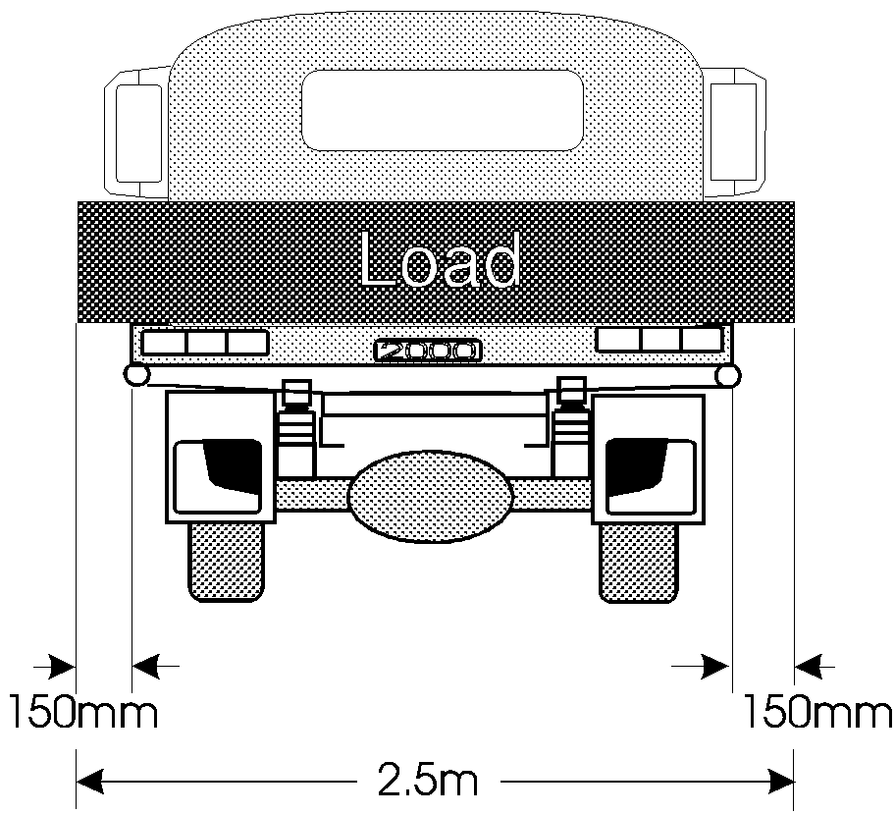
Maximum side projection of load allowed under regulation 19.
Note: The combined dimensions of a vehicle and its load must still meet the requirements of the Australian Vehicle Standards Rules in Schedule 6 even if the load projects from the vehicle in any direction.

20 Rear projections
(1) The rear of a load on a vehicle is to carry a warning signal if the load:
(a) projects more than 1.2 metres behind the vehicle;
(b) projects to the rear of the vehicle so that the end of the load cannot be seen easily from behind; or
(c) is on a pole-type trailer.
(2) In daylight, the warning signal referred to in subregulation (1) is to be a brightly coloured flag or piece of material, with each side at least 300 mm long.
(3) At night, the warning signal referred to in subregulation (1) is to be a red light that can be seen for 200 metres.

21 Dangerous projections
A load on a vehicle is not to project in a way that is dangerous to a person or to property, even if all dimension and warning requirements are met.

22 Projection of load on motor cycle
(1) The load or equipment of a motor cycle is not to project:
(a) beyond the extreme outer edge of the motor cycle;
(b) more than 150 mm to the front of the outer extremity of the front wheel of the motor cycle; and
(c) more than 300 mm to the rear of the outer extremity of the rear wheel of the motor cycle.
(2) The load or equipment of a motor cycle with a sidecar is not to project:
(a) beyond the extreme outer edge of the motor cycle and sidecar;
(b) more than 600 mm to the front of the outer extremity of the front wheel of the motor cycle; and
(c) more than 900 mm to the rear of the outer extremity of the rear wheel of the motor cycle.

23 Size limits
(1) Subject to regulation 33, a vehicle or a combination, and its load, is not to exceed a size limit set for the vehicle or combination in the Australian Vehicle Standards Rules.
(2) The distance measured at right angles between the rear overhang line of a vehicle and the rear of any load it is carrying is not to exceed the rear overhang that the vehicle is allowed under the Australian Vehicle Standards Rules.
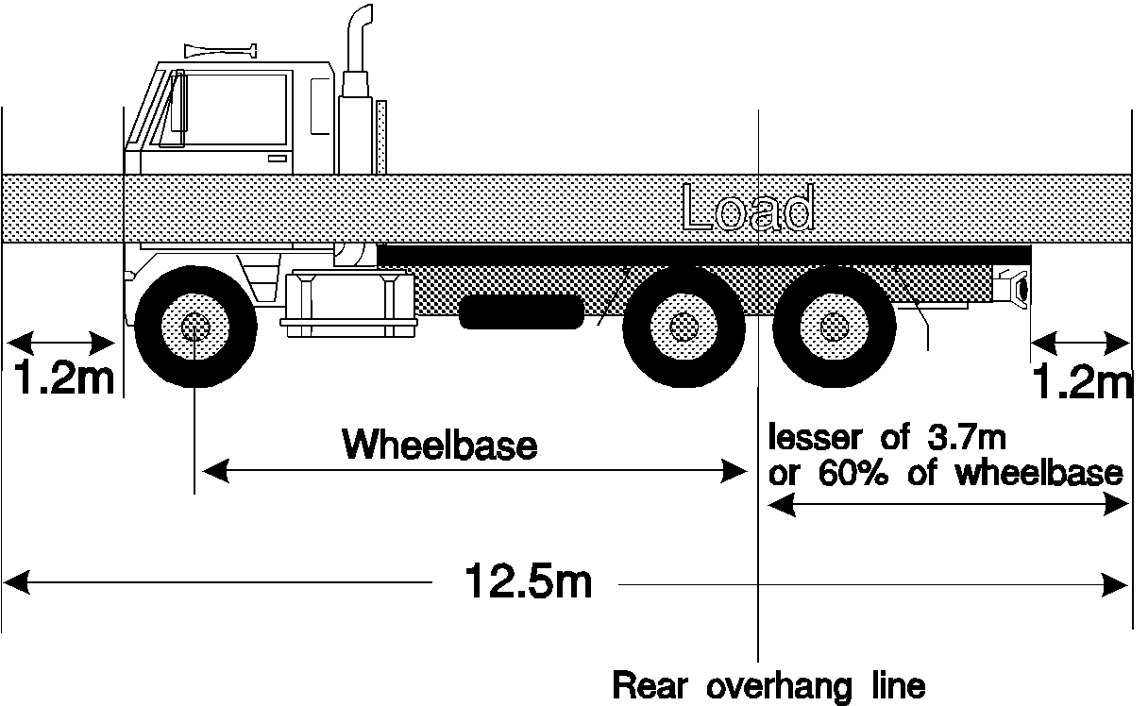
Illustration of:
• front projection limit; and
• rear overhang limit from Australian Vehicle Standards Rules; and
• maximum rear projection of load allowed without a warning signal.

Division 6 Requirements for converter dollies

24 Converter dollies used in road trains
A converter dolly is not to be used in a road train unless the converter dolly is so constructed that the torque reaction generated in the converter dolly from braking forces is:
(a) transmitted through the converter dolly's fifth wheel assembly into the vehicle towing the converter dolly, in which case:
(i) the drawbar of that converter dolly is to be attached to the chassis of the converter dolly through a flexible coupling that allows the drawbar to pivot vertically about a transverse horizontal axis; and
(ii) if the converter dolly has other than a single axle group – the axle group is to have an approved non-reactive load sharing suspension system;
(b) transmitted, through a tow coupling designed for the purpose, into the vehicle towing the converter dolly, in which case:
(i) the drawbar and chassis of the converter dolly are to be an integral unit and the converter dolly's fifth wheel assembly is to be able to pivot about a horizontal axis; and
(ii) if the converter dolly has other than a single axle group – the axle group is to have an approved single-pivot load-sharing suspension system; or
(c) if the converter dolly has an approved suspension system fitted to the axle group – carried through that suspension system, in which case the drawbar of the converter dolly is to be attached to the chassis of the dolly converter through a flexible coupling that allows the drawbar to pivot vertically about a transverse horizontal axis.

Division 7 Identification of road trains

25 Identification of hauling unit of road train
(1) A hauling unit used in a road train is to have displayed on it the following particulars:
(a) the gross vehicle mass of the hauling unit;
(b) the gross combination mass of the hauling unit.
(2) The particulars may be displayed by means of an identification device, registration certificate, inspection label or a document approved by the Registrar.
(3) A hauling unit used in a road train is to have an inspection label (or other document approved by the Registrar for the purposes of this regulation) that is in force.

26 Identification of trailers used in road train
(1) A trailer used in a road train is to have displayed on it the following particulars:
(a) the name or trademark of the manufacturer of the trailer;
(b) a distinguishing serial number of the trailer.
(2) The particulars may be displayed by means of an identification device, registration certificate, inspection label or a document approved by the Registrar.
(3) A trailer used in a road train is to have an inspection label (or other document approved by the Registrar for the purposes of this regulation) that is in force.

Part 3 Australian Vehicle Standards Rules

Division 1 Australian Vehicle Standards Rules

27 Australian Vehicle Standards Rules are law of the Territory
(1) The Australian Vehicle Standards Rules contained in Schedule 6 are made as regulations under the Act and are a law of the Territory.
(2) A reference in an Act or instrument of a legislative or administrative character to the Australian Vehicle Standards Rules is a reference to the Australian Vehicle Standards Rules contained in Schedule 6.

Division 2 Exemptions from certain rules

28 Exemption from right-hand drive requirement
(1) The requirement under rule 27(1) that a motor vehicle must have a right-hand drive does not apply to the following types of motor vehicles:
(a) a personally imported vehicle as defined in rule 23(1);
(b) a vehicle imported under an approval to import given under regulation 9F or 17 of the Motor Vehicle Standards Regulations 1989 (Cth) before their repeal;
(c) a vehicle imported under an approval to import given under regulation 11 of the Motor Vehicle Standards Regulations 1989 (Cth) before its repeal, on the basis that the vehicle satisfied the eligibility criterion set out in section 36 of the RVS Rules;
(d) a vehicle imported under an approval to import given under section 19 of the Motor Vehicle Standards Act 1989 (Cth) and supplied to market under section 14A or 16(2) of that Act, on the basis that the vehicle satisfied the rarity criterion set out in section 135 of the RVS Rules;
(e) a vehicle that is entered on the RAV because it satisfied the requirements of the concessional RAV entry approval pathway mentioned in section 15(2)(b) of the Road Vehicle Standards Act 2018 (Cth) by satisfying:
(i) the eligibility criterion set out in section 36 of the RVS Rules; or
(ii) the eligibility criterion set out in section 37 of the RVS Rules because it is covered by an entry on the SEVs register on the basis that it satisfied the rarity criterion set out in section 135 of the RVS Rules.
(2) In this regulation:
RVS Rules means the Road Vehicle Standards Rules 2019 (Cth).

29 Exemption from spray suppression requirement for B-double
The requirement under rule 33(1)(b) that certain spray suppression devices be fitted for each axle group and single axle on a vehicle that is a B-Double does not apply in the Territory.

30 Exemption from pneumatic tyre requirement for certain vehicles
The requirement under rule 47 that a vehicle built after 1932 must be fitted with pneumatic tyres does not apply to a vehicle that complies with Part 2, Division 3.

31 Exemption from ABS brakes for road trains
(1) The requirement under rule 136(1) that a prime mover used in a
B-Double must be fitted with an anti-lock braking system does not apply in the Territory if the prime mover is identified as a road train hauling unit in accordance with regulation 25.
(2) The requirement under rule 138(3) that a trailer used in a B-Double must, in certain circumstances, be fitted with an anti-lock braking system does not apply in the Territory if the trailer is identified as a road train trailer in accordance with regulation 26.

32 Exemption from speed-limiting requirement for road train
The speed limiting requirement under rule 155(3) does not apply to a motor vehicle used as a hauling unit in a road train providing that:
(a) the hauling unit of the road train has been certified to third edition ADR 65; and
(b) the hauling unit of the road train is fitted with an electronically programmable speed limiter; and
(c) the speed limiter is set to limit the road speed of the hauling unit to not more than 100 kilometres per hour.

33 Exemption in relation to vehicle carriers
Despite regulation 23:
(a) the height of a vehicle that is carrying vehicles on more than one deck, and its load, is not to exceed 4.6 metres; and
(b) the distance measured at right angles between the rear overhang line of a trailer carrying vehicles on more than one deck and the rear of the rearmost vehicle on the trailer is not to exceed 4.9 metres.
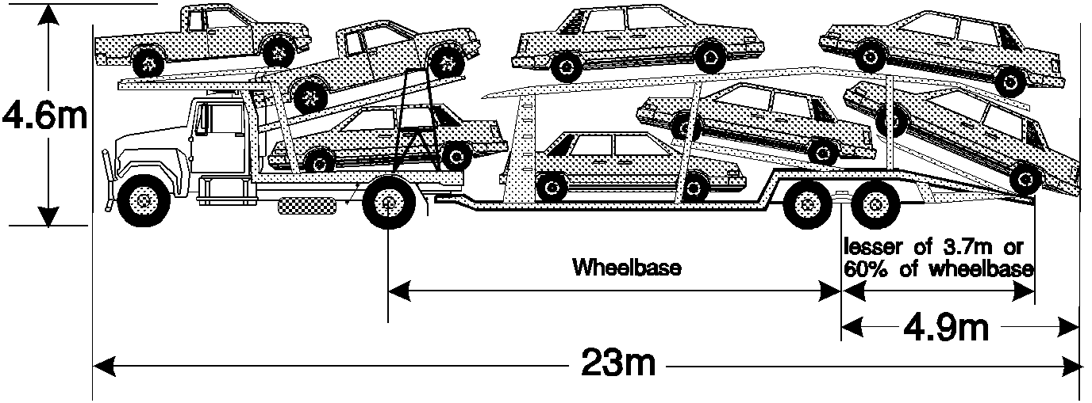
Maximum allowable dimensions of a loaded car carrier

Division 3 Additional requirements in relation to certain rules

34 Rear marking plates
(1) Rear marking plates required by rule 119 are to:
(a) comply with the requirements of AS 4001.1 – 1992 "Motor Vehicle – Rear Marker Plates" arranged according to AS 4001.2 – 1992 "Motor Vehicle – Rear Marker Plates – Installation and Arrangement Requirements"; or
(b) be mounted at the rear of the vehicle and arranged as follows and as depicted in the diagram:
(i) arrangement A – 2 Category 1 plates;
(ii) arrangement B – a single Category 2 plate;
(iii) arrangement C – one Category 2a plate and one Category 2b plate, arranged horizontally;
(iv) arrangement D – one Category 2a plate and one Category 2b plate, arranged vertically.
(2) Arrangement A is the preferred arrangement, but where that arrangement is not possible, an alternative arrangement listed in subsection (1)(b) may be utilised.
(3) The plates are to be orientated rearwards and mounted:
(a) at the same height and with the lower edge not less than 400 mm and not more than 1 500mm from the ground;
(b) so that the outer edge of a plate:
(i) does not protrude beyond the nearest outer face of the vehicle; and
(ii) is within 150 mm (if practicable, but in any case within 500 mm) of the nearest outer face of the vehicle.
(c) so that the lower edge of a plate is horizontal to the ground;
(d) as near as practicable to and in any case within 20 degrees (horizontally and vertically) of being in a vertical plane representing the back of the vehicle; and
(e) so that the plates are visible from a position within 30 degrees either side, and within 15 degrees up and down, of square from the face of a plate.
(4) The total plate area is to be not less than 0.32 square metres.
(5) No lamps are to be placed inside the boundaries of a marker plate, but the warning sign "DO NOT OVERTAKE TURNING VEHICLE" may be printed in black lettering 50 mm high on the yellow portion of one of the Category 1 plates.
(6) If the nature of the vehicle requires it:
(a) the plates may be attached to fabricated supports that can be removed or swung aside for loading or unloading;
(b) the plates may be attached to the underside of tip-up loading ramps so that they are visible when the ramp is in position for the vehicle to be driven; and
(c) the plates may be cut so that a plate can be mounted across the edges of movable or opening panels (the sections can be moved apart by not more than 25 mm or a strip of material not wider than 10 mm per side may be removed adjacent to the cut to enable the panels to separate).
(7) The Registrar may approve an installation that does not fully comply with this regulation.

Part 4 Offences

35 Compliance with Regulations
Subject to section 59 of the Act, a person must not drive, or cause or permit to be driven, on a road or in a public place a vehicle that does not comply with a requirement of these Regulations applicable to it.
Maximum penalty: If the offender is an individual – 20 penalty units.
If the offender is a corporation – 100 penalty units.

36 Regulatory offences
An offence that relates to the contravention of, or failure to comply with, a requirement of these Regulations is a regulatory offence.

37 Defence if excess loading within certain limits
If a person is prosecuted for an offence against regulation 35 where the substance of the breach is that a load limit set out in Part 2, Division 1, 2 or 3 was exceeded, it is a defence if the person charged with the offence proves that the person made, or caused to be made, all reasonable efforts to comply with the relevant regulation and that:
(a) the load the subject of the charge did not cause the manufacturer's recommendations, by specification or otherwise, of the safe working load for any component to be exceeded;
(b) the load limit set out in the relevant regulation was not exceeded:
(i) for a single steer axle – by more than .25 tonnes;
(ii) for a single axle other than a single steer axle – by more than .5 tonnes; or
(iii) for any other axle group – by more than one tonne; and
(c) the GVM or GCM was not exceeded by more than 10%.

Part 5 Miscellaneous

38 Certificate in relation to manufacturer's gross axle load limit etc.
(1) For the purposes of a prosecution for an offence against these Regulations, the particulars stated in a certificate issued by the Registrar as to:
(a) the manufacturer's gross axle load limit of an axle group;
(b) the GCM of a vehicle combination;
(c) the GVM of a vehicle;
(d) the manufacturer's maximum rim load of a rim of a tyre; or
(e) the manufacturer's maximum tyre load of a tyre,
are taken to be that limit, mass or load, as the case may be, unless the contrary is proven.
(2) The particulars included in a certificate under subregulation (1) may be derived from the records of the Registrar or from records kept by a registrar (however described) of vehicles in a State or another Territory of the Commonwealth.
(3) No proof as to the signature of the Registrar is required in relation to a certificate under subregulation (1).

39 Repeal
The following Regulations are repealed:
(a) Motor Vehicles (Standards) Regulations (Regulations No. 74, 1982);
(b) Amendments of Motor Vehicles (Standards) Regulations (Regulations No. 31, 1988).

40 Repealed Regulations continue to apply
Despite regulation 39, the Motor Vehicles (Standards) Regulations 1982 as in force immediately before the commencement of these Regulations continue to apply in relation to an offence that was committed before the commencement of these Regulations.

Schedule 1
regulation 7
Description of axle or axle group | Mass Limit  (tonnes)
Single axles and single axle groups
Single steer axle on a motor vehicle | 6.0
Single axle or single axle group fitted with single tyres with section width of:  (a) less than 375 mm  (b) at least 375 mm but less than 450 mm  (c) at least 450 mm | 6.0  6.7  7.0
Single axle or single axle group fitted with dual tyres on:  (a) a pig trailer  (b) a bus licensed to carry standing passengers  (c) any other vehicle | 8.5  10.0  9.0
Twinsteer axle groups
Twinsteer axle group without a load-sharing  suspension system | 10.0
Twinsteer axle group with a load-sharing suspension  system | 11.0
Tandem axle groups
Tandem axle group fitted with single tyres with section width of:  (a) less than 375 mm  (b) at least 375 mm but less than 450 mm  (c) at least 450 mm | 11.0  13.3  14.0
Tandem axle group fitted with single tyres on one axle and dual tyres on the other axle | 13.0
Tandem axle group fitted with dual tyres on:  (a) a pig trailer  (b) any other vehicle | 15.0  16.5
Tri-axle groups
Tri-axle group on a vehicle fitted with single tyres with section width of less than 375 mm on all axles, or single tyres on one or 2 axles and dual tyres on the other axle or axles |  | 15.0
Tri-axle group on a pig trailer with either single tyres with section width of at least 375 mm, dual tyres on all axles, or a combination of those tyres |  | 18.0
Tri-axle group, on a vehicle other than a pig trailer, with either single tyres with section width of at least 375 mm, dual tyres, or a combination of those tyres |  | 20.0
Quad axle groups
Quad-axle group fitted with single tyres with section width of less than 375 mm |  | 15.0
Quad-axle group fitted with single tyres with section width of at least 375 mm or dual tyres |  | 20.0
Other axle groups
Any other axle group not specifically referred to in this Schedule |  | 20.0

Schedule 2
regulation 12
Mass in kilograms = K x M x R x T
16
if:
K = drive efficiency constant for the type of drive axle fitted to the vehicle, being:
for a single drive axle – 0.055
for a single drive tandem axle group – 0.053
for a dual drive tandem axle group – 0.051;
M = number of tyre revolutions per kilometre as specified by the tyre manufacturer for the tyres fitted to the driving axle or axles;
R = overall gear reduction between engine and drive wheels;
T = maximum engine net torque in Newton metres.

Schedule 3
regulation 13
Distance between extreme of axle groups under consideration (metres) |  | Maximum permitted laden mass on axle groups (tonnes) | Distance between extreme axles of axle groups under consideration (metres) |  | Maximum permitted laden mass on axle groups (tonnes)
Equal to or greater than | Less than |  | Equal to or greater than | Less than
3.5 | 3.7 | 23.0 | 10.0 | 10.2 | 42.5
3.7 | 3.8 | 23.5 | 10.2 | 10.3 | 43.0
38. | 4.0 | 24.0 | 10.3 | 10.5 | 43.5
4.0 | 4.2 | 24.5 | 10.5 | 10.7 | 44.0
4.2 | 4.3 | 25.0 | 10.7 | 10.8 | 44.5
4.3 | 4.5 | 25.5 | 10.8 | 11.0 | 45.0
4.5 | 4.7 | 26.0 | 11.0 | 11.2 | 45.5
4.7 | 4.8 | 26.5 | 11.2 | 11.3 | 46.0
4.8 | 5.0 | 27.0 | 11.3 | 11.7 | 46.5
5.0 | 5.2 | 27.5 | 11.7 | 12.0 | 47.0
5.2 | 5.3 | 28.0 | 12.0 | 12.3 | 47.5
5.3 | 5.5 | 28.5 | 12.3 | 12.7 | 48.0
5.5 | 5.7 | 29.0 | 12.7 | 13.0 | 48.5
5.7 | 5.8 | 29.5 | 13.0 | 13.3 | 49.0
5.8 | 6.0 | 30.0 | 13.3 | 13.7 | 49.5
6.0 | 6.2 | 30.5 | 13.7 | 14.0 | 50.0
6.2 | 6.3 | 31.0 | 14.0 | 14.3 | 50.5
6.3 | 6.5 | 31.5 | 14.3 | 14.7 | 51.0
6.5 | 6.7 | 32.0 | 14.7 | 15.0 | 51.5
6.7 | 6.8 | 32.5 | 15.0 | 15.3 | 52.0
6.8 | 7.0 | 33.0 | 15.3 | 15.7 | 52.5
7.0 | 7.2 | 33.5 | 15.7 | 16.0 | 53.0
7.2 | 7.3 | 34.0 | 16.0 | 16.3 | 53.5
7.3 | 7.5 | 34.5 | 16.3 | 16.7 | 54.0
7.5 | 7.7 | 35.0 | 16.7 | 17.0 | 54.5
7.7 | 7.8 | 35.5 | 17.0 | 17.3 | 55.0
7.8 | 8.0 | 36.0 | 17.3 | 17.7 | 55.5
8.0 | 8.2 | 36.5 | 17.7 | 18.0 | 56.0
8.2 | 8.3 | 37.0 | 18.0 | 18.3 | 56.5
8.3 | 8.5 | 37.5 | 18.3 | 18.7 | 57.0
8.5 | 8.7 | 38.0 | 18.7 | 19.0 | 57.5
8.7 | 8.8 | 38.5 | 19.0 | 19.3 | 58.0
8.8 | 9.0 | 39.0 | 19.3 | 19.7 | 58.5
9.0 | 9.2 | 39.5 | 19.7 | 20.0 | 59.0
9.2 | 9.3 | 40.0 | 20.0 | 20.3 | 59.5
9.3 | 9.5 | 40.5 | 20.3 | 20.7 | 60.0
9.5 | 9.7 | 41.0 | 20.7 | 21.0 | 60.5
9.7 | 9.8 | 41.5 | 21.0 | – | 62.5
9.8 | 10.0 | 42.0

Schedule 4
regulations 15 and 16
Diameter of wheel in metres | Maximum mass in kilograms for each 25 millimetres width of tyre in contact with the ground
 | For other than pneumatic tyres and solid rubber tyres 30 mm thick | For solid rubber tyres not less than 30 mm thick
Less than 0.3 of a metre | 136 | 227
Not less than 0.3 of a metre and less than 0.6 of a metre | 181 | 272
Not less than 0.6 of a metre and less than 0.9 of a metre | 227 | 318
Not less than 0.9 of a metre and less than 1.2 metres | 272 | 363
Not less than 1.2 metres and less than 1.5 metres | 318 | 363
1.5 metres or more | 363 | 363

Schedule 5
regulation 16
Thickness of tyre in millimetres | Maximum mass in kilograms per 25 millimetres width of tyre in contact with the ground
Not less than 30 millimetres and less than 40 millimetres | 272
Not less than 40 millimetres and less than 45 millimetres | 295
Not less than 45 millimetres and less than 50 millimetres | 318
Not less than 50 millimetres and less than 55 millimetres | 340
55 millimetres or more | 363

Schedule 6
regulation 27
AUSTRALIAN VEHICLE STANDARDS RULES
for the avsr's – Please see separate document RePm020R7AVSR(NT)

ENDNOTES

1 KEY
Key to abbreviations

amd = amended od = order
app = appendix om = omitted
bl = by-law pt = Part
ch = Chapter r = regulation/rule
cl = clause rem = remainder
div = Division renum = renumbered
exp = expires/expired rep = repealed
f = forms s = section
Gaz = Gazette sch = Schedule
hdg = heading sdiv = Subdivision
ins = inserted SL = Subordinate Legislation
lt = long title sub = substituted
nc = not commenced
2 LIST OF LEGISLATION
Motor Vehicles (Standards) Regulations (SL No. 17, 2003)
Notified | 30 April 2003
Commenced | 1 May 2003 (Gaz S7, 30 April 2003)
Motor Vehicles (Standards) Amendment Regulations 2006 (SL No. 29, 2006)
Notified | 23 August 2006
Commenced | 23 August 2006
Penalties Amendment (Miscellaneous) Act 2013 (Act No. 23, 2013)
Assent date | 12 July 2013
Commenced | 28 August 2013 (Gaz G35, 28 August 2013, p 2)
Statute Law Revision Act 2017 (Act No. 4, 2017)
Assent date | 10 March 2017
Commenced | 12 April 2017 (Gaz G15, 12 April 2017, p 3)
Transport Legislation Amendment Act 2020 (Act No. 23, 2020)
Assent date | 10 July 2020
Commenced | 1 July 2021 (Gaz G23, 9 June 2021, p 1)
Amending Legislation
Statute Law Revision Act 2020 (Act No. 26, 2020)
Assent date |  | 19 November 2020
Commenced |  | 20 November 2020 (s 2)
3 GENERAL AMENDMENTS
General amendments of a formal nature (which are not referred to in the table of amendments to this reprint) are made by the Interpretation Legislation Amendment Act 2018 (Act No. 22, 2018) to: rr 1, 4, 23, 27 and 40 and sch 6.
4 LIST OF AMENDMENTS
r 3 amd Act No. 23, 2020, s 44
r 4 amd Act No. 23, 2020, s 45
r 4A ins Act No. 23, 2020, s 46
r 10 amd Act No. 23, 2020, s 47
r 12A ins No. 29, 2006, r 3
amd Act No. 23, 2020, s 48
r 25 amd Act No. 23, 2020, s 49
r 26 amd Act No. 23, 2020, s 50
pt 3 hdg amd Act No. 4, 2017, s 34
r 28 sub Act No. 23, 2020, s 51
r 32 amd Act No. 23, 2020, s 52
r 35 amd Act No. 23, 2013, s 4
sch 6
r 3A ins Act No. 23, 2020, s 54
r 10 amd Act No. 23, 2020, s 55
r 13 amd Act No. 23, 2020, s 56
r 14 amd Act No. 23, 2020, s 57
r 15 – 18 rep Act No. 23, 2020, s 58
r 21 amd Act No. 23, 2020, s 59
r 22 amd Act No. 23, 2020, s 60
r 23 amd Act No. 23, 2020, s 61
r 27 amd Act No. 23, 2020, s 62
r 34 amd Act No. 4, 2017, s 34
r 118 amd Act No. 4, 2017, s 34
dict amd Act No. 23, 2020, s 63

