NORTHERN TERRITORY OF AUSTRALIA
NORTHERN TERRITORY PRODUCTS SYMBOL regulations 1999
As in force at 7 April 1999
Table of provisions

Part 1 Preliminary
1 Citation 1
2 Prescription of symbol 1
Part 2 Infringement notices
3 Issuing of infringement notices 1
4 Particulars to be shown on infringement notice 1
5 Penalty for offence 2
6 Payment before expiry date of infringement notice 2
7 General 2
Schedule
ENDNOTES

northern territory of australia

____________________
As in force at 7 April 1999
____________________
Northern Territory Products Symbol regulations 1999
Regulations under the Northern Territory Products Symbol Act 1982

Part 1 Preliminary

1 Citation
These Regulations may be cited as the Northern Territory Products Symbol Regulations 1999.

2 Prescription of symbol
The symbol is the form of design depicted in the Schedule.

Part 2 Infringement notices

3 Issuing of infringement notices
If an inspector believes that an offence has been committed against section 4(2), 5(2), 6 or 12(1) of the Act, the inspector may serve an infringement notice on the person who appears to have committed the offence.

4 Particulars to be shown on infringement notice
An infringement notice served under regulation 3 is to have clearly shown on it:
(a) the date, time and place of the offence;
(b) the nature of the offence and the penalty payable;
(c) the place or places where the penalty may be paid;
(d) the date of the infringement notice and a statement that the penalty may be paid within 28 days after that date; and
(e) a statement to the effect that no further action will be taken if the amount specified in the infringement notice as the penalty for the offence is paid at a place referred to in the notice within the time specified in the notice.

5 Penalty for offence
The penalty that may be paid under these Regulations in lieu of the penalty that may otherwise be imposed in respect of an offence in respect of which an infringement notice has been issued is:
(a) $100; or
(b) $125 in respect of an offence against section 6 of the Act.

6 Payment before expiry date of infringement notice
(1) A person on whom an infringement notice is served is to be taken to have expiated the offence if he or she pays the amount of the penalty shown on the notice at a place specified in the notice before the period specified in the notice for paying the penalty expires.
(2) If the penalty is paid by cheque, the penalty is not to be taken to have been paid unless the cheque is cleared on presentation.

7 General
(1) Nothing in these Regulations:
(a) prevents more than one infringement notice in relation to the same offence being served but it is sufficient for the application of regulation 6 to a person on whom more than one notice has been served for the person to pay the amount of the penalty in accordance with any one notice served on the person;
(b) prejudices or affects (except as provided by regulation 6) the institution or prosecution of proceedings, or limits the penalty that may be imposed by a court, in relation to an offence; or
(c) is to be construed as requiring that an infringement notice be served or as affecting the liability of a person to be prosecuted in a court in relation to an offence in respect of which an infringement notice has not been served.

Schedule
regulation 2
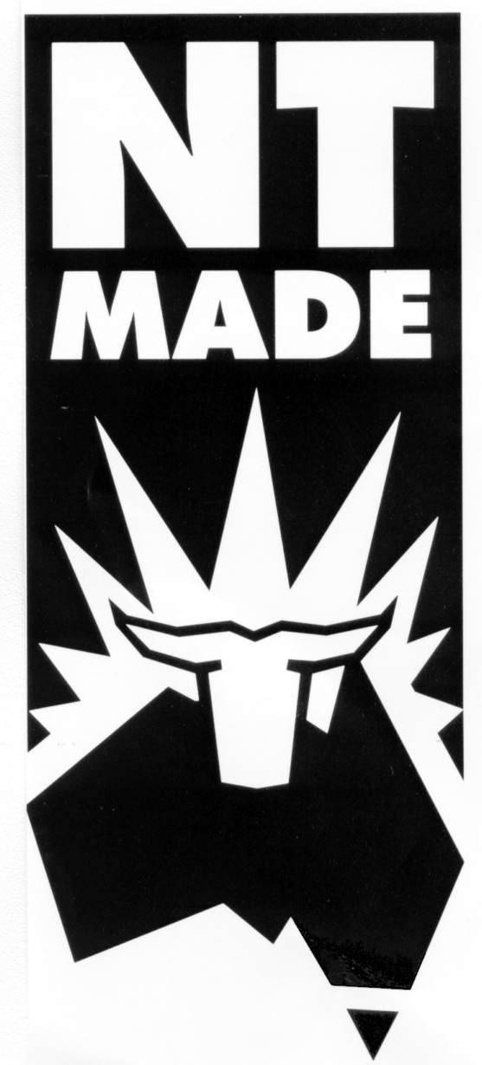

ENDNOTES

1 KEY
Key to abbreviations

amd = amended od = order
app = appendix om = omitted
bl = by-law pt = Part
ch = Chapter r = regulation/rule
cl = clause rem = remainder
div = Division renum = renumbered
exp = expires/expired rep = repealed
f = forms s = section
Gaz = Gazette sch = Schedule
hdg = heading sdiv = Subdivision
ins = inserted SL = Subordinate Legislation
lt = long title sub = substituted
nc = not commenced
2 GENERAL AMENDMENTS
General amendments of a formal nature (which are not referred to in the table of amendments to this reprint) are made by the Interpretation Legislation Amendment Act 2018 (Act No. 22, 2018) to: r 1.
3 LIST OF LEGISLATION
Northern Territory Products Symbol Regulations (SL No. 9, 1999)
Notified | 7 April 1999
Commenced | 7 April 1999

