NORTHERN TERRITORY OF AUSTRALIA
medical services (Royal darwin hospital parking) REGULATIONS
As in force at 28 April 2016
Table of provisions

Part 1 Preliminary matters
1 Citation 1
2 Definitions 1
Part 2 Parking in the grounds of the hospital
3 Parking prohibition offences 3
4 Parking in pay and display parking area 3
5 Parking in shared parking area 5
6 Parking in no charge parking area 5
7 Parking in reserved parking area 6
8 Parking in taxi rank 6
9 Parking in motorcycle parking area 6
Part 3 Administration
Division 1 Parking Areas
10 Parking areas 6
Division 2 Authorised persons
11 Appointment of authorised persons 7
12 Powers of authorised persons 7
13 Identity card 7
14 Return of identity card 7
15 Obstruction of authorised person 8
Part 4 Infringement notice offences
16 Infringement notice offence and prescribed amount payable 8
17 Service of infringement notice 8
18 Contents of infringement notice 9
19 Payment by cheque 10
20 Withdrawal of infringement notice 10
21 Application of Part 10
Schedule 1 Parking Areas
Schedule 2 Infringement notice offences and prescribed amounts
ENDNOTES

NORTHERN TERRITORY OF AUSTRALIA
____________________
As in force at 28 April 2016
____________________
medical services (Royal darwin hospital parking) REGULATIONS
Regulations under the Medical Services Act

Part 1 Preliminary matters

1 Citation
These Regulations may be cited as the Medical Services (Royal Darwin Hospital Parking) Regulations.

2 Definitions
In these Regulations:
appropriate parking fee:
(a) for a pay and display parking area – see regulation 4(4); or
(b) for a shared parking area – see regulation 5(2)(b)(ii).
Australian Disability Parking Permit means a permit mentioned in regulation 30 of the Traffic Regulations.
authorised person means a person appointed under regulation 11.
disabled parking area, see regulation 10(c).
expiry time, in relation to a person to whom a ticket has been issued, means the time:
(a) chosen as the end of the parking period during which the person is allowed to park the vehicle for which the ticket was issued; and
(b) printed on the ticket.
hospital means the premises known as the Royal Darwin Hospital declared to be a hospital by notice under section 6(2)(a)(i) of the Act.
infringement notice, see regulation 17(1).
infringement notice offence, see regulation 16(1).
motorcycle parking area, see regulation 10(g).
no charge parking area, see regulation 10(d).
park, in relation to a vehicle, means to allow the vehicle (whether unattended or not) to remain stationary otherwise than:
(a) in accordance with a direction of an authorised person; or
(b) for a reasonable time necessary for picking up or setting down passengers or loading or unloading goods.
parking area means a pay and display parking area, a shared parking area, a disabled parking area, a no charge parking area, a reserved parking area, a taxi rank or a motorcycle parking area.
parking period, in relation to a person to whom a ticket has been issued, means the period that starts when the vehicle to which the ticket relates has been parked and ends at the expiry time printed on the ticket.
parking permit means a permit that permits parking of a vehicle in accordance with its terms and that is issued by the person in charge under the Act.
pay and display parking area, see regulation 10(a).
person in charge means the person appointed under section 7(2)(a) of the Act to be the person in charge of the hospital.
person with a disability, in relation to an Australian Disability Parking Permit, means the person in relation to whom the Permit is issued.
prescribed amount, see regulation 16(2).
reserved parking area, see regulation 10(e).
serve, in relation to an infringement notice, see regulation 17(2).
shared parking area, see regulation 10(b).
taxi, see section 3 of the Commercial Passenger (Road) Transport Act.
taxi licence, see Part 4 of the Commercial Passenger (Road) Transport Act.
taxi rank, see regulation 10(f).
ticket means a ticket issued by a ticket vending machine on which is printed the date on which the ticket is issued and the expiry time for a parking period.
ticket vending machine means a machine situated in the grounds of the hospital from which, after information is entered into it and any appropriate parking fee is paid into it, a ticket is issued.

Part 2 Parking in the grounds of the hospital

3 Parking prohibition offences
(1) A person must not park a vehicle in the grounds of the hospital except in accordance with this Part.
Maximum penalty: 5 penalty units.
(2) Despite subregulation (1), a person must not park a vehicle in a disabled parking area.
Maximum penalty: 8 penalty units.
(3) Subregulation (2) does not apply if:
(a) an Australian Disability Parking Permit that is in effect is displayed in or on the vehicle; and
(b) the vehicle:
(i) is driven by, or carries, the person with a disability immediately before it is parked; or
(ii) is intended to be driven by, or carry, the person with a disability immediately after the end of the period during which the vehicle is parked.
(4) An offence against subregulation (1) or (2) is a regulatory offence.
(5) It is a defence to a prosecution for an offence against subregulation (1) or (2) if the person has a reasonable excuse.

4 Parking in pay and display parking area
(1) A person may park a vehicle in a pay and display parking area during a parking period if:
(a) the circumstances in subregulation (2) or (3) exist; and
(b) if there are lines delineating individual parking bays in the parking area – the person has parked the vehicle between the lines of one parking bay.
(2) If an Australian Disability Parking Permit is in effect, the circumstances are that:
(a) the permit is displayed in or on the vehicle; and
(b) the vehicle:
(i) is driven by, or carries, the person with a disability immediately before it is parked; or
(ii) is intended to be driven by, or carry, the person with a disability immediately after the end of the period during which the vehicle is parked.
(3) If subregulation (2) does not apply, the circumstances are that:
(a) unless subregulation (5) applies, the person pays the appropriate parking fee specified in subregulation (4) for the parking period; and
(b) the person obtains a ticket, within 10 minutes after parking the vehicle, on which are printed the date and the expiry time of the parking period; and
(c) the ticket is displayed in or on the vehicle in a way that shows the date and expiry time printed on the ticket.
(4) For subregulation (3)(a), the appropriate parking fee for the parking period is the following:
(a) if the parking period is no longer than 5 hours – $4.00;
(b) if the parking period is no longer than 6 hours – $6.00;
(c) if the parking period is no longer than 12 hours – $8.00.
(5) However, there is no parking fee payable by a person for parking a vehicle for a parking period during a particular day if:
(a) the parking period is no longer than 4 hours; and
(b) the parking period is the first parking period of no longer than 4 hours for the person and the vehicle on the day.

5 Parking in shared parking area
(1) A person may park a vehicle in a shared parking area if:
(a) the person holds a parking permit for the vehicle that is in effect; and
(b) the person parks the vehicle:
(i) in accordance with the permit; and
(ii) if there are lines delineating individual parking bays in the parking area – between the lines of one parking bay; and
(c) the permit is:
(i) displayed in or on the vehicle in a way that shows that the permit is in effect; or
(ii) a permit linked to the number plate or other identifying feature of the vehicle.
(2) A person who does not hold a parking permit that is in effect for a vehicle may park the vehicle in a shared parking area if the person complies with regulation 4 as if the shared parking area were a pay and display parking area, and:
(a) if an Australian Disability Parking Permit is in effect – as if regulation 4(2) applied; or
(b) if there is no Australian Disability Parking Permit in effect:
(i) as if the parking period were no longer than 12 hours; and
(ii) the appropriate parking fee were $3.00.

6 Parking in no charge parking area
A person may park a vehicle in a no charge parking area if:
(a) the vehicle is parked for a period that is no longer than 12 hours; and
(b) if there are lines delineating individual parking bays in the parking area – the person parks the vehicle between the lines of one parking bay.

7 Parking in reserved parking area
A person may park a vehicle in a reserved parking area if:
(a) the person holds a parking permit for the vehicle that is in effect; and
(b) the person parks the vehicle:
(i) in accordance with the permit; and
(ii) if there are lines delineating individual parking bays in the parking area – between the lines of one parking bay; and
(c) the permit is:
(i) displayed in or on the vehicle in a way that shows that the permit is in effect; or
(ii) a permit linked to the number plate or other identifying feature of the vehicle.

8 Parking in taxi rank
A licensed taxi driver may park a taxi in a taxi rank if:
(a) there is a taxi licence in effect for the taxi; and
(b) the driver stays in or near the taxi when it is parked.

9 Parking in motorcycle parking area
A person may park a motorcycle in a motorcycle parking area.

Part 3 Administration

Division 1 Parking Areas

10 Parking areas
Schedule 1 has effect as follows:
(a) an area indicated as "PD" is a pay and display parking area;
(b) an area indicated as "S" is a shared parking area;
(c) an area indicated with a symbolic representation of a person in a wheelchair is a disabled parking area;
(d) an area indicated as "N" is a no charge parking area;
(e) an area indicated as "R" is a reserved parking area;
(f) an area indicated as "T" is a taxi rank;
(g) an area indicated with a symbolic representation of a motorcycle is a motorcycle parking area.

Division 2 Authorised persons

11 Appointment of authorised persons
The person in charge may appoint a person to be an authorised person for these Regulations.

12 Powers of authorised persons
An authorised person may, subject to any limitations and conditions of appointment, exercise the powers conferred on an authorised person by these Regulations.

13 Identity card
(1) The person in charge must give an authorised person an identity card stating the person's name and that the person is an authorised person.
(2) The identity card must:
(a) show a recent photograph of the authorised person; and
(b) show the card's date of issue and expiry; and
(c) be signed by the authorised person.
(3) This regulation does not prevent the issue of a single identity card to a person for this and another Act.

14 Return of identity card
(1) A person who ceases to be an authorised person must return the person's identity card to the person in charge within 21 days after the cessation.
Maximum penalty: 8 penalty units.
(2) An offence against subregulation (1) is a regulatory offence.
(3) It is a defence to a prosecution for an offence against subregulation (1) if the person has a reasonable excuse.

15 Obstruction of authorised person
(1) A person must not obstruct an authorised person acting in an official capacity.
Maximum penalty: 8 penalty units.
(2) In this regulation:
acting in an official capacity, in relation to an authorised person, means the person is exercising powers or performing functions under, or otherwise related to the administration of, these regulations.
obstruct includes hinder and resist.

Part 4 Infringement notice offences

16 Infringement notice offence and prescribed amount payable
(1) An infringement notice offence is an offence against a provision specified in Schedule 2.
(2) The prescribed amount for an infringement notice offence is the amount in dollars specified for the offence in Schedule 2.

17 Service of infringement notice
(1) If an authorised person reasonably believes another person has committed an infringement notice offence, the authorised person may serve a notice (an infringement notice) on the other person.
(2) For subregulation (1), the authorised person serves an infringement notice on the other person when the authorised person does one of the following:
(a) gives the notice to:
(i) the other person; or
(ii) a person who is or appears to be the driver of the vehicle believed to have been involved in the offence; or
(iii) the owner of the vehicle;
(b) places or affixes the notice on the vehicle in a conspicuous position;
(c) posts the notice to the owner of the vehicle at the owner's postal address, place of residence or place of business.
(3) Subregulation (2) does not limit section 25 of the Interpretation Act.

18 Contents of infringement notice
(1) The infringement notice must specify the following:
(a) the name and address of the person on whom the infringement notice is served, if known;
(b) a brief description of the vehicle (including its number plate when the offence is believed to have been committed) believed to have been involved in the infringement notice offence;
(c) the date the notice is served on the person;
(d) the date, time and place of the offence;
(e) a description of the offence;
(f) the prescribed amount payable for the offence;
(g) the enforcement agency, as defined in the Fines and Penalties (Recovery) Act, to which the prescribed amount is payable.
(2) The infringement notice must include a statement to the effect of the following:
(a) the person may expiate the infringement notice offence and avoid any further action in relation to the offence by paying the prescribed amount to the specified enforcement agency within 28 days after the notice is served on the person;
(b) the person may elect under section 21 of the Fines and Penalties (Recovery) Act to have the matter dealt with by a court instead of under that Act by completing a statement of election and giving it to the specified enforcement agency;
(c) if the person does nothing in response to the notice, enforcement action may be taken under the Fines and Penalties (Recovery) Act, including (but not limited to) action for the following:
(i) suspending the person's licence to drive;
(ii) seizing personal property of the person;
(iii) deducting an amount from the person's wages or salary;
(iv) registering a statutory charge on land owned by the person;
(v) making a community work order for the person and imprisonment of the person if the person breaches the order.
(3) Also, the infringement notice must include an appropriate form for making the statement of election mentioned in subregulation (2)(b).

19 Payment by cheque
If the person on whom the infringement notice is served tenders a cheque in payment of the prescribed amount, the amount is not taken to have been paid unless the cheque is cleared on first presentation.

20 Withdrawal of infringement notice
(1) An authorised person, other than the authorised person who served a particular infringement notice, may withdraw the infringement notice by written notice given to the person on whom the infringement notice was served.
(2) The notice must be given:
(a) within 28 days after the infringement notice is served on the person; and
(b) before payment of the prescribed amount.

21 Application of Part
(1) This Part does not prejudice or affect the start or continuation of proceedings for an infringement notice offence for which an infringement notice has been served unless the offence is expiated.
(2) Also, this Part does not:
(a) require an infringement notice to be served; or
(b) affect the liability of a person to be prosecuted in a court for an offence if an infringement notice has not been served in relation to the offence; or
(c) prevent more than one infringement notice for the same offence being served on a person.
(3) If more than one infringement notice for the same offence has been served on a person, the person may expiate the offence by paying the prescribed amount in accordance with any of the notices.

Schedule 1 Parking Areas
regulation 10
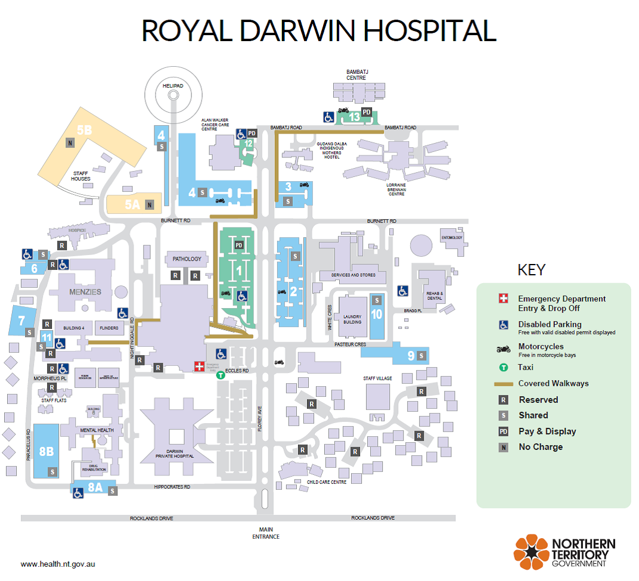

Schedule 2 Infringement notice offences and prescribed amounts
regulation 16(1) and (2)
Provision | Prescribed amount ($)
regulation 3(1) | 40
regulation 3(2) | 135

ENDNOTES

1 KEY
Key to abbreviations

amd = amended od = order
app = appendix om = omitted
bl = by-law pt = Part
ch = Chapter r = regulation/rule
cl = clause rem = remainder
div = Division renum = renumbered
exp = expires/expired rep = repealed
f = forms s = section
Gaz = Gazette sch = Schedule
hdg = heading sdiv = Subdivision
ins = inserted SL = Subordinate Legislation
lt = long title sub = substituted
nc = not commenced
2 LIST OF LEGISLATION
Medical Services (Royal Darwin Hospital Parking) Regulations (SL No. 12, 2016)
Notified | 28 April 2016
Commenced | 28 April 2016

