NORTHERN TERRITORY OF AUSTRALIA
Crimes at Sea Act
As in force at 13 November 2014
Table of provisions

1 Short title 1
2 Commencement 2
3 Definitions 2
4 Ratification of cooperative scheme 2
5 Prosecution of offences under laws of the Territory 2
6 Publication of intergovernmental agreement 2
7 Regulations 3
8 Schedule 3
9 Repeal 3
10 Saving and transitional 3
Schedule The Cooperative Scheme
ENDNOTES

northern territory of australia

____________________
As in force at 13 November 2014
____________________
Crimes at Sea act
An Act to give effect to a cooperative scheme for dealing with crimes at sea, to repeal the Criminal Law (Offences at Sea) Act and for related purposes
WHEREAS:
1. The Commonwealth, the States of the Commonwealth and the Territory have agreed to a cooperative scheme to apply the criminal law of the States of the Commonwealth and the Territory extraterritorially in the areas adjacent to the coast of Australia.
2. Under the scheme, the criminal law of a State of the Commonwealth or of the Territory is to apply in the area adjacent to the State or to the Territory:
(a) for a distance of 12 nautical miles from the baseline for the State or the Territory – by force of the law of the State or the Territory; and
(b) beyond 12 nautical miles up to a distance of 200 nautical miles from the baseline for the State or the Territory or the outer limit of the continental shelf (whichever is the greater distance) – by force of the law of the Commonwealth.
3. Responsibility for administering criminal justice in the area covered by the scheme will be divided between the Commonwealth, the States of the Commonwealth and the Territory under the scheme and an intergovernmental agreement.
4. The purpose of this Act is to give legal force to the cooperative, scheme, so far as it depends on the legislative power of the Territory, and to provide for consequential vesting of judicial and other powers.

1 Short title
This Act may be cited as the Crimes at Sea Act.

2 Commencement
The provisions of this Act come into operation on the date, or respective dates, fixed by the Administrator by notice in the Gazette.

3 Definitions
In this Act, unless the contrary intention appears:
cooperative scheme means the legislative and administrative scheme for applying and enforcing criminal law in the areas adjacent to the coast of Australia agreed to by the Commonwealth, the States of the Commonwealth and the Territory.
intergovernmental agreement means an agreement entered into under clause 5 of the cooperative scheme.

4 Ratification of cooperative scheme
To the extent that it is within the legislative competence of the Territory to give the cooperative scheme the force of law, the cooperative scheme has the force of law.

5 Prosecution of offences under laws of the Territory
(1) For the purposes of the operation of the cooperative scheme in relation to offences prosecuted under a law of the Territory:
(a) a reference in the cooperative scheme to an indictable offence is to be construed as a reference to an offence that is tried on indictment; and
(b) a reference in the cooperative scheme to a summary offence is to be construed as a reference to an offence that is tried summarily.
(2) Nothing in or under this Act or the cooperative scheme affects the discretion of a court under a law of the Territory to determine whether an offence is to be tried summarily or on indictment.

6 Publication of intergovernmental agreement
The Minister must publish the intergovernmental agreement, and any amendments of the intergovernmental agreement, in the Gazette.

7 Regulations
(1) The Administrator may make regulations, not inconsistent with this Act, prescribing matters that are:
(a) required or permitted by this Act to be prescribed; or
(b) necessary or convenient to be prescribed for carrying out or giving effect to this Act.
(2) Subsection (1) does not authorise the making of regulations for the purposes of the cooperative scheme.

8 Schedule
The cooperative scheme is set out in the Schedule.

9 Repeal
The Criminal Law (Offences at Sea) Act (Act No. 47 of 1979) is repealed.

10 Saving and transitional
(1) In this section, commencement day means the day on which section 9 comes into operation.
(2) Despite the repeal of the Criminal Law (Offences at Sea) Act by section 9, that Act continues to apply to and in relation to acts and omissions that take place before the commencement day as if it were not repealed.
(3) For the purposes of subsection (2), if an act or omission took place or is alleged to have taken place on a day occurring between a day before the commencement day and a day after the commencement day, the act or omission is to be taken to have taken place or to allegedly have taken place before the commencement day.

Schedule The Cooperative Scheme
section 8
Part 1 Preliminary
1 Definitions
(1) In this scheme:
adjacent area for a State has the meaning given by clause 14 of this Schedule.
Area A of the Zone of Cooperation has the same meaning as in the Petroleum (Australia-Indonesia Zone of Cooperation) Act 1990 (Commonwealth).
Australian ship means:
(a) a ship registered in Australia; or
(b) a ship that operates, or is controlled, from a base in Australia and is not registered under the law of another country; or
(c) a ship that belongs to an arm of the Defence Force.
baseline for a State has the meaning given by clause 15 of this Schedule.
foreign ship means a ship other than an Australian ship.
indictable offence means an offence for which a charge may be laid by indictment or an equivalent process (whether that is the only, or an optional, way to lay a charge of the offence).
inner adjacent area for a State means the parts of the adjacent area for the State that are:
(a) on the landward side of the baseline for the State; and
(b) on the seaward side, but within 12 nautical miles from, the baseline for the State.
intergovernmental agreement means the agreement entered into under clause 5 of this Schedule.
law of criminal investigation, procedure and evidence means law (including unwritten law) about:
(a) the investigation of offences (including coronial inquiry); or
(b) immunity from prosecution and undertakings about the use of evidence; or
(c) the arrest and custody of offenders or suspected offenders; or
(d) bail; or
(e) the laying of charges; or
(f) the capacity to plead to a charge, or to stand trial on a charge; or
(g) the classification of offences as indictable or summary offences (and sub-classification within those classes); or
(h) procedures for dealing with a charge of a summary offence; or
(j) procedures for dealing with a charge of an indictable offence (including preliminary examination of the charge); or
(k) procedures for sentencing offenders and the punishment of offenders; or
(m) the hearing and determination of appeals in criminal proceedings; or
(n) the rules of evidence; or
(p) other subjects declared by regulation to be within the ambit of the law of criminal investigation, procedure and evidence; or
(q) the interpretation of laws of the kinds mentioned above.
maritime offence means an offence against a law that applies in the adjacent area for a State under this scheme.
offence means an indictable or summary offence.
outer adjacent area for a State means the part of the adjacent area for the State that is outside the inner adjacent area for the State.
participating State Minister means a Minister responsible for administering a State Act that gives effect to this scheme.
ship means a vessel or boat of any description and includes:
(a) a floating structure; and
(b) a hovercraft or similar craft.
State includes the Northern Territory.
substantive criminal law means law (including unwritten law):
(a) creating offences or imposing criminal liability for offences; or
(b) dealing with capacity to incur criminal liability; or
(c) providing a defence or for reduction of the degree of criminal liability; or
(d) providing for the confiscation of property used in, or derived from, the commission of an offence; or
(e) providing for the payment of compensation for injury, loss or damage resulting from the commission of an offence, or the restitution of property obtained through the commission of an offence; or
(f) dealing with other subjects declared by regulation to be within the ambit of the substantive criminal law of a State; or
(g) providing for the interpretation of laws of the kinds mentioned above.
summary offence means any offence other than an indictable offence.
(2) The law of criminal investigation, procedure and evidence of the Commonwealth includes provisions of State law on the relevant subjects applied under the Judiciary Act 1903 (Commonwealth).
Part 2 Application of State criminal law in adjacent area
2 Application of State criminal law in adjacent area
(1) The substantive criminal law of a State, as in force from time to time, applies, by force of the law of the State, throughout the inner adjacent area for the State.
(2) The provisions of the substantive criminal law of a State, as in force from time to time, apply, by force of the law of the Commonwealth, throughout the outer adjacent area for the State.
(3) However, this clause does not:
(a) apply to a substantive criminal law that is incapable of applying in an adjacent area or is limited by its express terms to a place within the area of a State; or
Example:
A law making it an offence to drive a motor vehicle at a speed exceeding a prescribed limit on a road could not apply in an adjacent area because of the inherent localizing elements of the offence. The scheme does not therefore purport to extend the application of such a law to the adjacent area.
(b) give a legal effect to a provision of a substantive criminal law that the provision does not have within the area of the State.
Example:
If the effect of a provision of the substantive criminal law of a State is limited under section 109 of the Constitution within the area of the State, the effect is similarly limited in the outer adjacent area for the State even though the provision applies in the outer adjacent area under the legislative authority of the Commonwealth.
3 Application of laws of criminal investigation, procedure and evidence
(1) In this clause:
act includes an omission.
area of administrative responsibility for a particular State is:
(a) the area of the State; and
(b) the inner adjacent area for the State; and
(c) other parts of the adjacent area in which the State has, under the intergovernmental agreement, responsibility (which may be either exclusive or concurrent) for administering criminal justice.
authority includes an agent or official.
Commonwealth judicial proceeding means:
(a) a judicial proceeding related to a maritime offence:
(i) initiated by an authority of the Commonwealth; or
(ii) for the conduct of which an authority of the Commonwealth has assumed responsibility; or
(b) a judicial proceeding about an investigation, procedure or act by an authority of the Commonwealth in relation to a maritime offence.
judicial proceeding means:
(a) a proceeding in a court (whether between parties or not) or a proceeding incidental to or connected with a proceeding in court; or
(b) the laying of a charge; or
(c) the preliminary examination of a charge of an indictable offence or a proceeding incidental to or connected with the preliminary examination of a charge of an indictable offence.
preliminary examination of a charge of an indictable offence means a proceeding to decide whether the defendant should be committed for trial or, if the defendant pleads guilty to the charge, to commit the defendant for sentence or trial.
State judicial proceeding means:
(a) a judicial proceeding related to a maritime offence:
(i) initiated by an authority of a State; or
(ii) for the conduct of which an authority of a State has assumed responsibility; or
(b) a judicial proceeding about an investigation, procedure or act by an authority of a State in relation to a maritime offence.
(2) The laws of criminal investigation, procedure and evidence of the Commonwealth and the States apply to maritime offences as follows:
(a) the law of the Commonwealth applies to investigations, procedures and acts (other than judicial proceedings) by authorities of the Commonwealth; and
(b) the law of a State applies to investigations, procedures and acts (other than judicial proceedings) by authorities of the State operating within the area of administrative responsibility for the relevant State; and
(c) in a Commonwealth judicial proceeding the law of the Commonwealth applies and in a State judicial proceeding the law of the State in which the proceeding was commenced applies (subject to the Constitution) irrespective of whether:
(i) the maritime offence arises under the law of the State in which the proceeding was commenced or another State; or
(ii) the substantive criminal law against which the offence was committed applies in the relevant part of the adjacent area under the law of the State in which the proceeding was commenced, another State or the Commonwealth.
Example 1:
Suppose that a person is charged by a State authority with a maritime offence on the assumption that the offence was committed in the inner adjacent area for the State but the court is satisfied in the course of proceedings that the acts alleged against the defendant took place in the outer adjacent area for the State. In this case, the court could continue with the proceedings under the procedural laws of the State. However, the court could not (for example) convict the defendant on the basis of a majority verdict of a jury (because to do so would be contrary to the Commonwealth Constitution – see Cheatle v The Queen (1993) 177 CLR 541).
Example 2:
Suppose that a person is charged by a State authority in a South Australian court with a maritime offence alleged to have been committed in the adjacent area for Western Australia. For the purposes of the proceedings, the offence would be classified as a major indictable, minor indictable or summary offence according to the South Australian rules and not by reference to its classification under the law of Western Australia or the Commonwealth.
(3) This clause operates to the exclusion of any Commonwealth or State law that is inconsistent with it.
(4) A Commonwealth or State law enacted or made after the commencement of this clause is to be construed as having effect subject to this clause, unless the law expressly overrides this clause.
(5) The Administrative Decisions (Judicial Review) Act 1977 (Commonwealth) does not apply to a decision taken under a State law that applies to investigations, procedures and acts by authorities of the State under paragraph (b) of subclause (2).
4 Evidentiary presumption about the locus of an offence
If, in proceedings for a maritime offence, an alleged act, omission or state of affairs, that is an element of the offence, is proved, an allegation in the information or complaint that the act, omission or state of affairs happened in the adjacent area, inner adjacent area or outer adjacent area for a particular State is taken to be proved in the absence of proof to the contrary.
Part 3 The Intergovernmental agreement
5 Intergovernmental agreement
(1) The Commonwealth Attorney-General, on behalf of the Commonwealth, and the participating State Ministers may enter into an agreement providing for the division of responsibility for administering and enforcing the law relating to maritime offences.
(2) The intergovernmental agreement may provide for concurrent responsibility in specified parts of the adjacent area.
6 Effect of the agreement
(1) A charge of a maritime offence must not be brought in a court contrary to the intergovernmental agreement.
(2) If a charge of a maritime offence is brought in a court in contravention of subclause (1), the court must, on application by the Commonwealth Attorney-General or a participating State Minister, permanently stay the proceedings in that court.
(3) However:
(a) a contravention of subclause (1) does not affect a court’s jurisdiction; and
(b) if a charge of a maritime offence is brought in a court, the court will not (except on an application under subclause (2)) be concerned to enquire into whether the intergovernmental agreement has been complied with.
Part 4 Limitations and exclusions
7 Commonwealth Attorney-General’s consent required for certain prosecutions
(1) The Commonwealth Attorney-General’s written consent is required before a charge of a maritime offence can proceed to hearing or determination or, if the offence is an indictable offence, to a preliminary examination in committal proceedings, if:
(a) the offence is alleged to have been committed on or from a foreign ship; and
(b) the ship is registered under the law of a country other than Australia; and
(c) the country of registration has, under international law, jurisdiction over the alleged offence.
(2) Before granting such a consent, the Commonwealth Attorney-General must take into account any views expressed by the government of the country of registration.
(3) Even though the Commonwealth Attorney-General has not granted such a consent, the absence of consent is not to prevent or delay:
(a) the arrest of the suspected offender or proceedings related to arrest (such as proceedings for the issue and execution of a warrant); or
(b) the laying of a charge against the suspected offender; or
(c) proceedings for the extradition to Australia of the suspected offender; or
(d) proceedings for remanding the suspected offender in custody or on bail.
(4) If the Commonwealth Attorney-General declines to grant consent, the court in which the suspected offender has been charged with the offence must permanently stay the proceedings.
(5) In any proceedings, an apparently genuine document purporting to be a copy of a written consent granted by the Commonwealth Attorney-General in accordance with this clause will be accepted, in the absence of proof to the contrary, as proof of such consent.
8 Non-exclusion of consistent extraterritorial legislative schemes
This scheme does not exclude the extraterritorial operation of State law to the extent that the State law is capable of operating extraterritorially consistently with the scheme.
9 Exclusion of certain laws from ambit of scheme
This scheme does not apply to State and Commonwealth laws excluded by regulation from the ambit of the scheme.
10 Non-application of scheme to Area A of the Zone of Cooperation
This scheme does not apply to Area A of the Zone of Cooperation.
Part 5 Miscellaneous
11 Interpretation
The Acts Interpretation Act 1901 (Commonwealth) applies to this scheme in the same way as to a Commonwealth Act.
12 Regulations
(1) The Governor-General may make regulations prescribing matters:
(a) required or permitted by this scheme to be prescribed; or
(b) necessary or convenient to be prescribed for carrying out, or giving effect to, this scheme.
(2) However, a regulation affecting the operation of this scheme in relation to the inner adjacent area for a State may only be made with the agreement of the participating State Minister for the relevant State.
Part 6 Adjacent areas
13 Definitions
In this Part:
baseline of Australia’s territorial sea means the baseline from which the breadth of the territorial sea is to be measured under section 7 of the Seas and Submerged Lands Act 1973 (Commonwealth).
continental shelf has the same meaning as in the Seas and Submerged Lands Act 1973 (Commonwealth).
territorial sea has the same meaning as in the Seas and Submerged Lands Act 1973 (Commonwealth).
14 Adjacent areas
(1) The adjacent area for New South Wales, Victoria, South Australia or Tasmania is so much of the area described in Schedule 1 to the Offshore Petroleum and Greenhouse Gas Storage Act 2006 (Cth) in relation to that State as is within the outer limits of the continental shelf and includes the space above and below that area.
(2) The adjacent area for Queensland is:
(a) so much of the area described in Schedule 1 to the Offshore Petroleum and Greenhouse Gas Storage Act 2006 (Cth) in relation to Queensland as is within the outer limits of the continental shelf; and
(b) the Coral Sea area (within the meaning of section 8(2) of the Offshore Petroleum and Greenhouse Gas Storage Act 2006 (Cth) other than the territorial sea within the Coral Sea area; and
(c) the areas within the outer limits of the territorial sea adjacent to certain islands of Queensland as determined by proclamation on 4 February 1983 under section 7 of the Seas and Submerged Lands Act 1973 (Commonwealth); and
(d) the space above and below the areas described in paragraphs (a), (b) and (c).
(3) The adjacent area for Western Australia is so much of the area described in Schedule 1 to the Offshore Petroleum and Greenhouse Gas Storage Act 2006 (Cth) in relation to Western Australia as:
(a) is within the outer limits of the continental shelf; and
(b) is not within the Joint Petroleum Development Area,
and includes the space above and below that area.
(4) The adjacent area for the Northern Territory is:
(a) so much of the area described in Schedule 1 to the Offshore Petroleum and Greenhouse Gas Storage Act 2006 (Cth) in relation to the Northern Territory as:
(i) is within the outer limits of the continental shelf; and
(ii) is not within the Joint Petroleum Development Area; and
(b) the offshore area for the Territory of Ashmore and Cartier Islands (within the meaning of section 8(1) of the Offshore Petroleum and Greenhouse Gas Storage Act 2006 (Cth)) other than the territorial sea within that area; and
(c) the space above and below the areas described in paragraphs (a) and (b).
(5) However, the adjacent area for a State does not include any area inside the limits of any State or Territory.
(6) A reference in this clause to the area described in Schedule 1 to the Offshore Petroleum and Greenhouse Gas Storage Act 2006 (Cth) in relation to a State or Territory is a reference to the scheduled area for that State or Territory within the meaning given by that Schedule.
15 Baselines
The baseline for a State is the part of the baseline of Australia’s territorial sea from which the part of the territorial sea that is within the adjacent area for that State is measured.
16 Indicative map
(1) A map showing the various areas that are relevant to this scheme appears in Appendix 1 to this scheme.
(2) The map is intended to be indicative only. The provisions of this scheme and of the body of this Act prevail over the map if there is any inconsistency.
APPENDIX 1
clause 16
MAP
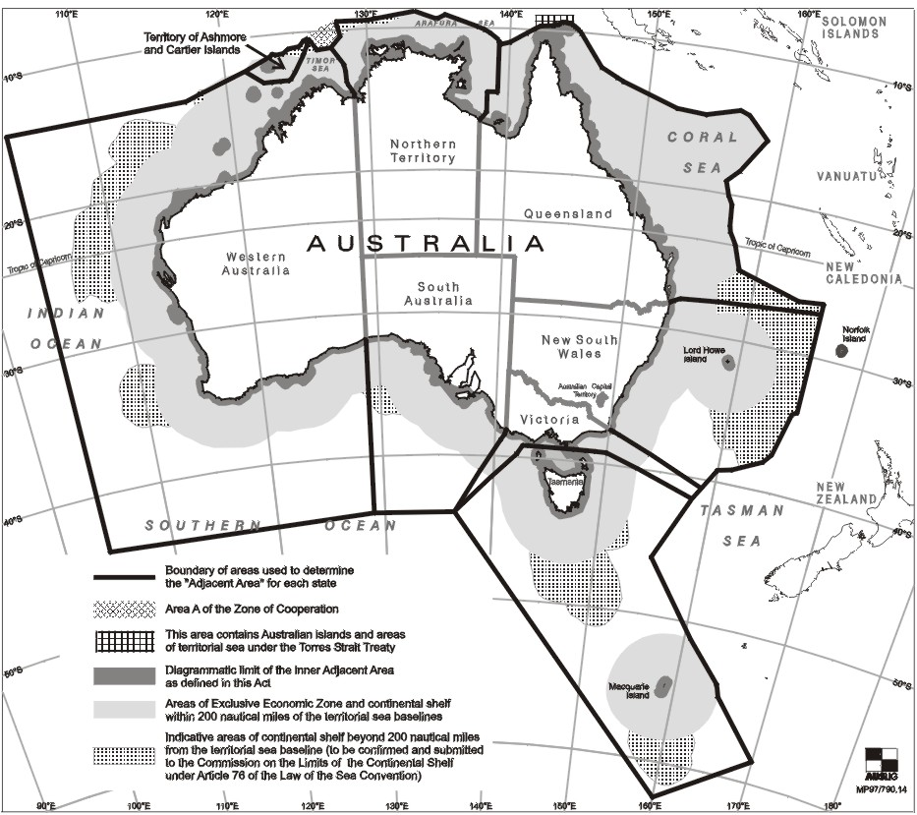

ENDNOTES

1 KEY
Key to abbreviations

amd = amended od = order
app = appendix om = omitted
bl = by-law pt = Part
ch = Chapter r = regulation/rule
cl = clause rem = remainder
div = Division renum = renumbered
exp = expires/expired rep = repealed
f = forms s = section
Gaz = Gazette sch = Schedule
hdg = heading sdiv = Subdivision
ins = inserted SL = Subordinate Legislation
lt = long title sub = substituted
nc = not commenced
2 LIST OF LEGISLATION
Crimes at Sea Act 2000 (Act No. 73, 2000)
Assent date | 14 December 2000
Commenced | 31 March 2001 (Gaz G11, 21 March 2001, p 3)
Statute Law Revision Act 2014 (Act No. 38, 2014)
Assent date | 13 November 2014
Commenced | 13 November 2014
3 LIST OF AMENDMENTS
sch amd No. 38, 2014, s 2

