NORTHERN TERRITORY OF AUSTRALIA
Nyirranggulung Mardrulk Ngadberre Community Government CONSTITUTION
As in force at 15 November 2006
TABLE OF PROVISIONS
Clause
PREAMBLE
PART 1 – PRELIMINARY
1. Name of constitution
2. Definitions
3. Community government area
PART 2 – NYIRRANGGULUNG MARDRULK NGADBERRE REGIONAL AUTHORITY
Division 1 – Establishment and Membership
4. Establishment and name
5. Community government area includes community areas
6. Membership of council

Division 2 – Election of Councillors
7. Councillors for Barunga community area
8. Councillors for Manyallaluk community area
9. Councillors for Mardrulk community area
10. Councillors for Wugularr community area
11. Councillors for Jodetluk/Werenbun area
11A. Councillors for Gulin Gulin community area
12. Eligibility to participate in election
13. Eligibility to be enrolled on electoral roll
14. Electoral rolls
15. Election period for general elections
16. Notice of general election
17. Method of election and notification of results
18. Declaration of members
19. Extension of election period in emergency
20. By-election to fill vacancy in membership
21. Election due to resignation of council or lack of quorum

Division 3 – Meetings and Procedure of Council
22. Meetings of council
23. Special meetings
24. Meetings to be open
25. Procedure at meetings of the council
PART 3 – REGIONAL EXECUTIVE
Division 1 – Establishment and membership of Regional Executive
26. Regional Executive
27. Meeting to elect members of Regional Executive
28. Composition of Regional Executive
29. Functions of Regional Executive
30. Regional Executive may be taken to constitute council

Division 2 – Meetings and Procedure of Regional Executive
31. President and Vice-President
32. Meetings of Regional Executive
33. Special meetings
34. Meetings not to be open
35. Procedure at meetings of Regional Executive
PART 4 – COMMUNITY MANAGEMENT COMITTEES
Division 1 – Establishment and Membership
36. Establishment of community management committees
37. Functions of community management committees
38. Membership of community management committees

Division 2 – Meetings and Procedure of Community Management Committees
39. Chairperson and deputy chairperson
40. Procedure of community management committee meeting
PART 5 – FUNCTIONS AND POWErS OF COUNCIL
41. Functions
42. Powers
43. CEO exercising powers of council

SCHEDULE 1
SCHEDULE 2
Notes
Table of Amendments

northern territory of australia

____________________
This reprint shows the Community Government Constitution as in force at 15 November 2006. Any amendments that may come into operation after that date are not included.
____________________

Nyirranggulung Mardrulk Ngadberre Community Government CONSTITUTION

Community Government Constitution under the Local Government Act

PREAMBLE

This constitution is shaped in accordance with the vision, needs and aspirations of the people of the Nyirranggulung Mardrulk Ngadberre region in the Northern Territory. The constitution is grounded in the traditional Aboriginal power structures and systems of governance for the region. The regional council is shaped so that the elders are in control. The elders have the cultural knowledge. Our intention is that younger and middle-aged people with appropriate communication skills and demonstrated respect for culture work under the direction of the elders, liaising with the wider Australian community and explaining Aboriginal ways to non-Aboriginal people, and also explaining
non-Aboriginal ways and systems of governance to the elders.
The way of life of our people is expressed through family life, which is our relationship to kin and country. Responsibility for family life has always belonged with the elders. The authority of elders provides direction and control. While many decisions are carried out by younger and middle-aged people, this is always under the direction of the elders.
Moiety is an important means by which our world is structured. There are two moieties, Dhuwa and Yirritja. People are born with a "skin" (called subsection by anthropologists), which they inherit, and through which they have rights and responsibilities within the community. Each skin is either Dhuwa or Yirritja moiety. Moieties are the basis of a system of governance in which "owners" (called gidjan) and "custodians" (called junggayi) have a reciprocal custodial relationship to each other. This system of reciprocal rights and responsibilities is all pervasive, since all people are owners for some tracts of land and for particular ceremonies and custodians for others. This is our traditional system.
In establishing this regional council our main aims are:
- To ground this constitution in the traditional Aboriginal power structures and systems of governance for the region, using tradition to strengthen the authority of the council, and the council's authority to strengthen traditional systems of governance.
- To put in place a system where our own people make the decisions, working as equals with non-Aboriginal people.
- To work towards getting our children into the mainstream, so that they can have careers, without weakening Aboriginal family structures or links to land.
- To establish culturally appropriate and viable economic opportunities for people living in our region.
- To make culture strong, and this will strengthen our society as a whole.

Through this vision we seek to maintain observance and respect for traditional values and to join the responsibilities and structures of traditional authority with modern local government to achieve a high quality of life and a wide range of opportunities and choices.
PART 1 – PRELIMINARY
1. Name of constitution
The name of this constitution is the Nyirranggulung Mardrulk Ngadberre Community Government Constitution. (See back note 1)
2. Definitions
In this constitution, unless the contrary intention appears –
"CEO" –
(a) means the person appointed under section 142 of the Local Government Act as the clerk, or chief executive officer, of the council; and
(b) for the purposes of Part 2, Division 2, includes the Electoral Commission;
"community area" has the meaning given in clause 5;
"community government area" means the area referred to in clause 3;
"community management committee" means a committee established under clause 36(1);
"constitution" means this community government constitution;
"council" means the Nyirranggulung Mardrulk Ngadberre Regional Authority;
"councillor" means a member of the council;
"election notice" means a notice displayed under clause 16;
"election period" means the period during which an election takes place;
"election year" means the year in which an election referred to in clause 15(2) is to take place;
"elector" means a person eligible under clause 12 to participate in an election;
"electoral roll" means an electoral roll maintained under clause 14(1);
"moiety" means one of the 2 Aboriginal cultural divisions of Dhuwa and Yirritja recognised in the community government area;
"President" means the person elected under clause 31(1) to be the President of the Regional Executive and the council;
"public place" includes –
(a) every place to which free access is permitted to the public, with the express or tacit consent of the owner or occupier of the place;
(b) every place to which the public is admitted on payment of money, the test of admittance being the payment of the money only;
(c) every road, street, footway, court, alley, thoroughfare or
cul-de-sac that the public is allowed to use, despite that the road, street, footway, court, alley, thoroughfare or cul-de-sac may be formed on private property; and
(d) land reserved under a law of the Territory for the use of the public or a member of the public;
"Regional Executive" means the executive committee of the council established under clause 26;
"Vice-President" means the person elected under clause 31(1) to be the Vice-President of the Regional Executive and the council.
3. Community government area
The community government area to which this constitution applies is comprised of the parcel of land indicated on the diagram in Schedule 1, Part A and described in Schedule 1, Part B.
PART 2 – NYIRRANGGULUNG MARDRULK NGADBERRE REGIONAL AUTHORITY
Division 1 – Establishment and Membership
4. Establishment and name
(1) A community government council is established to administer the community government area.
(2) The name of the community government council is Nyirranggulung Mardrulk Ngadberre Regional Authority.
5. Community government area includes community areas
(1) The community government area includes the following community areas:
(a) Barunga community area;
(b) Manyallaluk community area;
(c) Mardrulk community area;
(d) Wugularr community area;
(e) Gulin Gulin community area.
(2) The boundaries of the community areas are as described, and indicated on the diagrams, in Schedule 2.
(3) The area, in this constitution called "the Jodetluk/Werenbun area" and including the settlements of Jodetluk and Werenbun, comprises all of the community government area that is not included in the community areas and, unless the contrary intention appears, is taken to be a community area.
6. Membership of council
(1) The council has a maximum of 57 members elected in accordance with Division 2.
(2) A person is eligible for election as a councillor to represent a community area if the person –
(a) is enrolled on the electoral roll for the community area; and
(b) has ordinarily resided in the community government area for at least 3 years immediately before the closure of the electoral roll under clause 14(3) in respect of that election.
(3) Subject to this constitution, the term of office of a councillor expires on the declaration of the result of the next election of members.
(4) The office of a councillor becomes vacant if the councillor ceases to be ordinarily resident in the community government area or a declaration is made under clause 22(3).
Division 2 – Election of Councillors
7. Councillors for Barunga community area
The Barunga community area is represented by 12 councillors as follows:
(a) 2 councillors representing Jawoyn language group;
(b) 2 councillors representing Dalabon language group;
(c) 2 councillors representing Maiyali language group;
(d) 2 councillors representing Mangarrai language group;
(e) 2 councillors representing Rembarrnga language group;
(f) 2 councillors representing electors who are not of a language group listed in paragraphs (a) to (e).
8. Councillors for Manyallaluk community area
The Manyallaluk community area is represented by 5 councillors.
9. Councillors for Mardrulk community area
The Mardrulk community area is represented by 12 councillors as follows:
(a) 2 councillors (one of each moeity) representing Gulpulyu community;
(b) 2 councillors (one of each moeity) representing Mobarn community;
(c) 2 councillors (one of each moeity) representing Momob community;
(d) 2 councillors (one of each moeity) representing Mount Catt community;
(e) 2 councillors (one of each moeity) representing Mount Jean community;
(f) 2 councillors (one of each moeity) representing Weemol community.
10. Councillors for Wugularr community area
The Wugularr community area is represented by 12 councillors as follows:
(a) 2 councillors representing Dalabon language group;
(b) 2 councillors representing Jawoyn language group;
(c) 2 councillors representing Maiyali language group;
(d) 2 councillors representing Rembarrnga language group;
(e) 2 councillors representing Rithangu language group;
(f) 2 councillors representing electors who are not of a language group listed in paragraphs (a) to (e).
11. Councillors for Jodetluk/Werenbun area
The Jodetluk/Werenbun area is represented by 4 councillors.
11A. Councillors for Gulin Gulin community area
The Gulin Gulin community area is represented by 12 councillors as follows:
(a) 8 councillors representing Bulman community;
(b) 2 councillors representing Baghetti community;
(c) 2 councillors representing Barrapunta community.
12. Eligibility to participate in election
A person is eligible to participate in the election of a councillor for the community area to which the person belongs if the person is enrolled on the electoral roll for that community area before the closure of the electoral roll under clause 14(3) in respect of that election.
13. Eligibility to be enrolled on electoral roll
(1) A person is entitled to be enrolled on the electoral roll for the community area to which he or she belongs if the person –
(a) has attained the age of 18 years; and
(b) has ordinarily resided in the community government area for a period of at least 12 months immediately before enrolment.
(2) If it is uncertain whether a person belongs to a community area, the matter is to be decided by the persons who are acknowledged members of the relevant community, and their decision is final.
(3) A person can be enrolled on the electoral roll for only one community area at any given time.
14. Electoral rolls
(1) The CEO must maintain for each community area, by the means he or she thinks appropriate (including by electronic means), an electoral roll of the full names and addresses of persons who, under clause 13, are entitled to be enrolled.
(2) A resident of the community government area may inspect the electoral rolls at the office of the council during the time the office is open for business.
(3) The CEO must close the electoral roll or electoral rolls, as applicable –
(a) in respect of the first general election – at 12 noon on the day 21 days before the first day of the election period;
(b) in respect of a general election other than the first general election – at 12 noon on 10 July in an election year; or
(c) in respect of a by-election referred to in clause 20 or an election referred to in clause 21 – at 12 noon on the day 21 days before the first day of the election period.
(4) The CEO must not add any names to an electoral roll in the period between its closure and the conclusion of the election.
15. Election period for general elections
(1) The election period for the first general election of the council is to begin as soon as practicable after this constitution takes effect, during a month specified by the CEO that will enable compliance with clause 14(1) and (3)(a).
(2) Subsequent general elections of the council (other than elections under clause 21) are to take place every 3 years during the month of August.
16. Notice of general election
(1) The CEO must display a notice of a general election in the community government area –
(a) if the general election is the first general election of the council – not later than one month before the first day of the election period for the election; or
(b) not later than 1 July in the election year.
(2) The CEO must prominently display the notice of election in the places where the CEO thinks all residents of the community government area will be likely to see the notice.
(3) The notice of the election is to set out the following information:
(a) that a council is to be elected during the month of August in that year;
(b) that each community area may elect the number of councillors that are provided for in this constitution;
(c) the date on which the electoral rolls will be closed under clause 14(3);
(d) that only a person who is enrolled on an electoral roll and has ordinarily resided in the community government area for a period of at least 12 months immediately before the closure of that roll may participate in the election;
(e) that only a person who is enrolled on an electoral roll and has ordinarily resided in the community government area for a period of at least 3 years immediately before the closure of that roll may be elected as a councillor;
(f) the method of election and the notification of results as specified in clause 17 (as modified by subclause (4) if the election is the first general election of the council).
(4) Clauses 17 and 18, with the necessary modifications, apply in relation to the first general election as if –
(a) a reference in clause 17(2) to 31 August is a reference to the last day of the election period for the election; and
(b) a reference in clause 18 to 1 September is a reference to the first day following the election period for the election.
17. Method of election and notification of results
(1) The election of the councillors to represent a community area is to be by agreement between the persons who belong to that community area and who, under clause 12, are eligible to participate in the election.
(2) The name of each person elected as a councillor to represent a community area is to be given to the CEO not later than 31 August in an election year by a written declaration signed by 2 persons recognised by the CEO as having authority to declare the wishes of the community area.
18. Declaration of members
On 1 September in an election year, or as soon as practicable after that date, the CEO must –
(a) display a notice in the same places as the notice of the election was displayed –
(i) specifying each person whose name has been given to the CEO in accordance with clause 17(2) and the name of the community area the person is elected to represent; and
(ii) declaring that those persons have been elected as councillors for their respective community areas; and
(b) forward a copy of the notice to the Minister.
19. Extension of election period in emergency
(1) The CEO may extend an election period by a maximum of 21 days if it appears to the CEO to be necessary or desirable because of –
(a) natural disaster, civil disturbance or other emergency; or
(b) any other event, the consequences of which may impede the electoral process.
(2) If the CEO extends an election period, the CEO must take the steps he or she thinks necessary and practicable to inform persons eligible to participate in the election of the extension.
(3) If an election period is extended –
(a) the term of office of existing councillors continues until the end of the election period as extended and the new council takes office on the following day;
(b) the names of the persons elected as councillors are to be given to the CEO in accordance with clause 17(2) not later than the last day of the election period as extended; and
(c) the notice referred to in clause 18 is to be displayed, and a copy forwarded to the Minister, on the day following the election period as extended or as soon as practicable after that day.
20. By-election to fill vacancy in membership
(1) Subject to subclause (2), if the office of a councillor becomes vacant, a by-election is to take place to fill the vacancy by a person elected from among persons who belong to the same community area as the former councillor and who, under clause 12, are eligible to participate in the by-election.
(2) It is not necessary for a by-election to take place under subclause (1) if the vacancy arises after 31 January in an election year.
(3) A by-election is to take place during a period of 4 weeks beginning on a date decided by the council so as to enable it to comply with subclause (4), and the councillor elected takes office on the day following that election period.
(4) Not later than 4 weeks before the first day of the election period, the CEO must prominently display a notice of the by-election in the places where the CEO thinks that all residents of the relevant community area will be likely to see the notice.
(5) The notice of the by-election is to set out the following information:
(a) that a by-election is to take place to elect a councillor to represent the community area specified in the notice;
(b) the period during which the by-election is to take place;
(c) the date on which the electoral roll for the community area will be closed under clause 14(3);
(d) that only a person who is enrolled on an electoral roll and has ordinarily resided in the community government area for a period of at least 12 months immediately before the closure of that roll may participate in the election;
(e) that only a person who is enrolled on an electoral roll and has ordinarily resided in the community government area for a period of at least 3 years immediately before the closure of that roll may be elected as a councillor;
(f) the method of election and notification of results as specified in clause 17 (as modified by subclause (6)).
(6) Clauses 17 and 18, with the necessary modifications, apply in relation to a by-election as if –
(a) a reference in clause 17(2) to 31 August is a reference to the last day of the election period for the by-election; and
(b) a reference in clause 18 to 1 September is a reference to the first day following the election period for the by-election.
(7) Clause 19 (other than subclause (3)(a)), with the necessary changes, applies in relation to a by-election.
21. Election due to resignation of council or lack of quorum
(1) If –
(a) all councillors cease to hold office; or
(b) the Regional Executive is taken to constitute the council under clause 30 and, at 3 consecutive meetings of the Regional Executive a quorum is not present at the place and within one hour after the time specified for the meeting,
the CEO is taken to constitute the council and must determine the period during which a new council is to be elected.
(2) The election period determined by the CEO under subclause (1) is to begin as soon as practicable, but not later than 3 months after the event that gave rise to the determination.
(3) A council elected under this clause takes office on the day following the election period, and holds office for the remainder of the term for which the previously elected council would have been in office had it remained in office for its full term.
(4) This Division, with the necessary changes, applies in relation to an election under this clause.
Division 3 – Meetings and Procedure of Council
22. Meetings of council
(1) The council is to meet to transact its business not less than once in each 2 month period.
(2) The date, time and place of a meeting of the council is to be as decided –
(a) by the councillors at a previous council meeting or, in default of that, by the CEO; or
(b) if necessary – by the Minister or a person authorised by the Minister for that purpose.
(3) If a councillor is absent from 3 consecutive meetings of the council without the council's prior consent, the council may declare that the person is no longer a councillor and that there is a vacancy in the membership of the council.
23. Special meetings
(1) The CEO may call a special meeting of the council by giving the councillors at least 7 days written notice.
(2) Five or more councillors, or 10% or more of electors, may require the CEO to call a special meeting of the council by giving the CEO written notice requesting a special meeting and stating the reasons for requesting the meeting.
(3) If the CEO receives a notice under subclause (2), he or she must –
(a) call the meeting for a date and time not later than 10 days after the day on which the notice is received; and
(b) notify the councillors about the special meeting, the date and time on which it will be held and the reason why the meeting is called.
(4) If a special meeting is to be held under subclause (1) or (3), the CEO must cause written notice of the special meeting to be displayed at a place in each of the community areas where the CEO thinks that residents of the community government area are likely to see the notice.
(5) A notice of a special meeting given to the councillors or displayed to residents is to specify the date, time and place of the special meeting and the reason it is called.
24. Meetings to be open
Meetings of the council are to be open to persons who are not members, officers or employees of the council unless the council determines that a meeting, or part of a meeting, is to be closed.
25. Procedure at meetings of the council
(1) Meetings of the council are to be presided over by the President, or where he or she is absent, by the Vice-President, or where both persons are absent, by a councillor chosen by the other councillors present.
(2) The council is to determine its own procedure for meetings, subject to any standing orders it may make from time to time.
(3) The council must keep a record of its proceedings.
(4) The quorum for a meeting of the council is to be a majority of the councillors then in office.
(5) A matter arising at a meeting of the council is to be decided by a majority of the votes of the councillors then in office.
PART 3 – REGIONAL EXECUTIVE
Division 1 – Establishment and membership of Regional Executive
26. Regional Executive
There is an executive committee of the council, known as the Regional Executive, comprised of a maximum of 24 persons, being 4 persons (who must be councillors) from each of the community areas (including the Jodetluk/Werenbun area).
27. Meeting to elect members of Regional Executive
(1) The members of the Regional Executive are to be elected at a meeting held as soon as practicable (and in any event not more than 28 days) after the declaration of the polls under clause 18, and after that as required to fill vacancies in the membership of the Regional Executive.
(2) The following persons may attend the meeting to select the members of the Regional Executive:
(a) the 12 councillors representing Barunga community area;
(b) the 5 councillors representing Manyallaluk community area;
(c) up to 7 other persons chosen as community representatives for Manyallaluk community area;
(d) 12 councillors from Mardrulk community area;
(e) the 12 councillors from Wugularr community area;
(f) the 4 councillors from the Jodetluk/Werenbun area;
(g) up to 8 other persons chosen as representatives of the Jodetluk/Werenbun area;
(h) 12 senior cultural persons ("junggayi");
(i) the 12 councillors representing Gulin Gulin community area.
(3) In subclause (2)(h), the junggayi are the most senior cultural persons for each moeity in each of the 6 language groups of the area (Jawoyn, Dalabon, Maiyali, Rembarrnga, Rithangu and Mangarrai) or, if any of those persons cannot attend, another person authorised by the junggayi to attend in his or her place.
(4) If, at a meeting to elect the members of the Regional Executive, there are –
(a) less than the full number of junggayi entitled to attend the meeting under subclause (2)(h); or
(b) less than half the total number of persons who are entitled to attend under subclause (2),
the meeting cannot proceed.
28. Composition of Regional Executive
At a meeting to elect the members of the Regional Executive, the persons attending the meeting are to observe the principle that the Executive is to be comprised, as far as is reasonably achievable, of –
(a) an equal number of persons from each of the Dhuwa and Yirritja moieties;
(b) a balance of gender; and
(c) a balance of age groups.
29. Functions of Regional Executive
(1) The Regional Executive, as an executive committee of the council, is responsible for performing the functions of the council in relation to budget and financial matters and capital works.
(2) The Regional Executive directs the policy of the council, but (subject to clause 30) cannot make decisions that are binding on the council except in relation to the matters referred to in subclause (1).
30. Regional Executive may be taken to constitute council
If, at 3 consecutive council meetings, a quorum is not present at the place and within one hour after the time specified for the meeting, the Regional Executive is taken to constitute the council.
Division 2 – Meetings and Procedure of Regional Executive
31. President and Vice-President
(1) At the first meeting of the Regional Executive following the election of the members of the Executive, and after that as required, the members of the Executive are to elect a President and a Vice-President in that order from amongst their own number.
(2) The President and Vice-President are not to be from the same community, moiety or language group.
(3) The President and Vice-President are the President and
Vice-President of the Regional Executive and the council.
32. Meetings of Regional Executive
(1) The Regional Executive is to meet to transact its business not less than once every 2 months.
(2) The date, time and place of a meeting of the Regional Executive is to be as decided by its members at a previous meeting or, in default of that, by the CEO.
33. Special meetings
(1) The CEO may call a special meeting of the Regional Executive by giving the members of the Executive at least 7 days notice.
(2) Five or more members of the Regional Executive may require the CEO to call a special meeting of the Executive by giving the CEO written notice requesting a special meeting and stating the reasons for requesting the meeting.
(3) If the CEO receives a notice under subclause (2), he or she must –
(a) call the meeting for a date and time not later than 10 days after the day on which the CEO received the notice; and
(b) notify the members of the Regional Executive about the special meeting.
(4) A notice of a special meeting given to the members of the Regional Executive is to specify the date, time and place of the special meeting and the reason the meeting is called.
34. Meetings not to be open
Meetings of the Regional Executive are not open to persons who are not members of the Executive unless the Executive determines that a meeting, or part of a meeting, is to be open.
35. Procedure at meetings of Regional Executive
(1) Meetings of the Regional Executive are to be presided over by the President, or where the President is absent, by the Vice-President, or where both the President and Vice-President are absent, by a member of the Executive chosen by the other members present.
(2) The Regional Executive is to determine its own procedure for meetings, subject to any standing orders it may make from time to time.
(3) The Regional Executive must keep a record of its proceedings.
(4) The quorum for a meeting of the Regional Executive is a majority of the members of the Executive then in office.
(5) A matter arising at a meeting of the Regional Executive is to be decided by a majority of the votes of the members of the Executive then in office.
PART 4 – COMMUNITY MANAGEMENT COMITTEES
Division 1 – Establishment and Membership
36. Establishment of community management committees
(1) The council may establish a community management committee for each community area.
(2) The Jodetluk/Werenbun area is not a community area for the purposes of this Part.
37. Functions of community management committees
The functions of a community management committee are to exercise, in the community area for which it is established, the powers and perform, in that community area, the functions of the council that the council delegates to the committee.
38. Membership of community management committees
(1) A community management committee has the following members:
(a) the councillors who represent the community area for which the committee is established;
(b) other persons appointed by the council (who may be officers or employees of the council) on the recommendation of the councillors who represent the community area.
(2) A member of a community management committee appointed under subclause (1)(b) may be removed from the committee by the council on the recommendation of the councillors who represent the community area.
Division 2 – Meetings and Procedure of Community Management Committees
39. Chairperson and deputy chairperson
(1) At the first meeting of a community management committee following a general election, and after that as required, the committee is to elect a chairperson and a deputy chairperson who are to be chosen in that order by the members of the committee from amongst their own number.
(2) The deputy chairperson is to act as chairperson when the chairperson is absent from a meeting of the committee or is otherwise unable to perform the functions of the chairperson, or there is a vacancy in the office of the chairperson.
40. Procedure of community management committee meeting
(1) The council may determine the procedures to be followed by a community management committee.
(2) A community management committee may determine its own procedures, to the extent that they are not inconsistent with procedures determined by the council under subclause (1).
(3) A community management committee must meet at least once each month.
(4) The quorum for a meeting of a community management committee is a majority of the members of the committee.
PART 5 – FUNCTIONS AND POWErS OF COUNCIL
41. Functions
(1) The council may perform any of the following functions:
(a) the establishment, development, operation and maintenance of communication, television and radio broadcasting facilities for the community government area;
(b) the establishment and maintenance of parks, gardens and recreational areas and the carrying out of landscaping and other associated works;
(c) the establishment and maintenance of sports facilities, swimming pools, libraries, museums, cinemas, community halls, public toilets and ablution blocks;
(d) the provision of services for the collection and disposal of garbage, the maintenance of particular places where garbage is to be dumped, and the control of litter generally;
(e) the provision and maintenance of sanitation, sewerage, drainage and water supply facilities and removal of health hazards;
(f) the collection of charges in relation to electricity, water and sewerage facilities;
(g) the provision of educational, vocational and other training;
(h) the provision and maintenance of housing for residents and their families on the terms and conditions that the council thinks appropriate;
(i) the management of community employment programs;
(j) the promotion and provision of community welfare, health and care facilities for people of all ages;
(k) the prevention and control of substance abuse;
(l) the provision and maintenance of cemeteries;
(m) the control, prohibition and impounding of animals;
(n) the development and maintenance of roads within the community government area (including the provision of street lighting and traffic control devices);
(o) the development and maintenance, for reward, of roads outside the community government area;
(p) the provision and maintenance of airstrips and related facilities;
(q) the hiring out, for reward, of vehicles, plant, appliances or equipment owned by the council;
(r) the repair and maintenance, for reward, of vehicles, plant, appliances or equipment not owned by the council;
(s) the contracting of works projects (including the provision of services and the maintenance of capital works and undertakings) within and outside the community government area;
(t) the establishment and operation of pastoral and commercial enterprises;
(u) the establishment and maintenance of a firefighting service (including the acquisition of property and equipment and the training of personnel for the service) and protection of the community government area from fire;
(v) the promotion and development of tourist attractions, the provision and maintenance of tourist facilities and the production and sale of artefacts and souvenirs;
(w) the management and control of sites of historic and cultural interest;
(x) the support and encouragement of artistic, cultural and sporting activities;
(y) the control of public places;
(z) environmental control.
(2) The council may, for reward, act as the agent for a provider of a facility referred to in subclause (1).
42. Powers
Subject to the Local Government Act, the council has the power to do all things necessary or convenient to be done for, in connection with or incidental to, the performance of its functions and may do any thing that is not otherwise unlawful for that purpose.
43. CEO exercising powers of council
(1) If, under clause 21(1), the CEO is taken to constitute the council, the CEO may exercise the powers of the council under this constitution until the declaration of the results of the election of the new council.
(2) For the purposes of exercising a power of the council in pursuance of subclause (1), the CEO must appoint as his or her assistant a person who, under clause 12, is eligible to participate in the election.
____________________________
SCHEDULE 1
Clause 3
Part A – Diagram of Community Government Area
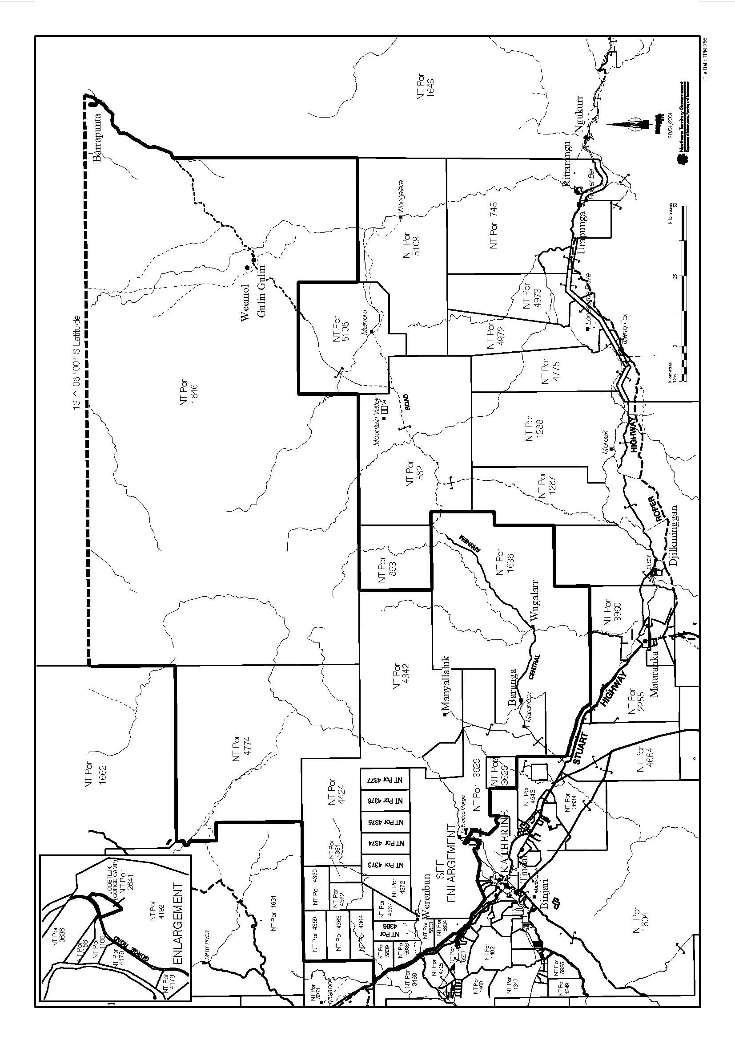

Part B – Description of Council Area
All those parcels of land near Katherine in the Northern Territory of Australia containing a total area of 30580 square kilometres more or less being Northern Territory Portions 1636, 1729, 2641, 3629, 4342, 4359 to 4364 inclusive, 4366, 4367, 4372 to 4377 inclusive, 4389, 4424, 4774, 5833, 5834, 5838 and 5839 more particularly delineated on Compiled Plan CP4187 and Survey Plans S79/45, LTO83/128A, S89/151A & B, S93/185A & B, S93/161A, S93/161D, S93/161E, S93/194, S93/161D, S93/185A & B, S2000/173A, S2000/173C, S2000/174D & E and S2000/174A & C respectively, lodged with the Surveyor General, Darwin together with that part of Northern Territory Portion 1646 bounded by lines described as follows: commencing at the southeastern corner of Northern Territory Portion 4774; thence northerly by part of a western boundary of Northern Territory Portion 1646 to parallel of South Latitude 13 degrees 8 minutes (AGD66); thence east by the said parallel to the centreline of Central Arnhem Road; thence generally southwesterly by the said centreline to the northerly prolongation of the eastern boundary of Northern Territory Portion 5109 (Wongalara); thence southerly by the said prolongation to the northeastern corner of the said Portion; thence westerly by the most north northern boundary of Northern Territory Portion 5109 (Wongalara) to the eastern boundary of Northern Territory Portion 5108 (Mainoru); thence northerly, westerly, southerly and again westerly by a western, a southern, an eastern and a southern boundary of Northern Territory Portion 1646 to the point of commencement.
____________________________
SCHEDULE 2
Clause 5

BARUNGA COMMUNITY AREA
All that parcel of land near Bamyili in the Northern Territory of Australia containing an area of 30 square kilometres more or less being that part of Northern Territory Portion 1636 bounded by lines described as follows: Commencing at a point situated at Australian Map Grid co-ordinates 267 221 metres East, 8 395 690 metres North; thence easterly, southerly and westerly by straight lines connecting in succession Australian Map Grid
co-ordinates 273 221 metres East, 8 395 690 metres North; 273 221 metres East, 8 390 690 metres North and 267 221 metres East, 8 390 690 metres North; thence northerly to the point of commencement, co-ordinates quoted herein being Zone 53, Australian Geodetic Datum 1966.
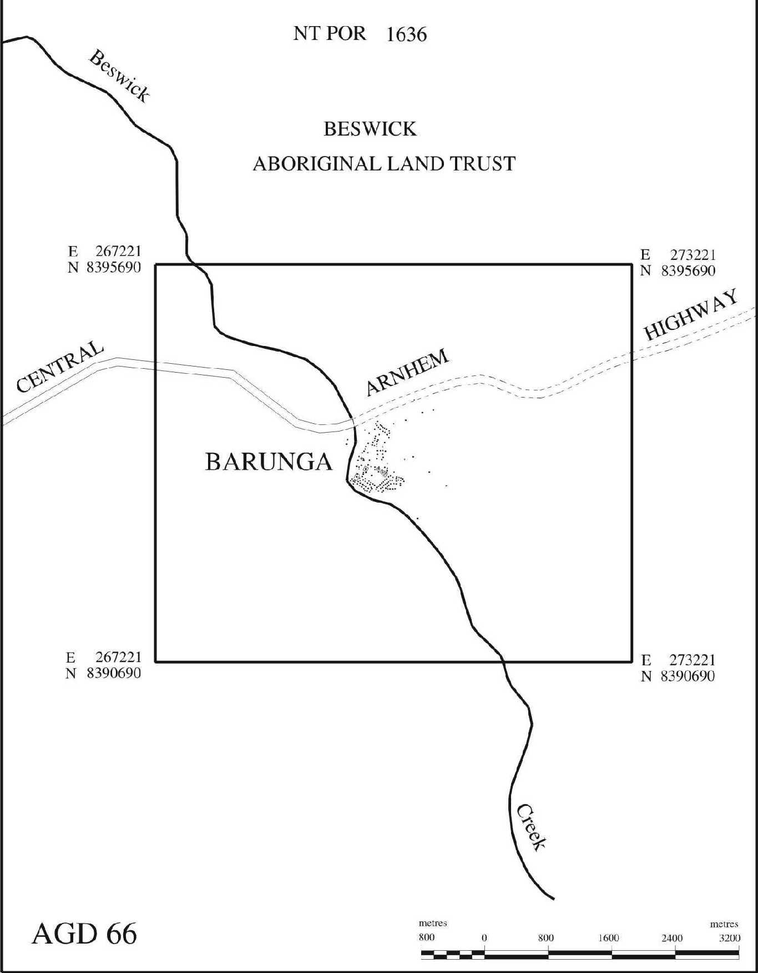
GULIN GULIN COMMUNITY AREA
All that parcel of land near Weemol in the Northern Territory of Australia containing an area of 37.5 square kilometres more or less being that part of Arnhem Land bounded by lines described as follows: Commencing at a point situated at Australian Map Grid co-ordinates 431 000 metres East 8 495 033 metres North; thence southeasterly, southwesterly and northwesterly by straight lines connecting in succession Australian Map Grid co-ordinates 434 853 metres East 8 491 873 metres North, 429 950 metres East 8 485 900 metres North and 426 114 metres East 8 489 081 metres North; thence northeasterly to the point of commencement, co-ordinates quoted herein being Zone 53, Australian Geodetic Datum 1966.
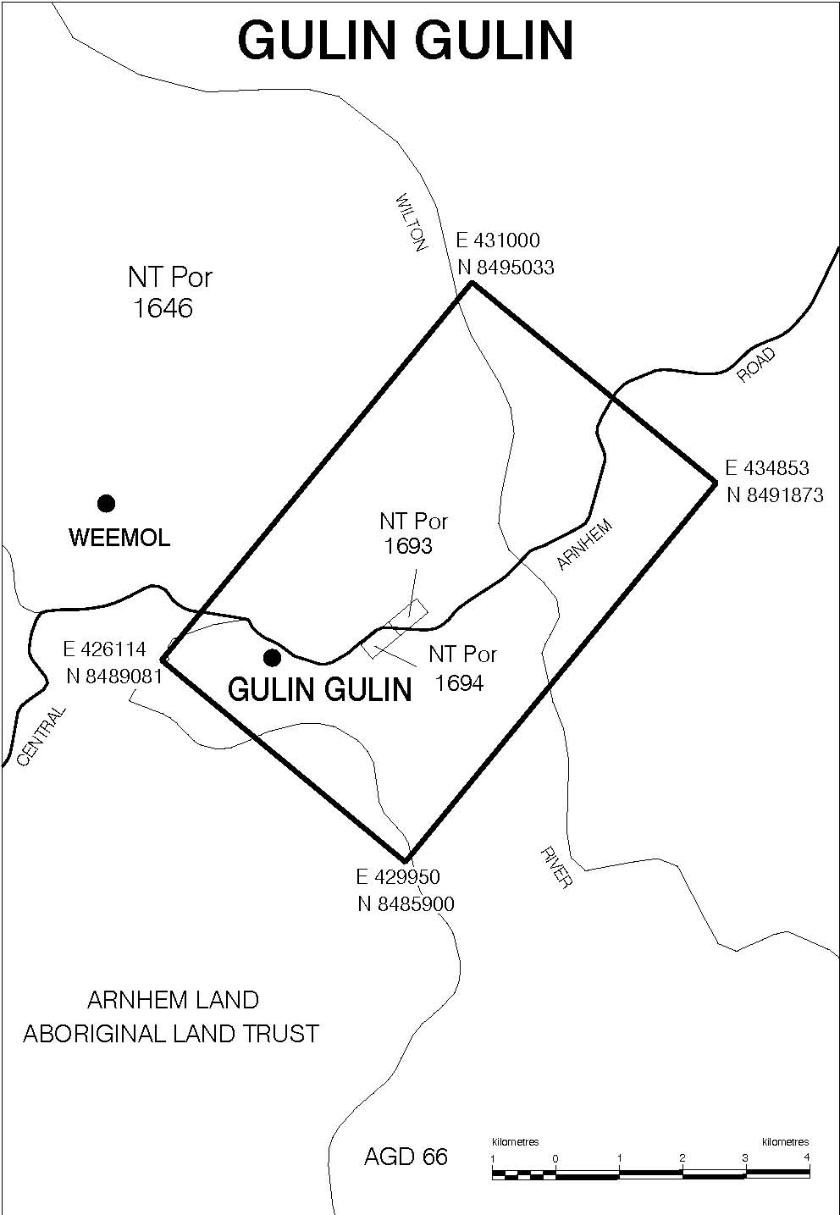
MANYALLALUK COMMUNITY AREA
All that parcel of land near Eva Valley in the Northern Territory of Australia containing an area of 29.7 square kilometres more or less and being that part of Northern Territory Portion 4342 bounded by lines described as follows: Commencing at a point situated at Australian Map Grid co-ordinates 262 692 metres East, 8 423 433 metres North; thence easterly, southerly, southwesterly and westerly by straight lines connecting in succession Australian Map Grid co-ordinates 268 645 metres East, 8 423 425 metres North; 268 645 metres East, 8 419 038 metres North; 266 539 metres East, 8 418 308 metres North and 262 692 metres East, 8 418 315 metres North; thence northerly to the point of commencement, co-ordinates quoted herein being Zone 53, Australian Geodetic Datum 1966.
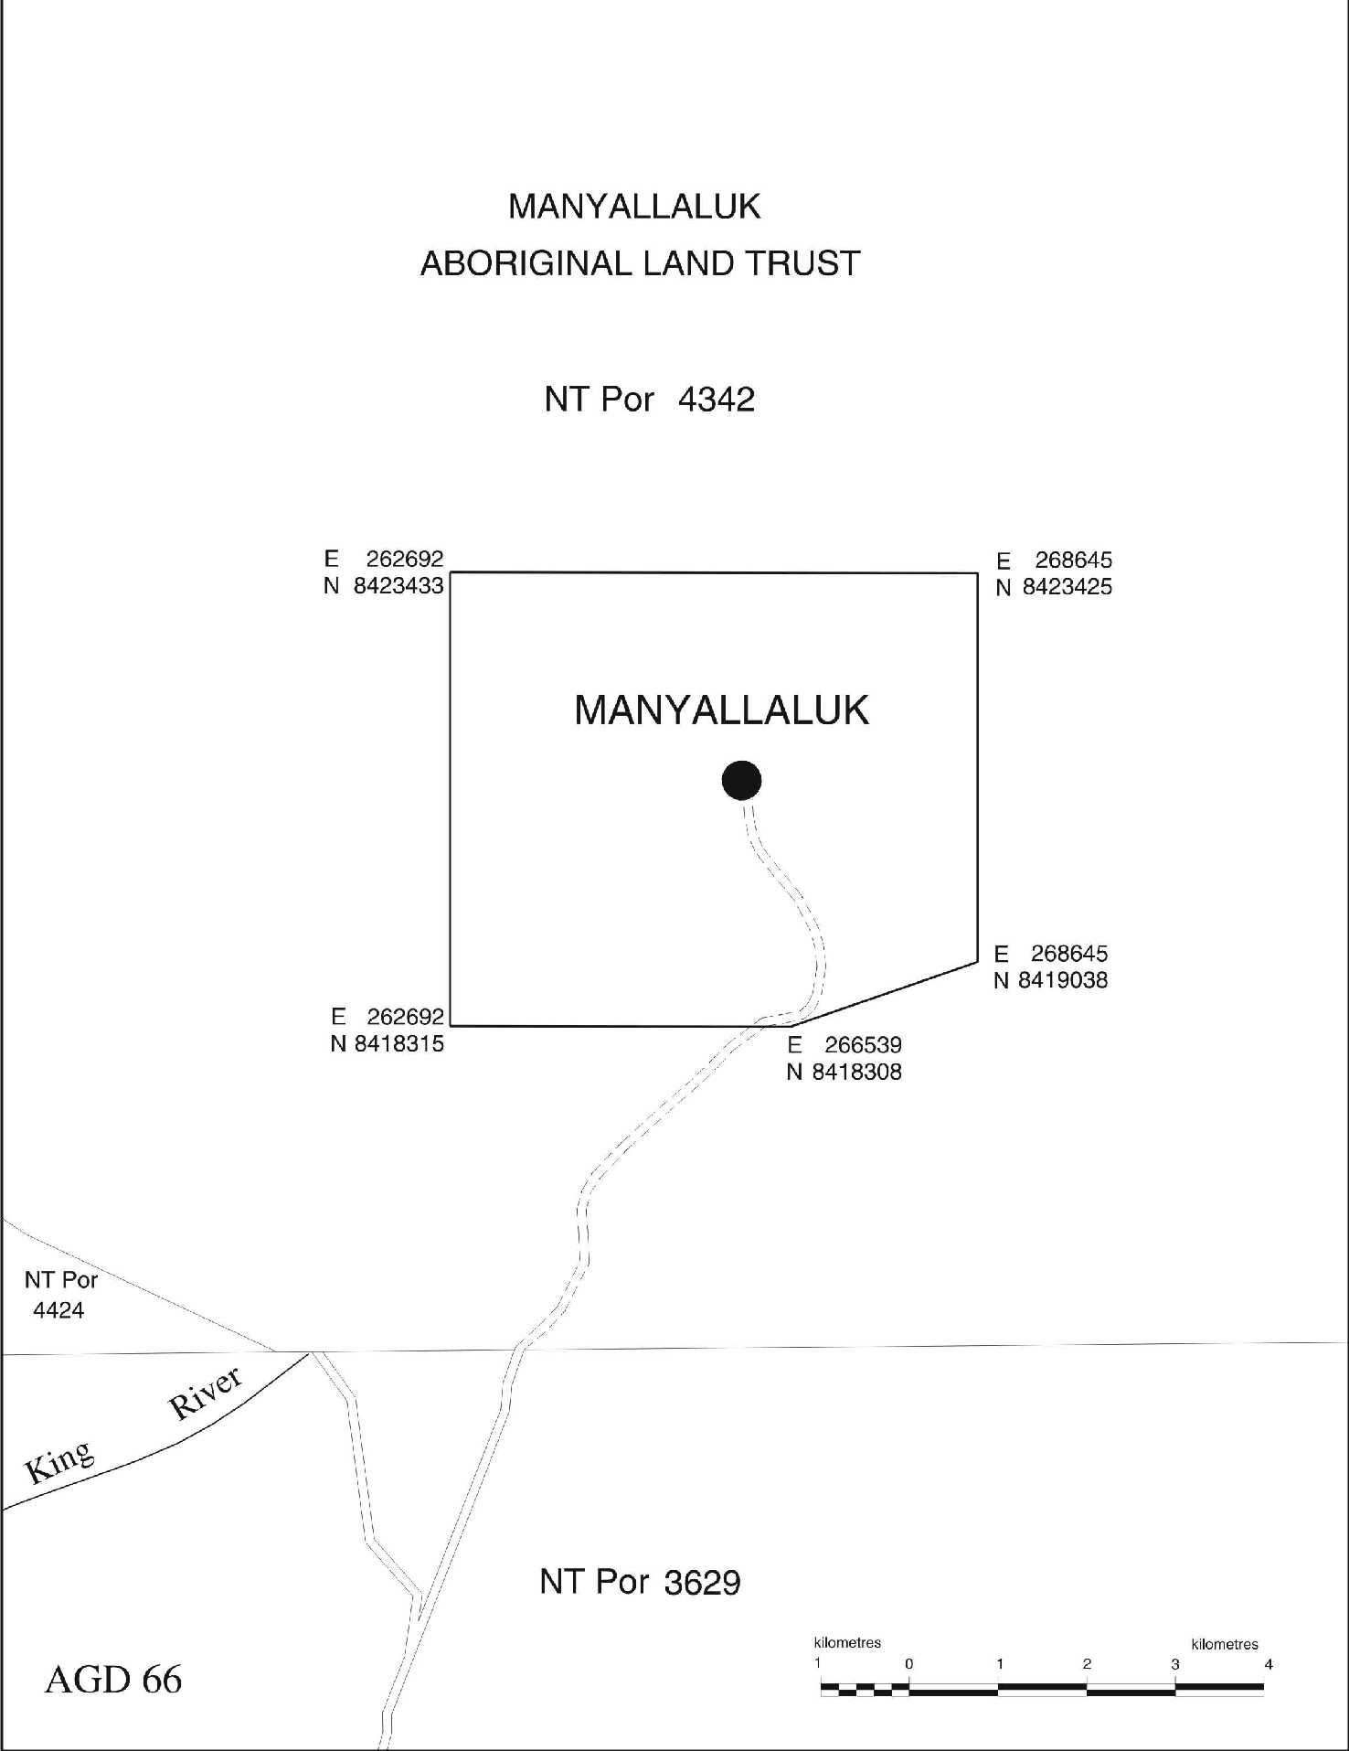
MARDRULK COMMUNITY AREA
All that parcel of land near Bulman in the Northern Territory of Australia containing an area of 37.5 square kilometres more or less being that part of Northern Territory Portion 1646 bounded by lines described as follows: Commencing at a point situated at Australian Map Grid co-ordinates 424 546 metres East, 8 495 033 metres North; thence southeasterly, southwesterly and northwesterly by straight lines connecting in succession Australian Map Grid co-ordinates 428 391 metres East, 8 491 873 metres North; 423 492 metres East, 8 485 921 metres North and 419 664 metres East, 8 489 081 metres North; thence northeasterly to the point of commencement, co-ordinates quoted herein being Zone 53, Australian Geodetic Datum 1966.
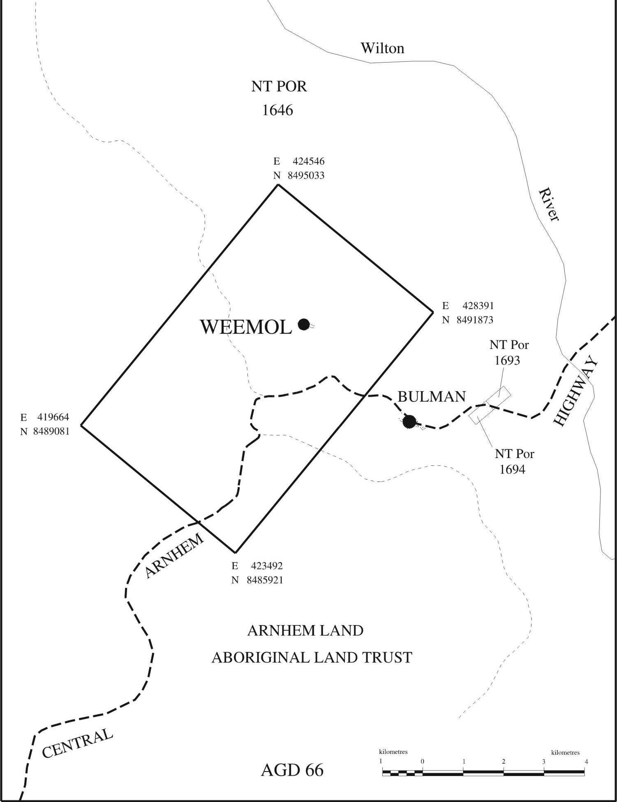
WUGULARR COMMUNITY AREA
All that parcel of land near Beswick in the Northern Territory of Australia containing an area of 34.2 square kilometres more or less being that part of Northern Territory Portion 1636 bounded by lines described as follows: Commencing at a point situated at Australian Map Grid co-ordinates 294 698 metres East, 8 391 780 metres North; thence easterly, southerly and westerly by straight lines connecting in succession Australian Map Grid
co-ordinates 300 871 metres East, 8 391 780 metres North; 300 871 metres East, 8 386 240 metres North and 294 698 metres East, 8 386 240 metres North; thence northerly to the point of commencement, co-ordinates quoted herein being Zone 53, Australian Geodetic Datum 1966.
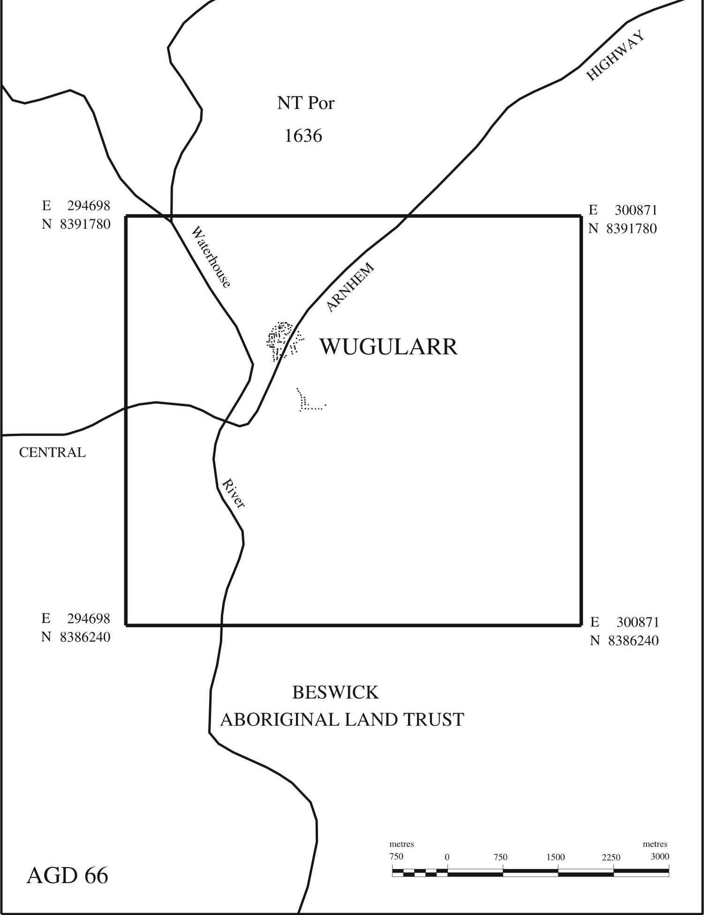
____________________________
Notes
1. The Nyirranggulung Mardrulk Ngadberre Government Constitution, in force under the Local Government Act and amendments made by other legislation, the details of which are specified in the following table:
Constitution | Date of approval | Date notified in the Gazette | Date of commencement
Original | 30 June 2003 | 1 July 2003 | 1 July 2003
Act No. 12, 2004 | – | – | 15 Mar 2004 (a)
Amendment | 3 Nov 2006 | 15 Nov 2006 | 15 Nov 2006
(a) See section 2, section 2 of the Electoral Act 2004 and Gazette S6, dated 15 March 2004.
____________________________
Table of Amendments
Clause
2. Amended by Act No. 12, 2004, s. 7
____________________________
__________________

