NORTHERN TERRITORY OF AUSTRALIA
NORTHERN TERRITORY Rates Regulations 1971
As in force at 1 July 2022
Table of provisions

1 Citation 1
2 Prescribed areas 1
Schedule Prescribed areas
ENDNOTES

northern territory of australia

____________________
As in force at 1 July 2022
____________________
NORTHERN TERRITORY RATES REGULATIONS 1971
Regulations under the Northern Territory Rates Act 1971

1 Citation
These Regulations may be cited as the Northern Territory Rates Regulations 1971.

2 Prescribed areas
Each area of land described in the Schedule is a prescribed area for the Act.

Schedule Prescribed areas
regulation 2
Part A
All that area of land shown bounded by thick black lines on the map in Part B.
Part B
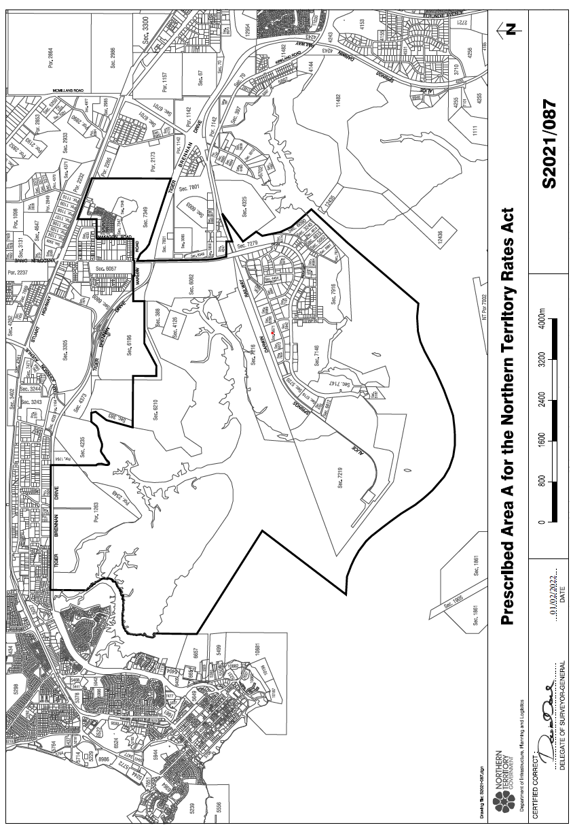

ENDNOTES

1 KEY
Key to abbreviations

amd = amended od = order
app = appendix om = omitted
bl = by-law pt = Part
ch = Chapter r = regulation/rule
cl = clause rem = remainder
div = Division renum = renumbered
exp = expires/expired rep = repealed
f = forms s = section
Gaz = Gazette sch = Schedule
hdg = heading sdiv = Subdivision
ins = inserted SL = Subordinate Legislation
lt = long title sub = substituted
nc = not commenced
2 LIST OF LEGISLATION
Darwin Rates Regulations (SL No. 18, 1971)
Notified | 30 June 1971
Commenced | 30 June 1971
Ordinances Revision Ordinance 1973 (Act No. 87, 1973)
Assent date | 11 December 1973
Commenced | 11 December 1973
Transfer of Powers (Further Provisions) Ordinance 1977 (Act No. 51, 1977)
Assent date | 9 December 1977
Commenced | 1 January 1978 (s 2)
Transfer of Powers (Self-Government) Ordinance 1978 (Act No. 54, 1978)
Assent date | 1 July 1978
Commenced | 1 July 1978
Amendments of Darwin Rates Regulations (SL No. 47, 1991)
Notified | 1 October 1991
Commenced | 1 October 1991
Darwin Rates Amendment Act 2014 (Act No. 47, 2014)
Assent date | 8 December 2014
Commenced | 11 February 2015 (Gaz G6, 11 February 2015, p 7)
Northern Territory Rates Amendment Regulations (SL No. 3, 2022)
Notified | 17 February 2022
Commenced | 1 July 2022
3 SAVINGS AND TRANSITIONAL PROVISIONS
s 6 Transfer of Powers (Further Provisions) Ordinance 1977
(Act No. 51, 1977)
s 8 Transfer of Powers (Self-Government) Ordinance 1978
(Act No. 54, 1978)
4 GENERAL AMENDMENTS
General amendments of a formal nature (which are not referred to in the list of amendments to this reprint) are made by section 11 of the Ordinances Revision Ordinance 1973 (Act No. 87, 1973) (as amended) to the following provisions: rr 2, 3 and Sch.
5 GENERAL AMENDMENTS
General amendments of a formal nature (which are not referred to in the table of amendments to this reprint) are made by the Interpretation Legislation Amendment Act 2018 (Act No. 22, 2018) to: r 1 and Sch.
6 LIST OF AMENDMENTS
r 1 amd Act No. 47, 2014, s 26
r 2 amd No. 47, 1991, r 4
sub Act No. 47, 2014, s 27
rr 3 – 5 amd No. 47, 1991, r 4
rep Act No. 47, 2014, s 27
r 6 amd Act No. 51, 1977; Act No. 54, 1978
rep Act No. 47, 2014, s 27
r 7 rep Act No. 47, 2014, s 27
rr 8 – 9 amd No. 47, 1991, r 4
rep Act No. 47, 2014, s 27
r 10 ins No. 47, 1991, r 1
rep Act No. 47, 2014, s 27
sch ins Act No. 47, 2014, s 28
sub No. 3, 2022, r 4
sch 1 amd Act No. 51, 1977; Act No. 54, 1978; No. 47, 1991, r 2
rep Act No. 47, 2014, s 28
sch 2 ins No. 47, 1991, r 3
rep Act No. 47, 2014, s 28

