NORTHERN TERRITORY OF AUSTRALIA
LAKE EYRE BASIN INTERGOVERNMENTAL AGREEMENT ACT 2009
As in force at 9 September 2009
Table of provisions

1 Short title 1
2 Commencement 1
3 Definitions 1
4 Approval and ratification of agreement 1
5 Facilitation of agreement 2
Schedule Agreement
ENDNOTES

northern territory of australia

____________________
As in force at 9 September 2009
____________________
LAKE EYRE BASIN INTERGOVERNMENTAL AGREEMENT ACT 2009
An Act to approve, ratify and facilitate the Lake Eyre Basin Intergovernmental Agreement

1 Short title
This Act may be cited as the Lake Eyre Basin Intergovernmental Agreement Act 2009.

2 Commencement
This Act commences on the date fixed by the Administrator by Gazette notice.

3 Definitions
In this Act:
agreement means the Lake Eyre Basin Intergovernmental Agreement as set out in the Schedule, comprising the original agreement, first amending deed and second amending deed.
first amending deed means the deed dated 10 June 2004 between the Commonwealth, the State of Queensland, the State of South Australia and the Territory, which forms schedule 2 to the agreement.
original agreement means the Lake Eyre Basin Intergovernmental Agreement dated 21 October 2000 between the Commonwealth, the State of Queensland and the State of South Australia.
second amending deed means the deed dated 23 January 2007 between the Commonwealth, the State of Queensland, the State of South Australia and the Territory, which forms schedule 3 to the agreement.

4 Approval and ratification of agreement
The agreement is approved and ratified.

5 Facilitation of agreement
The Minister and Agencies and instrumentalities of the Territory are authorised and required to do anything reasonably necessary to ensure the performance and observance of the agreement.

Schedule Agreement
section 3
LAKE EYRE BASIN INTERGOVERNMENTAL AGREEMENT
AN AGREEMENT MADE THE 21ST DAY OF OCTOBER 2000
BETWEEN:
THE COMMONWEALTH OF AUSTRALIA
AND
THE STATE OF QUEENSLAND
AND
THE STATE OF SOUTH AUSTRALIA
RECITALS:
A. The Lake Eyre Basin has within its boundaries areas of national and international ecological and environmental significance, areas of high economic worth from activities such as pastoralism, tourism, oil and gas extraction and mining, and areas of social, cultural and heritage value, the sustainability of much of which depends upon the continued health of the Thomson/Barcoo/Cooper, Georgina and Diamantina river systems within Queensland and South Australia (as defined in the Australian National Map Drainage Divisions and Basins and including their catchments, flood plains, lakes, wetlands and overflow channels).
B. Management of the Lake Eyre Basin which will best serve the object of sustainability requires a joint cooperative approach between the States of Queensland and South Australia and the Commonwealth.
C. The Parties to this Agreement entered into a Heads of Agreement dated 26 May 1997 whereby it was agreed that the above approach should be embodied in a formal interstate Agreement ratified by the Parliaments of each State.
D. This Agreement is entered into by the Parties in accordance with the Lake Eyre Basin Heads of Agreement, and is to provide for the establishment of arrangements for the management of water and related natural resources for that portion of the Lake Eyre Basin identified as the Lake Eyre Basin Agreement Area in Clause 1.1, including the development or adoption, and implementation of agreed Policies and Strategies for the avoidance of adverse cross-border impacts and the creation of a relevant institutional structure.
E. This Agreement is also entered into in recognition of the provisions of the Intergovernmental Agreement on the Environment dated 1 May 1992 between the Commonwealth, all States and Territories, and the Australian Local Government Association, that States use their best endeavours to establish appropriate mechanisms for ensuring cooperative management where significant adverse external effects on another State are expected and identified, and that the role of government is to establish the policy, legislative and administrative framework to determine the permissibility of land use, resource use or development proposals having regard to the appropriate, efficient and ecologically sustainable use of natural resources, and to provide for the consideration of regional implications where proposals for the use of a resource affect several jurisdictions.
F. The provisions of this Agreement are consistent with the Council of Australian Governments' National Water Reform Framework and the Natural Heritage Trust Partnership Agreements.
THE PARTIES AGREE AS FOLLOWS:
Part I – Application and Interpretation
Application
1.1 This Agreement applies to that area of the Lake Eyre Basin (the Agreement Area) encompassing portions of Queensland and South Australia, as depicted in Schedule 1 of this Agreement, including within that area the following river systems and associated catchments, floodplains, overflow channels, lakes, wetlands and sub-artesian waters dependent on surface flows:
(a) the Cooper Creek system including the Thomson and Barcoo Rivers, and associated tributaries; and
(b) the Diamantina River system, including the Georgina River, and including Warburton Creek in South Australia, and associated tributaries.
Definitions
1.2 In this Agreement save where inconsistent with the context:
Ecosystem means a community of organisms, interacting with one another, and the natural resources comprising the environment in which those organisms live and with which they also interact.
Lake Eyre Basin Agreement Area means the area referred to in clause 1.1 to which the Agreement applies.
Management Plan means a plan or other document of a State that has been adopted by the Ministerial Forum.
Ministerial Forum means the group of Ministers of the Crown in right of the Commonwealth and the State parties constituted under Part V.
Natural resources means water, soil, the atmosphere, plants, animals and micro-organisms that maintain and form components of ecosystems.
Principles means the guiding principles referred to in Part III.
Policy means a document setting out a course or line of action developed or adopted and pursued by the Ministerial Forum for the purpose of implementing this Agreement.
Related natural resources means natural resources the use or management of which affects or might affect, or is or might be affected by the quantity or quality of water in the water systems described in clause 1.1 of this Agreement, or the ecosystems of which such water is a component part.
Strategy means a document setting out a course or line of action developed or adopted and pursued by the Ministerial Forum for the purpose of implementing a Policy.
Interpretation
1.3 In this Agreement, unless the context otherwise requires:
(a) a reference to any law or legislation or legislative provision includes any statutory modification or re-enactment of, or legislative provision substituted for, and any subordinate legislation issued under, that legislation or legislative provision;
(b) a reference to a Recital, Clause or Schedule is to a recital, clause or schedule in this Agreement;
(c) a reference to a person includes a corporation, partnership, joint venture, association, authority, trust, state or government;
(d) the singular includes the plural and vice versa
(e) a reference to any gender includes the other gender;
(f) a reference to any agreement or document is to that agreement or document (and, where applicable, any of its provisions) as amended, novated, supplemented or replaced from time to time; and
(g) a reference to "amendment" includes addition, alteration, deletion, extension, modification and variation.
1.4 In this Agreement, headings are for convenience of reference only and do not affect interpretation.
1.5 In the interpretation of a provision of this Agreement, a construction that would promote the purpose or object underlying the Agreement (whether or not that purpose or object is expressly stated in the Agreement) will be preferred to a construction that would not promote that purpose or object.
1.6 Questions of interpretation of this Agreement are to be raised in the Ministerial Forum.
Part II – Purpose and Objectives
Purpose
2.1 The purpose of this Agreement is to provide for the development or adoption, and implementation of Policies and Strategies concerning water and related natural resources in the Lake Eyre Basin Agreement Area to avoid or eliminate so far as reasonably practicable adverse cross-border impacts.
Objectives
2.2 The objectives of this Agreement are:
(a) to provide a means for the Parties to come together in good faith to achieve the purposes of the Agreement;
(b) to define a process and context for raising and addressing water and related natural resource management issues in the Lake Eyre Basin Agreement Area that have cross-border impacts, particularly those related to water quantity and quality, and flow regimes;
(c) to establish institutional arrangements for the development or adoption of Policies and Strategies and for the adoption of any relevant management plans established by a State;
(d) to provide for each of the Parties, so far as they are able within their respective jurisdictions, to progress the implementation of Policies and Strategies developed or adopted under this Agreement and to make management decisions and allocate resources accordingly;
(e) to provide a mechanism to review Policies and Strategies;
(f) to provide for the Parties to jointly promote and support the management of water and related natural resources through a cooperative approach between community, industry and other stakeholders, and all levels of government in the sustainable management of the Lake Eyre Basin Agreement Area;
(g) to encourage, promote and support water and related resource management practices which are compatible with the spirit and intent of the Agreement;
(h) to encourage and promote research and monitoring to improve understanding and support informed decision making in the Lake Eyre Basin Agreement Area;
(i) to provide for the review and, if necessary, revision of the Agreement from time to time; and
(j) to raise general public awareness of the special biodiversity and heritage values of the Lake Eyre Basin Agreement Area.
Part III – Guiding Principles
3.1 Consideration of all issues and the making of all decisions under this Agreement will be guided by the following Principles, namely that it be acknowledged:
(a) that the Lake Eyre Basin Agreement Area has important social, environmental, economic and cultural values which need to be conserved and promoted;
(b) that there are landscapes and watercourses in the Lake Eyre Basin Agreement Area that are valuable for aesthetic, wilderness, cultural and tourism purposes;
(c) that naturally variable flow regimes and the maintenance of water quality are fundamental to the health of the aquatic ecosystems in the Lake Eyre Basin Agreement Area;
(d) that the water requirements for ecological processes, biodiversity and ecologically significant areas within the Lake Eyre Basin Agreement Area should be maintained, especially by means of flow variability and seasonality;
(e) that flooding throughout the catchments within the Lake Eyre Basin Agreement Area is beneficial in that it makes a significant contribution to pastoral activities as well as flood plain ecosystem processes;
(f) that the storage and use of water both within and away from watercourses, and the storage and use of water from associated ground water, are all linked and should be considered together, and that water resources throughout catchments within the Lake Eyre Basin Agreement Area should be managed on an integrated basis;
(g) that precautionary approaches need to be taken so as to minimise the impact on known environmental attributes, and reduce the possibility of affecting poorly understood ecological functions;
(h) that natural resource management decisions need to be made within the context of the National Strategy for Ecologically Sustainable Development and relevant national and international obligations;
(i) that the collective local knowledge and experience of the Lake Eyre Basin Agreement Area communities are of significant value; and
(j) that decisions need to be based on the best available scientific and technical information together with the collective local knowledge and experience of communities within the Lake Eyre Basin Agreement Area.
Part IV – Roles of the Parties
Responsibilities and Interests of all Parties
4.1 The following will guide the Parties in defining the roles, responsibilities and interests of the Parties in relation to the achievement of the objectives of this Agreement.
Responsibilities and Interests of the Commonwealth
4.2 The responsibilities and interests of the Commonwealth in safeguarding and accommodating matters of national interest include ensuring that the policies or practices of a State that affect or might affect the water and related natural resources to which this Agreement applies, do not result in significant adverse external effects in relation to another State.
4.3 When considering its responsibilities and interests under Clause 4.2 the Commonwealth will have regard to the role of the States in dealing with significant adverse external effects in accordance with the requirements of the Intergovernmental Agreement on the Environment, and any action taken pursuant to that Agreement.
4.4 The Commonwealth will monitor the activities of the States in the Lake Eyre Basin Agreement Area to ensure Australia meets its international obligations in accordance with the Intergovernmental Agreement on the Environment.
4.5 The Commonwealth has responsibility for the management (including operational policy) of natural resources on land which the Commonwealth owns or which it occupies for its own use.
4.6 The Commonwealth will ensure that matters of national interest relating to environmental protection, sustainable agriculture and water and related natural resources management in the Lake Eyre Basin Agreement Area are appropriately addressed in consultation with the States.
4.7 The Commonwealth will consult with the States as required by the Intergovernmental Agreement on the Environment prior to entry into any international agreement which may directly impact on the Lake Eyre Basin Agreement Area.
Responsibilities and Interests of the States
4.8 Each State will continue to have responsibility for the development and implementation of policy in relation to matters concerning the Lake Eyre Basin Agreement Area which have no significant effects on the water and related natural resources of the Lake Eyre Basin Agreement Area.
4.9 Each State will continue to have responsibility for its policy formulation and the administration of its legislation relevant to water and related natural resource management within the Lake Eyre Basin Agreement Area, but in so doing will, to the fullest extent that it is able, comply with this Agreement and any applicable Policies and Strategies developed or adopted under it. Further, to the extent that may be necessary, each State will use its best endeavours to secure the passage through its respective Parliament of legislation for the purpose of conforming with and implementing this Agreement and any such Policies and Strategies.
4.10 Each State will assist in the encouragement and promotion of research and monitoring to facilitate informed decision making for the Lake Eyre Basin Agreement Area, and the sharing of access to the results of such research and monitoring so far as either State may control such access.
4.11 Each State will consult with and involve Local Government (where relevant) in the implementation of this Agreement and the Policies and Strategies developed or adopted under it to the extent that State statutes and administrative arrangements authorise or delegate relevant responsibilities to Local Government, and in a manner which reflects the concept of partnership between the Commonwealth, State and Local Governments.
Part V – Institutional Structure
Constitution of the Ministerial Forum
5.1 The Ministerial Forum is constituted.
5.2 The Ministerial Forum will consist of one Minister from each State and one Minister of the Commonwealth. Each Party will appoint its Minister from time to time, by notice in writing to each other Party.
5.3 Whenever a member of the Ministerial Forum is:
(a) unable for any reason to attend a meeting of the Ministerial Forum; or
(b) otherwise unable to perform the duties of a member of the Ministerial Forum, another Minister of that State or the Commonwealth will be appointed to act in the place of that member, and while so acting that other Minister will have all the responsibilities and perform all the duties of that member.
Procedures of the Ministerial Forum
5.4 The Ministerial Forum will meet at least once in each year but otherwise at such times as it sees fit and will, subject to this Agreement, determine its own procedure.
5.5 A resolution before the Ministerial Forum will be carried only by a unanimous vote.
5.6 The Commonwealth Minister will act as the chair of the Ministerial Forum.
5.7 A permanent record of all resolutions of the Ministerial Forum will be kept.
Functions of the Ministerial Forum
5.8 The Ministerial Forum will be responsible for the implementation of this Agreement.
Community Advice and Representation
5.9 The Ministerial Forum will ensure that it has satisfactory access to community advice in relation to matters relevant to this Agreement.
5.10 For that purpose the Ministerial Forum may either:
5.10.1 adopt one or more independently formed groups, committees or bodies to provide community advice representation and feedback; or
5.10.2 appoint the members of a committee to perform that function.
5.11 Whichever means of access to community advice the Ministerial Forum selects the following will apply:
5.11.1 There will be appropriate representation of:
(a) Aboriginal interests;
(b) pastoral interests;
(c) agricultural interests;
(d) mining and petroleum interests;
(e) conservation interests;
(f) tourism interests;
(g) matters and interests affecting the Cooper Creek River system as referred to in clause 1.1 of this Agreement; and
(h) matters and interests affecting the Diamantina River system as referred to in clause 1.1 of this Agreement; and
5.11.2 The following roles will be satisfactorily performed:
(a) representation of the various interests referred to in sub-clause 5.11.1;
(b) the seeking out of community views relevant to matters covered by this Agreement and the communication of those views to the Ministerial Forum;
(c) the communication of decisions and initiatives of the Ministerial Forum to the various communities; and
(d) the performance of such other functions relevant to this Agreement as the Ministerial Forum may require.
5.12 This clause will apply if the Ministerial Forum chooses to adopt one or more independently formed groups, committees or bodies to provide advice representation and feedback.
(a) Subject to the availability of funds under Part XI of this Agreement, the independently formed groups committees and bodies will receive such allowances and expenses as the Ministerial Forum may from time to time determine, such payments to be disbursed or divided amongst individual members in such manner as those groups committees or bodies may themselves decide.
(b) The Ministerial Forum may at any time determine that any one or more or all of the adopted groups committees or bodies will cease to be its provider of community advice, representation and feedback provided however that the Ministerial Forum will within a reasonable time (and in any event before any relevant significant decisions are made) replace that source of community advice in accordance with this Agreement.
5.13 This clause will apply if the Ministerial Forum chooses to appoint a committee to provide community advice, representation and feedback.
(a) Each member will be appointed by the Ministerial Forum.
(b) In appointing members to represent Aboriginal interests the Ministerial Forum will have regard, as a fundamental element of its decisions, to such recommendations as the Aboriginal communities of the Lake Eyre Basin Agreement Area may choose to make.
(c) The Ministerial Forum may appoint members of the committee from time to time to fill vacancies.
(d) The Ministerial Forum may at any time appoint to the committee such additional members as it thinks fit.
(e) The appointment of members of the committee will be for a period of three years from the date of each appointment provided however that members will be eligible for re-appointment for such terms from time to time as the Ministerial Forum thinks appropriate.
(f) Subject to the availability of funds under Part XI of this Agreement, a member of the committee will receive such allowances and expenses as the Ministerial Forum may from time to time determine.
(g) The Ministerial Forum may at any time terminate the appointment of individual members or disband the committee:
(i) if of the opinion that the member or members or the committee is or are no longer substantially representing the interests or matters in respect of which the member or members or the committee as the case may be was or were appointed; or
(ii) for such reason as the Ministerial Forum considers appropriate, provided however that the Ministerial Forum will within a reasonable time (and in any event before any relevant significant decisions are made) appoint or re-appoint members of the committee in accordance with this Agreement, or, if the whole committee has been disbanded, replace that source of community advice in accordance with this Agreement.
(h) The Ministerial Forum may appoint to the committee the individual members of a group, committee or body independently formed. To the extent that may be necessary to satisfy the requirements of this Agreement, the Ministerial Forum will appoint additional members.
Part VI – Conference
6.1 The Ministerial Forum may from time to time arrange a conference to be attended by the members of the Ministerial Forum, members of committees appointed or adopted under this Agreement and of other interested groups, interested individuals, scientific and technical advisers and senior government officers.
6.2 There will be a conference at least once before the second anniversary of the effective date of this Agreement and thereafter on at least a biennial basis.
6.3 The purpose of such conferences will be to exchange information and views on issues relevant to the operation of this Agreement.
Part VII – Scientific and Technical Advice
7.1 The Ministerial Forum may seek scientific and technical advice relevant to this Agreement from such persons or bodies as it thinks appropriate. In particular, the Ministerial Forum may obtain scientific and/or technical advice in relation to the identification of requirements for the effective monitoring of the condition of the rivers and catchments within the Lake Eyre Basin Agreement Area and the establishment of programs to meet those requirements.
7.2 The Ministerial Forum may if it thinks appropriate, establish a panel of scientists and technicians for the purpose of providing advice to the Ministerial Forum relevant to this Agreement.
Part VIII – Policies and Strategies
8.1 The Ministerial Forum will, without unnecessary delay, develop or adopt Policies and Strategies for the management of the Lake Eyre Basin Agreement Area in accordance with the purpose, objectives and Principles set out in this Agreement.
8.2 The Ministerial Forum may vary or revoke such Policies and Strategies, and may make supplementary Policies and Strategies.
8.3 The Ministerial Forum may adopt management plans prepared by the States if those plans are consistent with this Agreement and with the Policies developed or adopted by the Ministerial Forum for the management of the Lake Eyre Basin Agreement Area, and once adopted, such management plans prepared by the States will be treated as plans of the Ministerial Forum under this Agreement.
Content of Policies and Strategies
8.4 The Policies and Strategies will make provision for such matters as the Ministerial Forum thinks fit, including but not limited to:
(a) objectives for water quality and river flows;
(b) objectives for water and related natural resource management in the Lake Eyre Basin Agreement Area for the achievement of the water quality and river flow objectives;
(c) catchment management policies and strategies for the achievement, as far as practicable, of the water quality and river flow objectives;
(d) policies for dealing with relevant existing entitlements under State laws and significant water related developments; and
(e) research and monitoring requirements and programs to meet those requirements.
Part IX – Ratification and Effective Date
9.1 This Agreement, other than Part IX, is subject to approval and ratification by the Parliaments of South Australia and Queensland and will come into effect when so approved and ratified by the Parliaments of both States.
9.2 Any amendment of this Agreement, including the addition or amendment of a Schedule approved by the Ministerial Forum under clause 10 or 12, is subject to approval and ratification by the Parliaments of South Australia and Queensland and will come into effect when so approved and ratified.
9.3 Each State will take all practical steps to seek the enactment of legislation:
(a) approving and ratifying this Agreement, and any amendment to this Agreement which may be approved by the Ministerial Forum from time to time, on behalf of the State; and
(b) authorising and requiring the performance and observance of this Agreement by the Government of the State.
Part X – Review and Amendment Review
10.1 The Ministerial Forum must cause a review of:
(a) the operation of this Agreement; and
(b) the extent to which the objectives set out in Clause 2.2 of this Agreement have been achieved,
to be undertaken without unnecessary delay after the fifth anniversary of the effective date of this Agreement, and thereafter on a ten yearly basis.
10.2 A report of each review required under clause 10.1 is to be tabled in the Parliament of each State and presented to the Commonwealth Minister within 12 months after completion of it.
10.3 The Ministerial Forum must cause a review of all Policies and Strategies to be undertaken without unnecessary delay after the fifth anniversary of the development or adoption of them, and thereafter as necessary but in any event not less frequently than every ten years.
10.4 The Ministerial Forum must cause a review of the condition of all watercourses and catchments within the Lake Eyre Basin Agreement Area to be undertaken without unnecessary delay after the effective date of this Agreement, and thereafter on a ten yearly basis.
Amendment
10.5 The Ministerial Forum may approve such amendments to this Agreement, including amendments to or addition of schedules to this Agreement, as the Ministerial Forum considers desirable from time to time.
Part XI – Funding and Accountability Arrangements
11.1 Subject to the availability of respective appropriations, the Commonwealth and the States will make available all necessary financial and other resources for the establishment and operation of the Ministerial Forum and associated institutional arrangements.
11.2 The Commonwealth and the States will determine and agree appropriate cost-sharing arrangements which reflect their respective roles and responsibilities under this Agreement.
11.3 Any group committee or body appointed or adopted under Part V and which receives funding under this Agreement will produce to the Ministerial Forum in respect of each financial year a full account of its application of all funds received by it together with a report of its activities towards which such funding has been applied.
Part XII – Further Parties
Accession by New Parties
12.1 The State of New South Wales and the Northern Territory may become parties to this Agreement:
(a) with the consent of the existing Parties; and
(b) on such terms and conditions as may be prescribed by the existing Parties in a Schedule to this Agreement.
12.2 The Ministerial Forum may approve any Schedule prepared pursuant to Clause 12.1(b).
12.3 This Agreement will not apply to the State of New South Wales or the Northern Territory until:
(a) a copy of the Agreement incorporating the Schedule provided for in Paragraph 12.1(b) has been signed on behalf of that State or Territory and the Parliament of that State or Territory has approved this Agreement, including the Schedule; and
(b) the Schedule has been approved and ratified by the States under Part IX.
12.4 Each State will take the steps referred to in Part IX for the approval and ratification of any schedule approved by the Ministerial Forum under this clause.
Part XIII – General
Counterparts
13. This Agreement may be executed in any number of counterparts and all of those counterparts taken together constitute one and the same instrument.
[Signed on 13 October 2000 in the presence of a witness by the Minister for the Environment and Heritage of the Commonwealth.
Signed on 21 October 2000 in the presence of a witness by the Minister for Environment and Heritage and Natural Resources of the State of Queensland.
The common seal of the Minister for Water Resources of the State of South Australia affixed and signed by the Minister in the presence of a witness on 21 October 2000.]

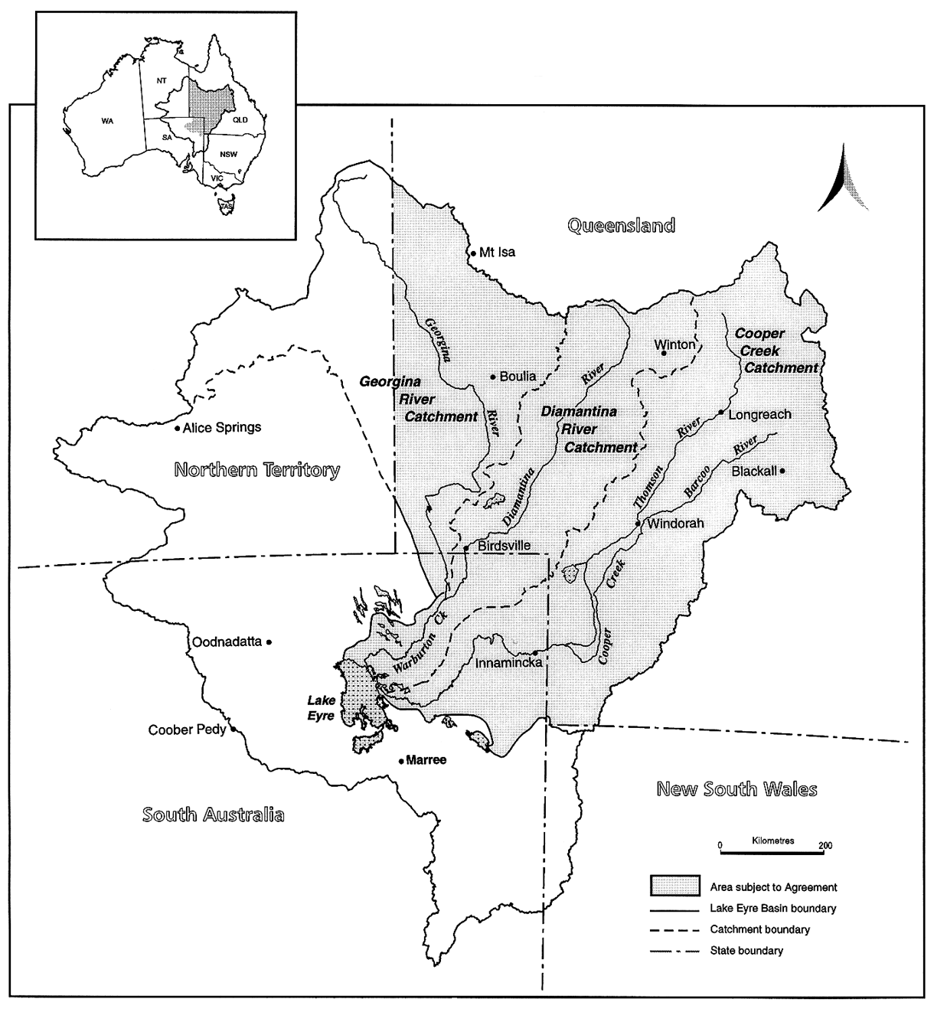
Schedule 1:
THE LAKE EYRE BASIN AGREEMENT AREA

Schedule 2
DEED dated the Tenth day of June 2004.
BETWEEN:
THE COMMONWEALTH OF AUSTRALIA ("the Commonwealth")
AND
THE STATE OF QUEENSLAND ("Queensland")
AND
THE STATE OF SOUTH AUSTRALIA ("South Australia")
AND
THE NORTHERN TERRITORY OF AUSTRALIA ("the Northern Territory")
BACKGROUND
1. On the 21st day of October 2000, the Commonwealth, Queensland and South Australia (“the Original Parties”) entered into the LAKE EYRE BASIN INTERGOVERNMENTAL AGREEMENT (“the Original Agreement”) to provide for the establishment of arrangements for the management of water and related natural resources for that portion of the Lake Eyre Basin as identified in Clause 1.1 of the Agreement.
2. The Northern Territory wishes to become a party to the Original Agreement.
3. The Original Parties:
(a) have agreed to admit the Northern Territory as a party to the Original Agreement; and
(b) wish to amend certain provisions of the Original Agreement as set out in this Deed.
OPERATIVE PART:
1. MEANING OF WORDS
(a) "Effective Date" means, pursuant to clause 12 of the Original Agreement, the date on which this Deed is approved and ratified by the Parliaments of Queensland, South Australia and the Northern Territory.
(b) All other capitalised terms in this Deed have the meaning given to them in the Original Agreement.
2. CHANGES TO PARTIES
On and from the Effective Date the Northern Territory:
(a) becomes a Party to the Original Agreement; and
(b) is bound by the terms of the Original Agreement in all respects as if the Northern Territory had been named as a Party to the Original Agreement.
3. AMENDMENTS TO THE AGREEMENT
The Original Agreement is varied in the following manner:
(a) by removing clause 1.1 and replacing it with the following clause:
“1.1 This Agreement applies to that area of the Lake Eyre Basin (the Agreement Area) encompassing portions of Queensland, South Australia and the Northern Territory of Australia, as depicted in Schedule 1 of this Agreement, including within that area the following river systems and associated catchments, floodplains, overflow channels, lakes, wetlands and sub-artesian waters dependent on surface flows of:
a. the Cooper Creek system and associated tributaries in Queensland and South Australia;
b. the Diamantina River system and associated tributaries in Queensland and South Australia;
c. the Georgina River system and associated tributaries in Queensland, South Australia and the Northern Territory;
d. the Hay River system and associated tributaries in Queensland and the Northern Territory; and
e. the Finke River and Todd River systems and associated tributaries in the Northern Territory.
(b) by adding the following sub-clause (h) to clause 1.3:
“a reference to a “State” includes the Northern Territory.”
(c) by removing sub-clause 9.2 and replacing it with the following sub-clause:
“9.2 Any amendment of this Agreement, including the addition or amendment of a Schedule approved by the Ministerial Forum under clause 10 or 12, is subject to approval and ratification by the Parliaments of Queensland, South Australia and the Northern Territory and will come into effect when so approved and ratified.”
(d) by replacing the map in Schedule 1 of the Original Agreement with the map at Annexure A to this Deed.
(e) by this Deed becoming a schedule to the Original Agreement being “Schedule 2”.
4. TERMS AND CONDITIONS
For the purpose of clause 12.1 of the Original Agreement, the terms and conditions prescribed by the Original Parties are as set out in Annexure B to this Deed.
5. GENERAL
(a) Each party must:
(a) use its best efforts to do all things necessary or desirable to give full effect to this Deed; and
(b) refrain from doing anything that might hinder performance of this Deed.
(b) This Deed may be signed in any number of counterparts.
(c) Except as varied above the Original Agreement remains in full force and effect.
[Signed, sealed and delivered on 10 June 2004 in the presence of a witness by the Minister for the Environment and Heritage of the Commonwealth.
Signed, sealed and delivered on 10 June 2004 in the presence of a witness by the Minister for Natural Resources Mines and Energy of the State of Queensland.
Signed, sealed and delivered on 10 June 2004 in the presence of a witness for and on behalf of the Northern Territory of Australia by the Minister for Central Australia.
The common seal of the Minister for Environment and Conservation of the State of South Australia affixed and signed by the Minister in the presence of a witness on 10 June 2004.]
Annexure A

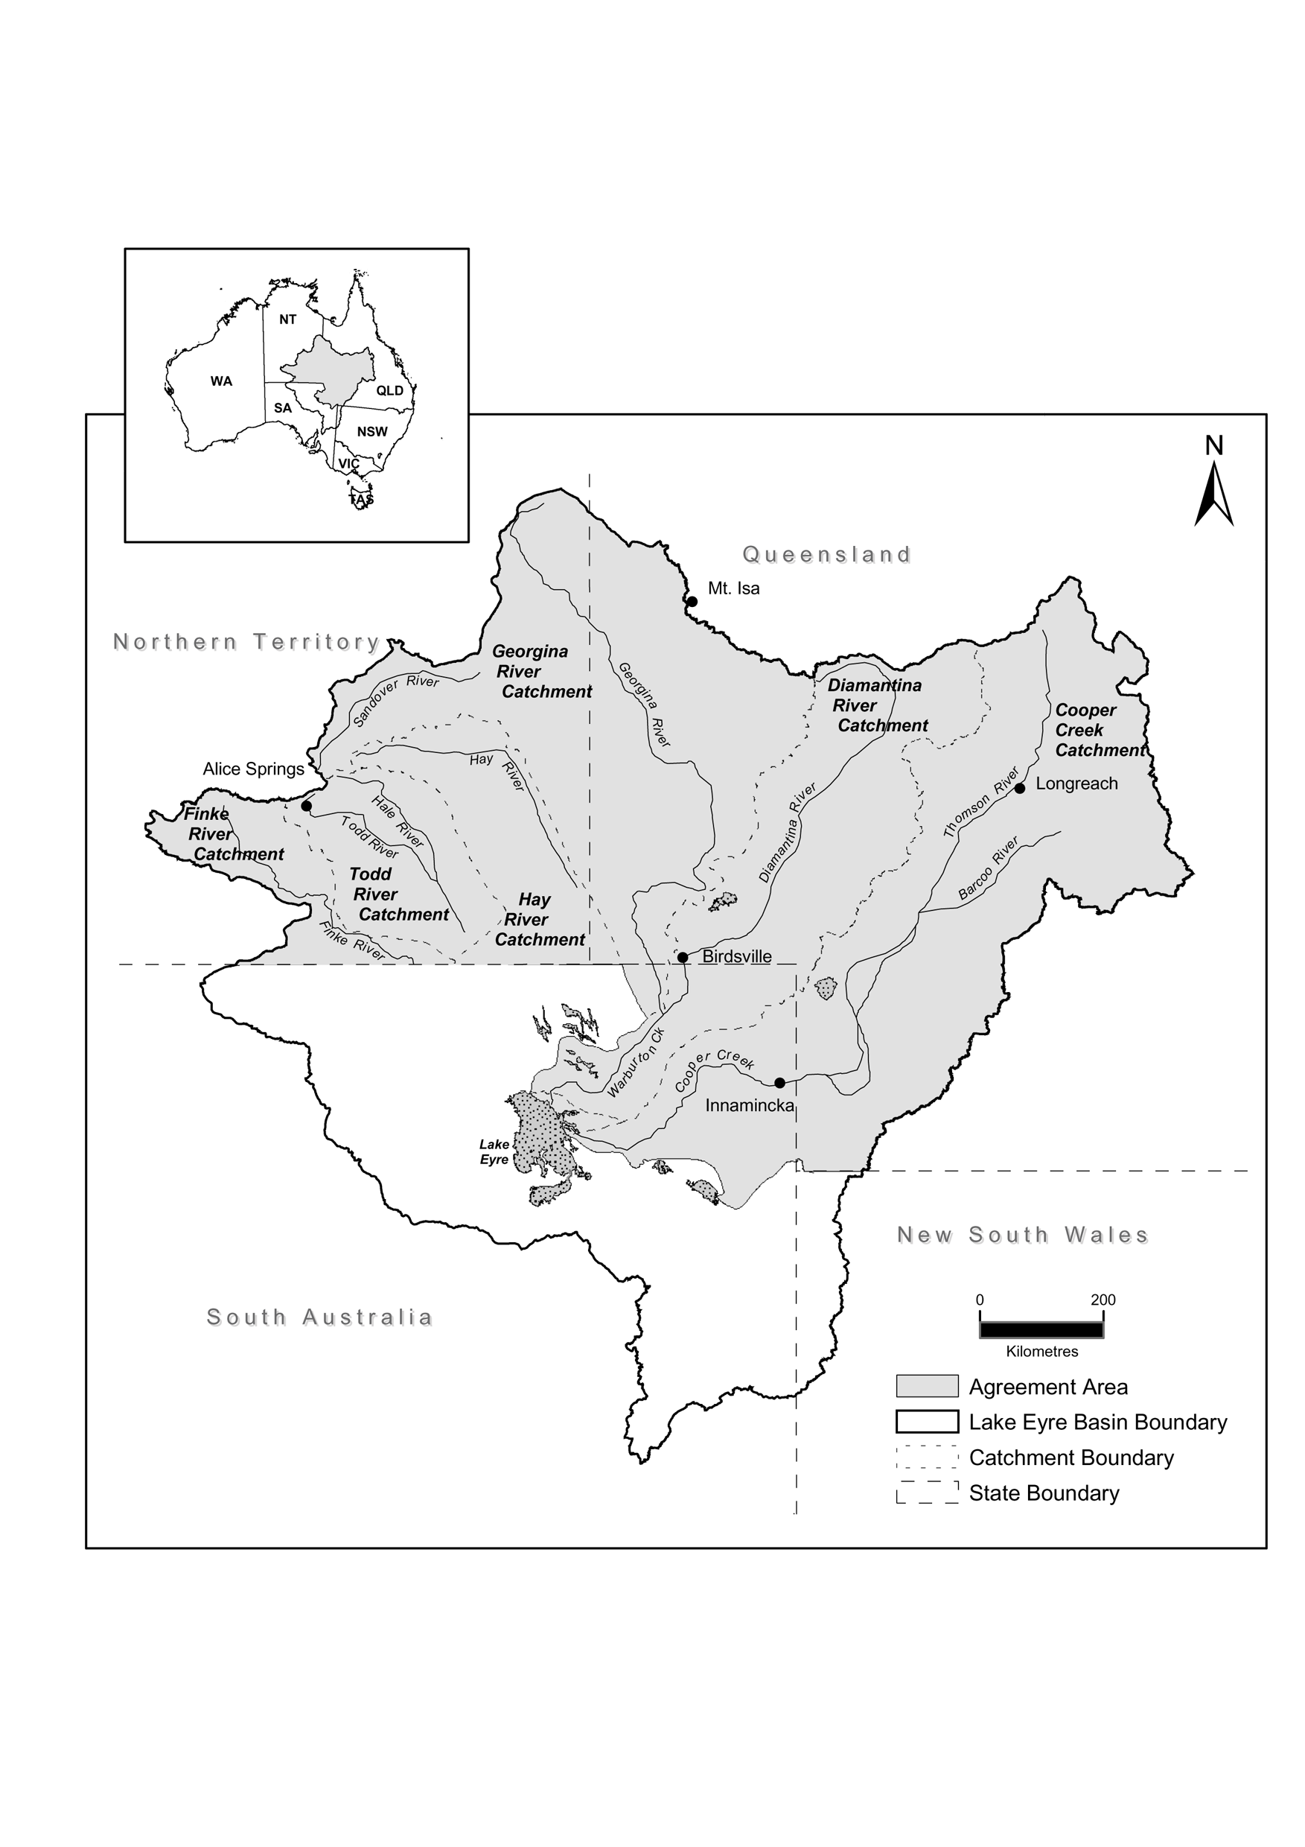
Annexure A:
THE LAKE EYRE BASIN AGREEMENT AREA
Annexure B
Terms
The Northern Territory will join the Original Agreement on the following terms agreed by and with the Original Parties:

a) the Northern Territory will contribute financial and other resources of $50,000 per annum towards the Ministerial Forum Budget, at least $10,000 of which will provided as a cash contribution;

b) the cash component of the Northern Territory contribution will be managed in accordance with existing financial arrangements agreed by parties, but will be targeted to travel and other costs involved in supporting Northern Territory participation in the Community Advisory Committee to the Ministerial Forum;

c) the remainder of the Northern Territory contribution will be drawn from natural resource management, environmental or other program activities within the Agreement Area that support the objectives of the Lake Eyre Basin Inter-governmental Agreement (but excluding any activities funded jointly through existing Commonwealth – Territory agreements).
Schedule 3
DEED dated the 23rd day of January 2007
BETWEEN:
THE COMMONWEALTH OF AUSTRALIA ("the Commonwealth")
AND
THE STATE OF QUEENSLAND ("Queensland")
AND
THE STATE OF SOUTH AUSTRALIA ("South Australia")
and
THE NORTHERN TERRITORY OF AUSTRALIA ("the Northern Territory")
BACKGROUND:
A. On the 21st day of October 2000, the Commonwealth, Queensland and South Australia (“the Original Parties”) entered into the LAKE EYRE BASIN INTERGOVERNMENTAL AGREEMENT (“the Original Agreement”) to provide for the establishment of arrangements for the management of water and related natural resources for that portion of the Lake Eyre Basin as identified in clause 1.1 of the Original Agreement.
B. On the 10th day of June 2004, the Original Parties and the Northern Territory executed a Deed to admit the Northern Territory as a party to the Original Agreement and to make certain other amendments to the Original Agreement.
C. The Parties now wish to extend the boundaries of the area covered under the Original Agreement as set out in this Deed.
OPERATIVE PART:
1. DEFINITIONS AND INTERPRETATION
1.1 “Effective Date” means, pursuant to clause 9.2 of the Original Agreement, the date on which this Deed is approved and ratified by the Parliaments of Queensland, South Australia and the Northern Territory.
1.2 All other capitalised terms used in this Deed have the meaning given to them in the Original Agreement.
2. EFFECTIVE DATE
On and from the Effective Date, the parties become bound by the terms of this Deed.
3. AMENDMENTS TO THE AGREEMENT
The Original Agreement is varied in the following manner:
3.1 By removing clause 1.1 and replacing it with the following clause:
3.2 “1.1 This Agreement applies to that area of the Lake Eyre Basin (the Agreement Area) encompassing portions of Queensland, South Australia and the Northern Territory of Australia as depicted in Schedule 1 to this Agreement, including within that area the following river systems, associated catchments, floodplains, overflow channels, lakes, wetlands and sub-artesian waters dependent on surface flows of:
3.2.1 the Cooper Creek system and associated tributaries in Queensland and South Australia;
3.2.2 the Diamantina River system and associated tributaries in Queensland and South Australia;
3.2.3 the Georgina river system and associated tributaries in Queensland, South Australia and the Northern Territory;
3.2.4 the Hay river system and associated tributaries in Queensland, South Australia and the Northern Territory;
3.2.5 the Finke River systems and associated tributaries in South Australia and Northern Territory including the Finke, Hamilton, Alberga and Macumba River systems,
3.2.6 Witjira National Park, Simpson Desert Conservation Park and Simpson Desert Regional Reserve in South Australia;
3.2.7 the Todd River systems and associated tributaries Northern Territory; and
3.2.8 the Neales river systems and associated tributaries including Arkaringa, Lora and Peake Creeks in South Australia
3.2.9 the Douglas Creek river system and including Umbum and Sunny Creeks
3.3 by replacing the map in Schedule 1 to the Original Agreement with the map at Annexure A to this Deed,
3.4 by this Deed becoming a schedule to the Original Agreement being “Schedule 3”.
4. GENERAL
4.1 Each party must:
4.1.1 use its best efforts to do all things necessary or desirable to give full effect to this Deed; and
4.1.2 refrain from doing anything that might hinder performance of this Deed.
4.2 This Deed may be signed in any number of counterparts.
4.3 Except as varied above the Original Agreement remains in full force and effect.
[Signed, sealed and delivered in the presence of a witness by the Minister for the Environment and Heritage of the Commonwealth.
Signed, sealed and delivered in the presence of a witness by the Minister for Natural Resources and Water of the State of Queensland.
The common seal of the Minister for Environment and Conservation of the State of South Australia affixed and signed by the Minister in the presence of a witness.
Signed, sealed and delivered in the presence of a witness for and on behalf of the Northern Territory of Australia by the Minister for Natural Resources, Environment and Heritage.]

ENDNOTES

1 KEY
Key to abbreviations

amd = amended od = order
app = appendix om = omitted
bl = by-law pt = Part
ch = Chapter r = regulation/rule
cl = clause rem = remainder
div = Division renum = renumbered
exp = expires/expired rep = repealed
f = forms s = section
Gaz = Gazette sch = Schedule
hdg = heading sdiv = Subdivision
ins = inserted SL = Subordinate Legislation
lt = long title sub = substituted
nc = not commenced
2 LIST OF LEGISLATION
Lake Eyre Basin Intergovernmental Agreement Act 2009 (Act No. 13, 2009)
Assent date | 26 May 2009
Commenced | 9 September 2009 (Gaz G36, 9 September 2009, p 3)

